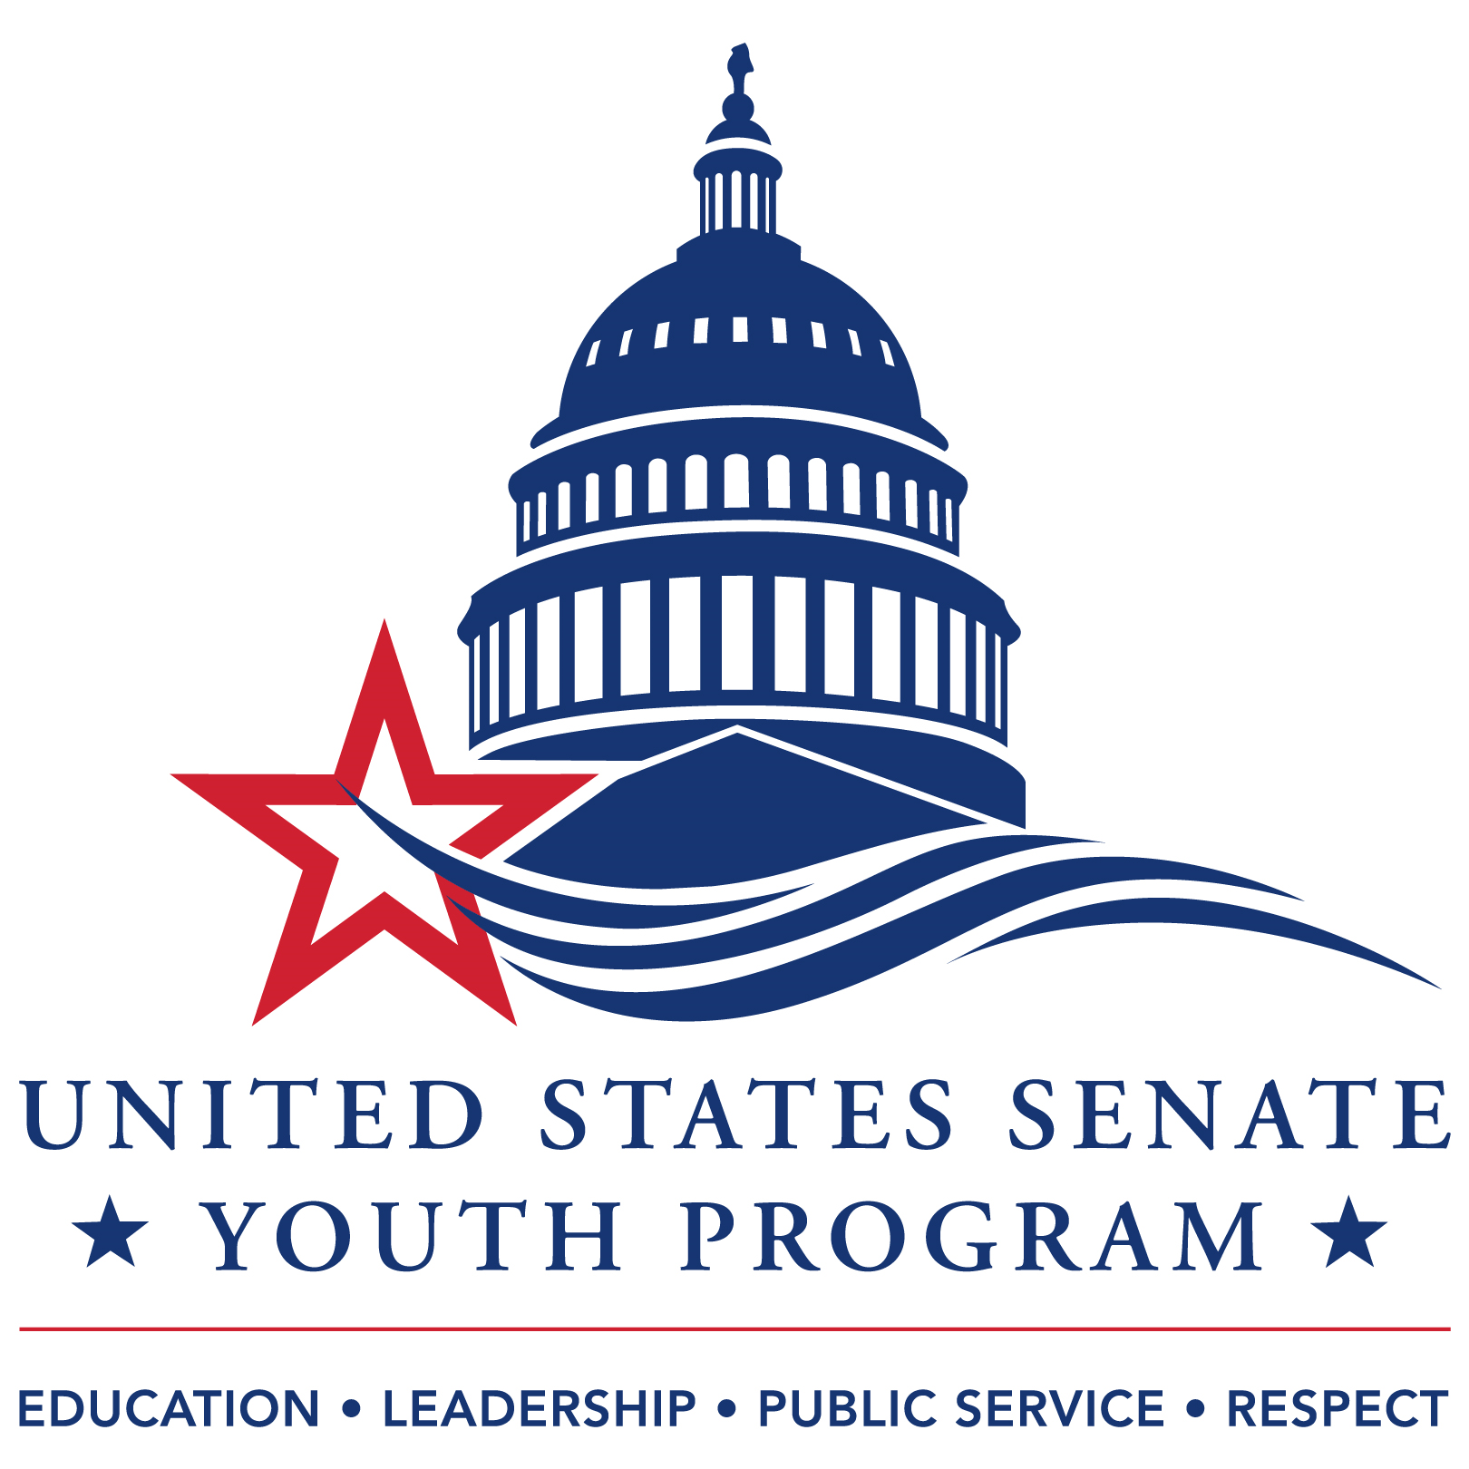 | - 2026 UNITED STATES SENATE YOUTH PROGRAM  - DELAWARE DEPARTMENT OF EDUCATION STUDENT APPLICATION | 

Part I of VII
Contact Information
Full Name: First Middle Last | Preferred Pronouns: Preferred Pronouns here
Date of Birth: Date of Birth | Graduating Class: Year
Home Address: Street Address  City, State Zip | Home Phone: Area Code + Number  Cell Phone: Area Code + Number  Email Address: Email Address  (Use an email address that is regularly monitored.)
Note: Applicants must be U.S. citizens or have permanent residency at the time of application.
☐Yes, I am a U.S. citizen.
☐No, I am not a U.S. citizen, but I am a permanent resident in possession of my official Green Card at the time of this application. Having applied for a Green Card, but not in possession, means you cannot apply for USSYP.

Parent/Guardian Information
Name: First, Last  Address: Street Address  City, State Zip  Home/Cell Phone: Area Code + Number  Email: Email Address | Name: First, Last  Address: Street Address  City, State Zip  Home/Cell Phone: Area Code + Number  Email: Email Address
High School Information
*Note: Student must be attending high school and reside with at least one parent/guardian in Delaware for the entire school year. For additional information, visit the USSYP’s How to Apply webpage here: https://ussenateyouth.org/selection_process_qualify/.

Name of School: Name of School
School Address: Street Address  City, State Zip | School Phone: Area Code + Number
Principal/Head of School: Name | Principal/Head of School Email Address: Email Address
School Counselor: Name | Counselor Email Address: Email Address

Part II of VII
Qualifying Elected/Appointed Leadership Position
The USSYP requires that all nominated students are:
- currently serving in an elected or appointed position in organizations that relate to government, public affairs, history, and/or community service.
- serving a constituency as part of their regular duties in that position.
- serving in that position during the entire 2025-2026 school year.

All student leadership qualifying positions are subject to the judgment of the state selection administrator and will be verified. Keep in mind that being the founder or chairperson of a self-created club or organization does not qualify the student for the program. For additional information, visit the USSYP’s How to Apply webpage here: https://ussenateyouth.org/selection_process_qualify/.

Check the elected/appointed office you now hold for the entire 2025-2026 school year in one of the following student government, civic, or educational organizations:

☐Student Body President | ☐Class President
☐Student Body Vice President | ☐Class Vice President
☐Student Body Secretary | ☐Class Secretary
☐Student Body Treasurer | ☐Class Treasurer
☐Student Council Representative
☐Officer in a National Honor Society chapter
☐Student representative elected or appointed (appointed by a panel, commission, or board) to a local, district, regional or state-level civic, service and/or educational organization whose primary purpose is public/ community service and constituent representation. Such positions will be subject to approval by the state selection administrator.

The positions listed below DO NOT qualify for the USSYP program:
- Attendance or officer position at Boys/Girls Nation or State summer conference
- General Member of a National Honor Society (serving as an elected officer is acceptable)
- Member or leader of the Boy Scouts, Girl Scouts, or a sports team
- A founder or chairperson of a self-created group
- A participant, captain or officer in Mock Trial, Debate Team, Model UN or other academic club, mock legislature, conference, or competition where the primary engagement is for individual educational benefit.

If you did not check one of the elected/appointed leadership positions above, answer each of the following: Name and describe your qualifying elected/appointed position? How does it relate to government, public affairs, history, and/or community service? What constituency do you serve, year-round, in this position?
Explain here in 50 words or less. (Personal essays will allow for more explanation).

Principal or Counselor Confirmation Signature: | _______________________________________________
 | I confirm that this student holds the above leadership position for the entire 2025-2026 school year.

Part III of VII
Written Essays
Each student is required to complete two essays. Each essay must meet the following criteria:
- Entered directly into the designated space below
- No more than 500 words in length
- Single-spaced
- Written in 12-point Times New Roman font
- The student’s original work
- Include proper citations for any sources used, when applicable

Academic Integrity
Each essay must be the student’s original work and adhere to the highest standards of academic integrity. Any evidence of plagiarism or the use of generative artificial intelligence tools (e.g., ChatGPT) will result in disqualification of the application, and the student’s school will be notified.

Essay 1 of 2
In 500 words or less, please address the following elements as they relate to your experience and aspirations:
- Your current elected or appointed student position and any previous involvement in student government or leadership roles.
- Activities and accomplishments that highlight your leadership within your school and community, particularly those that support your interest in serving as Delaware’s U.S. Senate Youth Program (USSYP) delegate.
- Your participation in community service initiatives or programs outside of school.
- How taking part in USSYP will deepen your understanding of and engagement with the political and governmental processes of the United States. Describe how being selected as a USSYP delegate would help you explore the most pressing questions you have about the challenges currently facing the nation.

Respond to Essay 1 here in 500 words or less.

Essay 2 of 2
Write a persuasive, research-based essay (500 words or less) on a socially significant topic connected to a current state, national, or global issue. Choose an issue that is personally meaningful, clearly articulate your position, explain its relevance to you, and support your argument with well-researched evidence. All sources must be properly cited. Essays will be evaluated based on the quality of ideas and content, organization, personalization, use of evidence, and adherence to writing conventions, including correct citation practices.

Respond to Essay 2 here in 500 words or less.

Part IV of VII
Video Presentation
Public speaking is a central component of the United States Senate Youth Program (USSYP). Each student must submit a video presentation, no longer than 3 minutes, which will be evaluated based on the following criteria:
- Public speaking ability
- Vocabulary and word choice
- Originality of content
- Organization and structure
- Depth of knowledge and understanding of content
- Clarity of visual aids (e.g., charts, graphs, slides, if used)
- Overall presentation, including attire, professionalism, and the appropriateness of the setting of the video

Video Presentation Instructions
Imagine you have just been elected as a U.S. Senator from Delaware. In your video, please address the following:
- Introduce yourself and share why you are proud to represent the state of Delaware.
- Highlight the personal qualities that you believe will make you an effective leader in Washington, D.C.
- Identify the legislative issues or initiatives you would champion and explain their significance to you and your constituents.
- Share a historical leader you admire and explain how their example influences your approach to leadership.

Reminder
This video will be used to help select two student delegates to represent Delaware at the USSYP’s Washington Week in Washington, D.C. Your presentation should reflect a high level of professionalism, confidence, and respect for the significance of this opportunity. Dress appropriately, and ensure your tone, setting, and demeanor reflect the honor of representing your state on a national stage.

To submit your video, upload your submission to YouTube: Insert YouTube link to your video here.

Part V of VII
Parent/Guardian Consent
The USSYP requires that student applicants confirm that, to the best of their knowledge, they do not have a scheduling conflict with the Washington Week program (March 7-14, 2026). Attendance during the entire Washington Week program is required to receive the financial scholarship.

Parents or guardians must sign below to approve for students to go to Washington, D.C. for Washington Week program (March 7-14, 2026) under the conditions set forth in the rules and regulations in the program brochure: https://ussenateyouth.org/selection_process_brochure/

Student Name: First and Last
Student Signature: | Date: Today’s Date

1st Parent’s/Guardian’s Name: First and Last | Sole Guardian? ☐Yes☐No
1st Parent’s/Guardian’s Signature: | Date: Today’s Date

2nd Parent’s/Guardian’s Name: First and Last
2nd Parent’s/Guardian’s Signature: | Date: Today’s Date

Part VI of VII
Required Attachments
  - Two (2) Signed Letters of Recommendation:
- One letter must be from either a high school principal or teacher
- One letter must be from another adult (non-family member) who can speak to the student’s leadership and service—this may include an advisor, coach, mentor, or representative of an organization or activity in which the student has demonstrated leadership or currently holds a qualifying leadership position for USSYP.

  - Copy of School Transcript - this information will remain confidential.

Part VII of VII
Submission Process

Student Responsibilities:
- Step One: Complete all components of the USSYP application, including all required attachments, links, and signatures.

- Step Two: Submit the completed application to your high school counselor by your school’s internal deadline.

School Counselor Responsibilities:
- Step 3: Review all student submissions and select one nominee to represent your school for the United States Senate Youth Program.

- Step 4: Compile the selected nominee’s full application—including all required documents, links, and signatures—into a single file.

- Step 5: Submit the completed nomination via email to both:
  - Michael Feldman, Education Associate for Social Studies: michael.feldman@doe.k12.de.us
  - Michelle Christman, Secretary: michelle.christman@doe.k12.de.us

Please ensure all materials are submitted by your school’s internal deadline to allow time for review and timely submission to the Delaware Department of Education.

