

Request for Proposals (RFP) and Contract for

Preplated Meal Vendor

United States Department of Agriculture

Child Nutrition Programs

SFA NAME

SFA ADDRESS

SFA CONTACT INFORMATION

In accordance with federal civil rights law and U.S. Department of Agriculture (USDA) civil rights regulations and policies, this institution is prohibited from discriminating on the basis of race, color, national origin, sex (including gender identity and sexual orientation), disability, age, or reprisal or retaliation for prior civil rights activity.

Program information may be made available in languages other than English. Persons with disabilities who require alternative means of communication to obtain program information (e.g., Braille, large print, audiotape, American Sign Language), should contact the responsible state or local agency that administers the program or USDA’s TARGET Center at (202) 720-2600 (voice and TTY) or contact USDA through the Federal Relay Service at (800) 877-8339.

To file a program discrimination complaint, a Complainant should complete a Form AD-3027, USDA Program Discrimination Complaint Form which can be obtained online at: <https://www.usda.gov/sites/default/files/documents/ad-3027.pdf>, from any USDA office, by calling (866) 632-9992, or by writing a letter addressed to USDA. The letter must contain the complainant’s name, address, telephone number, and a written description of the alleged discriminatory action in sufficient detail to inform the Assistant Secretary for Civil Rights (ASCR) about the nature and date of an alleged civil rights violation. The completed AD-3027 form or letter must be submitted to USDA by:

1. **mail:**  
   U.S. Department of Agriculture  
   Office of the Assistant Secretary for Civil Rights  
   1400 Independence Avenue, SW  
   Washington, D.C. 20250-9410; or
2. **fax:**  
   (833) 256-1665 or (202) 690-7442; or
3. **email:**  
   [Program.Intake@usda.gov](mailto:program.intake@usda.gov)

This institution is an equal opportunity provider.

**REQUEST FOR PROPOSAL AND CONTRACT INDEX**

Contents

I. Intent of Request 3

II. REQUEST FOR PROPOSAL / INSTRUCTIONS 3

**A. Legal Notice** 3

**B. Request for Proposal** 3

**C. Pre-Proposal Meeting / Timeline** 5

**D. Proposal Submission and Award** 5

**E. Evaluation of Proposal** 7

**F. Firm Offer** 9

**G. Final Contract** 9

**H.** **Bonding Requirements** 9

III. STANDARD TERMS AND CONDITIONS 10

**A. Definitions** 10

**B. Scope and Purpose** 12

**C. Food Service** 15

**D. Use of Advisory Group/Menus** 17

**E. Purchases** 17

**F. USDA Foods (Does not apply to SFSP or CACFP At-Risk)** 17

**G. Employees** 18

**H. Use of Facilities, Inventory, Equipment, and Storage** 18

**I. Health Certifications/Food Safety/Sanitation** 19

**J. Financial Terms** 19

**Fixed-Fee, Per-Meal Proposal** 20

**K. Record Keeping** 21

**L. Term and Termination** 21

**M. Insurance** 23

**N. Trade Secrets and Proprietary Information** 23

**O. Certifications** 24

**P. Miscellaneous** 25

IV. AGREEMENT 29

Exhibit A: SITE INFORMATION *[To be completed by The SFA]* 30

*ADP- Average Daily Participation 30

Exhibit B: List of the SFA CHARTS and attachments 31

Exhibit C: contract provisions for the sfa contracts under cnp awards 32

Exhibit D: cycle menu 37

Exhibit E: Food Specifications 38

EXHIBIT F: DEBARMENT AND SUSPENSION FORM 39

EXHIBIT G: CERTIFICATION REGARDING LOBBYING .40

Exhibit H: ANTI-COLLUSION AFFIDAVIT .44

**EXHIBIT I: CERTIFICATION REGARDING DRUG-FREE WORKPLACE . ………………………………… 45 EXHIBIT J: NATIONAL SCHOOL LUNCH & SCHOOL BREAKFAST PROGRAM MEAL PATTERNS…. 47 EXHIBIT K: AFTERSCHOOL SNACK PROGRAM MEAL PATTERN….………………………………………… 49 EXHIBIT L: SUMMER FOOD SERVICE PROGRAM MEAL PATTERN……………………………………………...50 EXHIBIT M: CHILD AND ADULT CARE FOOD PROGRAM MEAL PATTERN…………………………………… 51**

1. **INTENT OF REQUEST**

[School/Facility Name], hereinafter referred to as the “School Food Authority” or “SFA”, is accepting proposals from Pre-plated Meal Vendors to provide meals for the programs listed below that meet all United States Department of Agriculture (USDA) guidelines for meals served in the Child Nutrition Programs. The SFA participates in the following programs (SFA to select all applicable programs):

* National School Lunch Program (NSLP)
* School Breakfast Program (SBP)
* Afterschool Snack Program (ASSP)
* A la carte/Competitive Foods
* Child and Adult Care Food Program (CACFP) At-Risk Afterschool Supper Program
* CACFP At-Risk Afterschool Snack Program
* Fresh Fruit & Vegetable Program (FFVP)
* Summer Food Service Program (SFSP)
* Seamless Summer Option (SSO)

The intent of this Request for Proposal (RFP) is to establish a per-meal, fixed-price contract with the awarded vendor.

This contract shall be for a period of one year beginning on or about July, 1 ________, and ending June 30, ______. This contract may be renewed annually for up to two years by mutual written agreement between the SFA and the vendor. **Each contract extension must receive prior approval from DDOE**. Contract extensions or renewals, if applicable, are contingent upon the fulfillment of all contract provisions related to donated foods as required by 7 CFR 250.53(a)(12).

1. **REQUEST FOR PROPOSAL / INSTRUCTIONS**

***A. Legal Notice***

No intent should be construed from this legal notice that the SFA intends to enter into a contract with any party for alternative food service unless, in the sole opinion of the SFA, it is in the SFA’s best interest to do so.

All costs involved in submitting a response to this Request for Proposal (RFP) shall be borne in full by the interested party. The SFA is not liable for any cost incurred by any bidder prior to the signing of a contract by all parties.

The SFA reserves the right to reject any and all proposals or to accept the proposal that it finds to be the most responsive and responsible proposal submitted.

The Offeror to this RFP will be referred to as the Vendor, and any contract that may arise from this RFP will be between the Vendor and the SFA.

***B. Request for Proposal***

1. The SFA will consider a proposal for fixed-fee per-meal only. The fixed-fee per-meal price shall be inclusive of delivery.
2. In accepting proposals, the SFA reserves the right to reject any and all proposals and to waive any minor informality in order to take the action which it deems to be in the best interest of the SFA.
3. Offerors must submit a complete response to this Request for Proposal (RFP), including all certifications, for consideration as a responsive proposal. Bidders must complete, sign, and return this entire packet. No proposal may be altered, amended, or withdrawn after the specified time for opening and review of proposals.
4. Contracts entered into on a basis of submitted proposals are revocable if contrary to law.
5. RFPs will be publicized and identify all evaluation factors and their relative importance. Any response to publicized requests for proposals shall be honored to the maximum extent practical.
6. Proposals will be solicited from an adequate number of qualified sources.
7. Awards will be made to the responsible firm whose proposal is most advantageous to the program, with price and other factors considered. Price is to be the most heavily weighted evaluation criteria.
8. Discussions for the purpose of clarification may be conducted with responsible offerors who submit proposals determined to be considered for award selection, to assure full understanding of all terms and conditions of the RFP response and Contract requirements following state regulations and The SFA policy.
9. In conducting these discussions, there shall be no disclosure of any information derived from proposals submitted by competing offerors.
10. All procurement transactions shall be conducted in a manner that provides maximum open and free competition consistent with 2 CFR § 200.319. Some of the situations considered to be restrictive of competition include but are not limited to: placing unreasonable requirements on firms in order for them to qualify to do business, requiring unnecessary experience and excessive bonding, Noncompetitive pricing practices between firms or between affiliated companies, noncompetitive awards to consultants that are on retainer contracts, organizational conflicts of interest, specifying only a “brand name” product instead of allowing “an equal” product to be offered and describing the performance of other relevant requirements of the procurement, and any arbitrary action in the procurement process.
11. The SFA must maintain written standards of conduct covering conflicts of interest and governing the actions of its employees engaged in the selection, award and administration of contracts. No employee, officer, or agent may participate in the selection, award, or administration of a contract supported by a Federal award if he or she has a real or apparent conflict of interest. This applies if the SFA has a parent, affiliate, or subsidiary organization that is not a state, local government or Indian tribe.
12. If more than one proposal is offered by any one party, by or in the name of a clerk, partner, or other assistance or employee, all such bids will be rejected.
13. Bidders or their authorized representatives are expected to fully inform themselves as to the conditions, requirements, and specifications before submitting proposals; failure to do so will be at the bidder’s own risk and he/she cannot secure relief on the plea of error.
14. Any person that develops or drafts specifications, requirements, statements of work, invitations for bids, requests for proposals, contract terms and conditions, or other documents for use by the SFA in conducting a procurement under the USDA entitlement programs specified in 2 CFR 200.319 shall be excluded from competing for such procurements. Such persons are ineligible for contract awards resulting from such procurements regardless of the procurement method used.
15. Bidders certify, by signing this bid, that they will comply with Title VI of the Civil Rights Act of 1964 (P.L. 88-352). In accordance with Title VI of that Act, no person in the United States shall, on the grounds of race, color, or national origin, be excluded from participation in, be denied the benefits of, or be otherwise subjected to discrimination under this contract.
16. The subject matter of this RFP is subject to legislative changes either by the federal or State government. If any such changes occur prior to contract award, then all bidders will have the opportunity to modify their bids to reflect such changes. If any such changes occur after a contract award has been made, then the SFA (i) reserves the right to negotiate modifications to the Contract reflecting such legislative changes; and (ii) shall have no obligation to provide unsuccessful bidders with the opportunity to modify their bids to reflect such legislative changes.
17. This RFP is issued pursuant to 29 *Del. C.* §§ 6981 and 6982.
18. **All bid proposals must be reviewed by the Delaware Department of Education (DDOE) prior to acceptance by the SFA.**
19. See Standard Terms and Conditions herein below.

***C. Pre-Proposal Meeting / Timeline***

1. A pre-bid meeting is scheduled for [date and time]. Attendance is required. No bid or proposal will be accepted from a vendor not in attendance at this meeting. [Virtual pre-bid meetings via platforms such as Zoom, Webex, Microsoft Teams, or other teleconference services, are allowable. If conducting a pre-bid opening by virtual and/or teleconference, the SFA must include details such as date/time/phone number, and/or how an invitation link will be sent. The SFA must have a process in place to record attendance, with date and time stamp, and include language that outlines tardiness.] Pre-bid meetings are optional.

***D. Proposal Submission and Award***

1. Proposal packets will be sent to interested parties by contacting:

[List Contact Information]

1. The SFA will allow written requests for clarification of the RFP. All questions should be directed to the designated contact, [contact name and information]. If clarification of the specifications and/or instructions is required, the SFA will clarify the specifications and/or instructions in the form of an addendum issued to all prospective bidders by [date].
2. Proposals, including all required documentation and attachments, must be received no later than [Date and Time]. Proposals received after this date and time will not be considered. Proposals must be addressed to [Name, Title, and Address] in a sealed envelope. The outside of the envelope should be clearly marked Child Nutrition Proposal.
3. The proposed schedule of events subject to the RFP is outlined below:

Deadline for Receipt of Proposals Date: [Date and Time].

Public Opening and Review of Proposals Date: [Date and Time].

Notification of Award Date: [Date and Time].

1. No proposal may be altered, amended, or withdrawn after the specified time for opening and review of proposals.
   1. Any changes, amendments, or modifications to a proposal must be made in writing, submitted in the same manner as the original response, and conspicuously labeled as a change, amendment, or modification to a previously submitted proposal. Changes, amendments, or modifications to proposals shall not be accepted or considered after the hour and date specified as the deadline for submission of proposals.

### Vendor may modify or withdraw its proposal by written request, provided that both proposal and request to modify or withdraw is received by the SFA prior to the proposal due date. Proposals may be re-submitted in accordance with the proposal due date in order to be considered further.

### Proposals become the property of the SFA at the proposal submission deadline. All proposals received are considered firm offers at that time.

1. Late proposals will not be accepted.
2. To be considered, each offeror must submit a complete response to this solicitation **using the forms provided**.
   1. No other documents submitted with the RFP and Contract will affect the Contract provisions, and **there may be no modifications to the RFP and Contract language**.
   2. In the event that Offeror modifies, revises, or changes the RFP and/or Contract in any manner, the SFA may reject the offer as non-responsive.
3. Each proposal must be accompanied by a transmittal letter, which briefly summarizes the proposing firm’s interest in providing the required professional services. The transmittal letter must also clearly state and justify any exceptions to the requirements of the RFP, which the applicant may have taken in presenting the proposal. Furthermore, the transmittal letter must attest to the fact that no activity related to this proposal contract will take place outside of the United States.

### 

### Prices quoted in the proposal shall remain fixed and binding on the bidder at least through until at least the end of the one-year contract term.

### The SFA discourages overly lengthy and costly proposals. It is the desire that proposals be prepared in a straightforward and concise manner. Unnecessarily elaborate brochures or other promotional materials beyond those sufficient to present a complete and effective proposal are not desired. The SFA’s interest is in the quality and responsiveness of the proposal.

### It is the expectation of the SFA that vendors can fully satisfy the obligations of the proposal in the manner and time frame defined within the proposal. Proposals must be realistic and must represent the best estimate of time, materials, and other costs including the impact of inflation and any economic or other factors that are reasonably predictable.

### The SFA shall bear no responsibility or increase obligation for a vendor’s failure to accurately estimate the costs or resources required to meet the obligations defined in the proposal.

### All documents submitted as part of the vendor’s proposal will be deemed confidential during the evaluation process. Vendor proposals will not be available for review by anyone other than the SFA or its designated agents. There shall be no disclosure of any vendor’s information to a competing vendor prior to award of the contract.

### Vendor is fully responsible for the completeness and accuracy of their proposal, and for examining this RFP and all addenda. Failure to do so will be at the sole risk of vendor. Should vendor find discrepancies, omissions, unclear or ambiguous intent or meaning, or should any questions arise concerning this RFP, vendor shall notify the SFA’s designated contact [enter contact information], in writing, of such findings. All unresolved issues should be addressed in the proposal.

### The SFA reserves the right to accept or reject any or all proposals or any part of any proposal; to waive defects, technicalities or any specifications; to sit and act as sole judge of the merit and qualifications of each product offered; or to solicit new proposals on the same project or on a modified project which may include portions of the originally proposed project as the school may deem necessary in the best interest of the school.

1. Awards will be made to the responsible firm whose proposal is most advantageous to the program, with price and other factors considered (2 CFR 200.320):
   1. A responsible offeror is one who’s financial, technical, and other resources indicate an ability to perform the services required.
   2. Offeror shall submit for consideration such records of work and further evidence as may be required by the SFA’s Board of Trustees.
   3. Failure to furnish such records and evidence, or the inclusion of any false or misleading information therein shall be sufficient cause for the rejection of the proposal or termination of any subsequent contract.
   4. The qualification data shall be submitted by each offeror along with the proposal, and shall include the following:
      1. Offeror must be incorporated or licensed to do business in the State of Delaware.
      2. Annual reports or financial statements for the past fiscal year, certified by a licensed public accountant, must be included in the pre-qualification data.
      3. Information that offeror is doing business with like school systems and is familiar with the regulations pertaining to operations in such environments, if applicable.

### The final award of a contract is subject to approval by the Executive Board of the SFA and the Delaware Department of Education (DDOE). The school has the sole right to select the successful vendor(s) for award, to reject any proposal as unsatisfactory or non-responsive, to award a contract to other than the lowest priced proposal, to award multiple contracts, or not to award a contract, as a result of this RFP.

### Notice in writing to a vendor of the acceptance of its proposal by the SFA and the subsequent full execution of a written contract will constitute a contract. No vendor will acquire any legal or equitable rights or privileges until the occurrence of both such events.

1. Offerors or their authorized representatives must fully inform themselves as to the conditions, requirements, and specifications before submitting proposals; failure to do so will be at the offeror’s own risk who cannot secure relief on plea of error.
2. Any person that develops or drafts specifications, requirements, statements of work, invitations for bids, requests for proposals, contract terms and conditions or other documents for use by the SFA in conducting a procurement under the USDA entitlement programs specified in 2 CFR 200.319 shall be excluded from competing for such procurements. Such persons are ineligible for contract awards resulting from such procurements regardless of the procurement method used.
3. The SFA is not liable for any cost incurred by the offeror in submitting a proposal. **Paying the Vendor from Child Nutrition Program (CNP) funds is prohibited until the Contract is provided to DDOE and signed by the SFA.**

**All bid proposals must be reviewed by the Delaware Department of Education (DDOE) prior to acceptance by the SFA.**

***E. Evaluation of Proposal***

### Award Criteria

* 1. Proposals will be evaluated by the SFA committee based on the offer per meal or meal equivalent and the criteria, categories, and assigned weights as stated herein below (to the extent applicable).
  2. Committee members must consist of SFA employees familiar with the regulations and requirements of the Child Nutrition Programs.
  3. If a committee member is an agent for, employee of, or in any manner associated with a Vendor, that Vendor may not participate in the RFP and subsequent contract or comply with the conflict of interest policies of the SFA or district.
  4. Each area of the award criteria must be addressed in detail in the Proposal.
  5. The SFA will maintain records sufficient to detail the significant history of a procurement to include, but not limited to, the following: rationale for the method of procurement, selection of contract type, contractor selection or rejection, and the basis for the contract price.
  6. The SFA reserves the right to:
     1. Reject any and all proposals or portions of proposals received in response to this RFP or to make no award or issue a new RFP.
     2. Waive or modify any information, irregularity, or inconsistency in proposals received.
     3. Request modification to proposals from any or all vendors during the contract review and negotiation.
     4. Negotiate any aspect of the proposal with any vendor and negotiate with more than one vendor at the same time.

### Evaluation Process

* 1. The SFA will evaluate proposals on a variety of quantitative criteria. Neither the lowest price nor highest scoring proposal will necessarily be selected. Price will be the most heavily weighted evaluation criteria for submitted proposals.
  2. The SFA reserves full discretion to determine the competence and responsibility, professionally and/or financially, of vendors. Vendors are to provide, in a timely manner, any and all information that the school may deem necessary to make a decision.

1. Weight Criteria
   1. The SFA must determine prior to advertising the RFP what percentage (total of 100 points which equals 100%) each category below will be given when comparing proposals. Cost must be the most heavily weighted criteria.
   2. The SFA may insert additional categories if needed.
   3. The SFA may not include as a category: prior experience with the SFA, as it would violate USDA’s free and open competition regulation for procurement.

|  |  |
| --- | --- |
| **Points** | **Criteria** |
|  | Cost (must be primary consideration)   * Vendor provides pricing that aims to develop a cost-neutral program for the school including vendor support and responsibility for waste management. |
|  | Service Capability Plan (Vendor’s ability to provide services as stated in the RFP)   * Vendors is able to provide meals at the locations and times in the RFP * Vendor is able to provide HACCP trained server(s) to both serve food as well as operate POS systems for the SFAs (if applicable) * Vendor is responsive to the SFA needs and remedies problems immediately * Vendor will provide paperwork that incorporates daily HACCP and production worksheet required information (provide sample) * Vendor provides necessary paperwork and documents to the SFA, including the SFA invoices, menus and production worksheets, menu substitutions, in order for the SFA to properly monitor performance This includes FFVP, SFSP, and CACFP documentation if necessary |
|  | Experience, References with programs like the SFA’s and familiarity with regulations pertaining to such operations   * Vendor is able to provide three references with programs like the SFAs * Vendor is able to describe familiarity with program regulations |
|  | Financial Condition/Stability, Business Practices   * Vendor is able to finance meal preparation and delivery without pre-payments * Vendor is able to provide documentation of financial stability and sound business practices |
|  | Accounting and Reporting Systems   * Vendor is able to provide monthly invoices that show credits for USDA foods (if not applicable, do not use this criteria) * Vendor is able to provide a year-end summary of the total meals invoiced/served by meal type, total amount of USDA foods credited, and total fees charged by site, (if not applicable, do not use this criteria) |
|  | Menu and Food Quality   * Vendor is able to provide a cycle menu that meets the specifications of the programs being served * Vendor involves students, staff, and patrons in menu planning * Portion and serving sizes are easily identifiable and provided by the Vendor * Menus offer a variety of food items appropriate for each grade/age group served * Vendor is able to accommodate special dietary needs as outlined in the RFP * Food specifications meet the requirements of the RFP * Food delivered is prepared fresh, free of spoilage, and minimally processed. Fresh fruit and vegetable options are available daily. |
|  | Flexibility in Ordering   * The SFA has flexibility and autonomy to request meals at dates/times of their choosing, despite traditional closed days * Field trip and shelf-stable meals are available (meet USDA reimbursable meal requirements.) |
|  | Waste Management   * Vendor works with the SFA to look at trends for more accurate ordering and to help reduce waste |
| 100 | TOTAL |

***F. Firm Offer***

1. By submitting a response to this RFP, and if such response is not withdrawn prior to the time for opening proposals arrives, the offeror understands and agrees that they are making a firm offer to enter into a contract, which may be accepted by the SFA and which will result in a binding contract.
2. Such proposal is irrevocable for a period of ninety (90) days after the time for opening of proposal has passed.**_______________(Vendor must initial and date to show agreement)**

***G. Final Contract***

A duplicate copy, preferably electronic, of the submitted proposal and all required documents listed below must be provided to the SFA for submission to DDOE. The complete contract to submit to DDOE includes:

1. All documents included by the SFA in the DDOE-approved RFP template with the Vendor responses.
2. Any additional negotiations that have been completed and terms that are included in additional documents that are not included in the DDOE RFP/contract template.
3. All documents submitted by the Vendor that have been mutually agreed upon by both parties (i.e. worksheets, attachments submitted by the Vendor in the proposal, and operating cost sheets).
4. All of the above terms need to be added to the original DDOE-approved RFP/contract and signed by all parties.
5. The contract must be approved and signed by DDOE prior to the SFA signing and accepting the proposal and awarding the final contract.

***H. Bonding Requirements***

**SNP and CACFP:**

**Bid Bonds** - The bid bond security need not be for a specific sum but may be stated to be for a sum equal to 10% of the bid to which it relates. A bid bond or bid security may be stated as a certain stated sum provided that the sum is equal to or greater than 10% of the bid. A SFA or a CACFP sponsor may choose to waive the requirement of a bid bond. **The decision to waive the requirement of a bid bond must be clearly stated in the bid special provisions.**

**Performance Bonds** - The procuring agency shall require the successful bidder to execute a good and sufficient bond to the State for the benefit of the agency. In cases where contracts for the purchase of material with a value less than the $50,000 formal purchase threshold, a SFA or a CACFP sponsor may waive, or reduce, the performance bond requirement from the successful bidder. Such a waiver or reduction must be stated in the bid specifications. The Performance bonds shall be with a corporate surety authorized to do business in this state and be in a sum equal to 100% of the contract award. **The decision to waive the requirement of a bid bond must be clearly stated in the bid special provisions.**

**SFSP:** The SFSP requires the following regarding bonds:

**Bid Bond Requirement** - For bids over $150,000, a bid bond in the amount of 10 percent of the estimated value of the contract for which the bid is made must accompany the bid. The bid bond must be from a company listed in the current United States Department of Treasury Circular 570 certified to do business in Delaware. No other type of bid bond is acceptable.

**Performance Bond Requirement** - For contracts over $150,000, a performance bond equal to at least 10 percent, but not more than 25 percent of the value of the winning contract, must be obtained by the contractor. The performance bond must be from a company listed in the current United States Department of Treasury Circular 570 certified to do business in Delaware. The contractor must furnish a copy of the bond to the sponsor within 10 days of the contract’s award. The performance bond must include the entire period that sponsor will operate the feeding program. Sponsors may not accept cash, letter of credit, trust account, land or any other form of guarantee in lieu of the performance bond.

**III. STANDARD TERMS AND CONDITIONS**

***A. Definitions***

The following definitions shall apply within this document and its attachments:

1. “Accounting Periods” means _______________ [enter accounting period to use (i.e., first day of the month through the last day of the month]*.*
2. “Applicable Credit” refers to the meaning established in 2 CFR 200.406.
3. “Buy American”—The term ‘domestic commodity or product’ means an agricultural commodity that is produced in the United States; and a food product that is processed in the United States substantially using agricultural commodities that are produced in the United States.
4. “Child Nutrition Program (CNP) ” means the USDA Child Nutrition Programs in which the SFA participates.
5. “Contract” means this RFP and Contract, the exhibits attached to this RFP and Contract and Vendor’s Proposal.
6. “DDOE” means the Delaware Department of Education.
7. “Effective Date” means [contract start date] through [contract end date] (must not exceed one year in length).
8. “Fixed Fee” Contracts that provide for fixed fees such as those that provide for fees established on a per meal basis are allowed. All services provided are to be incorporated into the fixed fee per meal, and no other fees will be allowed. The offer amount should be based on assumption that no donated USDA Foods will be available for use and includes all expected rebates, discounts and other applicable credits.
9. “Vendor’s Proposal” means Vendor’s response to the RFP and Contract.
10. “Meal Equivalent” In a fixed-fee, per-meal contract, the Vendor is paid on the basis of the number of meals served. In order for the Vendor to be paid for non-meal food service, non-program meal sales activity and revenues are converted into a specific number of reimbursable lunches. The conversion of non-meal activity into an equitable number of meals is completed by dividing the total of cash receipts, other than from sales of NSLP and SBP meals, ASSP and SFSP meals, by the current equivalency factor. The equivalency factor for the Meal Equivalent shall remain fixed for the term of the Contract and all renewals and is in Section: J Financial Terms.
11. Healthy Hunger Free Kids Act of 2010 (HHFKA): The current Child Nutrition Program Reauthorization is due for reauthorization and is pending.
12. “Non-profit Food Service Account” means the restricted account in which all of the revenue from all food service operations conducted by the SFA principally for the benefit of school children is retained and used only for the operation or improvement of the nonprofit food service.
13. Procurement standards. The SFA may use its own procurement procedures which reflect applicable State and local laws and regulations, provided that procurements made with nonprofit food service account funds adhere to the standards set forth in 2 CFR 200 Part D and 7 CFR 200.21. The SFA procedures must include a written code of standards of conduct meeting the minimum standards of 2 CFR 200.318, as applicable. No employee, officer or agent of the SFA shall participate in selection, or in the award or administration of a contract supported by Federal funds if a conflict of interest, real or apparent, would be involved. To the extent permitted by State or local law or regulations, such standards or conduct will provide for penalties, sanctions, or other disciplinary actions for violations of such standards
14. “Program(s)” or “Child Nutrition Program (CNP)(s)” means the USDA Child Nutrition Programs in which the SFA participates.
15. “Program Funds” means all funds that are required to be deposited into the Non-profit School Food Service Account.
16. “Proposal” means vendor’s response to the RFP and Contract.
17. “RFP” means the SFA’s Request for Proposal and Contract**,** and all of its attachments.
18. “Services” means the services and responsibilities of Vendor as described in this Contract, including any additional services described in Section P of this Contract.
19. “The SFA” or “School Food Authority” as defined in 7 CFR §210.2.
20. “The SFA’s Food Service Budget” means the Food Service Budget for the Current School Year, which is attached to this Contract as “Exhibit C” and fully incorporated herein.
21. “The SFA’s Food Service Facilities” means areas, improvements, personal property, and facilities made available by The SFA to Vendor for the provision of the food services as described herein.
22. “The SFA’s Food Service Program” means the preparation and service of food to The SFA’s students, staff, employees and authorized visitors, including the following programs: *National School Lunch Program (NSLP), School Breakfast Program (SBP), After School Care Snack Program (ACSP), Summer Food Service Program (SFSP), Fresh Fruit and Vegetable Program (FFVP), Child and Adult Food Care Program (CACFP), and a la carte food service.*
23. “The SFA’s Food Service Location(s)” means the schools or other locations where Program meals are served to The SFA’s schoolchildren.
24. “USDA” means United States Department of Agriculture, Food and Nutrition Service.
25. “Vended Meals”: In a fixed-fee, vended meals contract, the contractor provides the meals only (pre-packaged, pre-plated) and does not manage any other aspect of the school food service. However, if the contractor’s employees are responsible for final preparation and/or serving of prepackaged, pre-plated school meals, the additional services are included in the fixed-fee bid and may not be charged separately.

***B. Scope and Purpose***

1. During the term of this Contract, Vendor shall operate the SFA’s Food Service Program in conformance with the SFA’s agreement with the DDOE School Nutrition Programs.
2. It is strongly recommended that subcontracting of services be prohibited. At a minimum, all subcontracts are subject to prior approval by the SFA. The vendor may not subcontract USDA foods for further processing.
3. Vendor shall have the exclusive right to prepare and provide meals for the programs specified by the SFA in Exhibit A: Site Information, which is attached to this Contract and fully incorporated herein.
4. Renegotiation of price changes will be allowed in any subsequent years of the agreement pertaining to unit price. The annual percentage increase must be based on the Consumer Price Index of Food Eaten Away From Home (from the United States Department of Labor, Bureau of Labor Statistics), or 3%, whichever is less. Before price increases can be implemented, the FSMC must document, through cost or price analysis, the need for such price increase. The SFA must forward all documentation to the DDOE for review and approval. No price increase may be implemented under this provision without prior written approval of the DDOE. If a program is planned/added later (i.e. a breakfast program or snack program) which is beyond the scope or original intent of this RFP/Contract or if a proposed contract modification changes the scope of a contract or increases the contract amount by more than the simplified acquisition threshold the appropriate procurement procedures must be followed, including a new competitive solicitation.
5. Any change to the scope of services to be provided by Vendor that is beyond the scope or original intent of this RFP/Contract or involves a total increase of ≥10% of the total contract value must be rebid.
6. The SFA must perform a cost or price analysis in connection with every procurement action in excess of the simplified acquisition threshold including contract modifications. Documentation of this analysis must be maintained.
7. The Vendor shall:
   1. Cooperate with and ensure the resolution of Vendor facility reviews conducted by the State Agency (SA) (DDOE). The SA may inspect the Vendor’s facilities as part of the SFA’s administrative review or as part of a meal quality test.
   2. Maintain all records necessary, in accordance with applicable regulations, for the SFA, DDOE and USDA to complete required monitoring activities and must make said records available to the SFA, DDOE, and USDA upon request for the purpose of auditing, examination, and review (7 CFR § 210.16(c)(1)).
   3. Cooperate with the SFA in promoting nutrition education, health, and wellness policies.
   4. Comply with applicable federal, state and local laws, rules and regulations, policies, and instructions of DDOE and USDA and any additions or amendments thereto, including USDA Regulation 7 CFR Parts 210, 215, 220, 225, 226, 245, 250, if applicable; OMB Circulars, 2 CFR 200 and the other laws described in the “Contract Provisions for The SFA Contracts under CNP Awards,” which is attached to this Contract as “Exhibit E” and fully incorporated herein by reference.
   5. Comply with all the SFA building rules and regulations.
   6. The selected Vendor will warrant that it possesses, or has arranged through subcontractors, all capital and other equipment, labor, materials, and licenses necessary to carry out and complete the work hereunder in compliance with any and all Federal and State laws, and County and local ordinances, regulations and codes.
   7. The Vendor will provide a warranty that the deliverables provided pursuant to the contract will function as designed for a period of no less than one (1) year from the date of system acceptance. The warranty shall require the Vendor correct, at its own expense, the setup, configuration, customizations or modifications so that it functions according to the School’s requirements.
8. The SFA shall be responsible for:
   1. Signature authority for the application/contract, free and reduced-price policy statement, and Programs indicated in Exhibit A: Site Information, herein, and the monthly claim for reimbursement (7 CFR 210.9(a) and (b) and 7 CFR 210.16(a)(5)).
   2. Operating the SFA’s Food Service Program for the benefit of the SFA’s students, faculty and staff.
   3. Development and distribution of the parent letter and Application for Free and Reduced-Price Meals and/or Free Milk and participating in Direct Certification.
   4. Determination of eligibility for free or reduced-price meals and free milk, if applicable.
   5. Conducting any hearings related to determinations of free and reduced-price eligibility.
   6. Verification of applications for Free and Reduced-Price Meals as required by USDA regulations.
   7. Establishment and maintenance of the free and reduced-price meals’ eligibility roster. (7 CFR 210.7(c), 7 CFR 210.9(b) (18) and 7 CFR 245.6(e)). (Does not apply to SFSP)
   8. Conduct of the SFA’s Food Program.
   9. Supervision of the food service operations in such manner as will ensure compliance with all applicable statutes, regulations, rules and policies including regulations, rules, and policies of DDOE and USDA regarding the Child Nutrition Programs.
   10. Establishing all selling prices, including price adjustments, for all reimbursable and non-reimbursable meals/milk and a la carte (including vending, adult meals, and catering) prices. (Exception: Non-pricing programs need not establish a selling price for reimbursable meals/milk.)
   11. Maintaining control of the non-profit food service account and overall financial responsibility for the SFA’s food service program, as well as the quality, extent and general nature of the food service.
   12. Ensuring the resolution of Program administrative reviews and audit findings. The results of these reviews may affect the amount of reimbursement the SFA will receive and the payment to the Vendor. Vendor shall fully cooperate with the SFA in resolving review and audit issues. Vendor shall indemnify the SFA for any fiscal action, claims, losses or damages, fault, fraud, required repayment or restoration of funds, including reasonable attorney’s fees incurred in defending or resolving such issues, that results from Vendor’s intentional or negligent acts.
   13. Monitoring the food service operation of the Vendor through periodic on-site visits to ensure that the food service is in conformance with USDA program regulations (7 CFR § 210.16(a)(3)).
   14. Conducting an on-site review of the counting and claiming system at each the SFA Food Service Location no later than February 1 of each year if there is more than one the SFA Food Service Location. (Does not apply to SFSP.)
   15. The counting and claiming system, including compliance with required internal control procedures. (7 CFR § 210.8(a)(1), 7CFR 225.9(d)).
   16. Ensuring that DDOE has reviewed and approved the contract terms and that the SFA has incorporated all DDOE-required changes into the contract or amendment before any contract or amendment to an existing Vendor contract is executed.
   17. Ensure that all federally donated foods received by the SFA and made available to the Vendor accrue only to the benefit of the SFA’s non-profit food service account and are fully utilized therein. (Does not apply to SFSP or CACFP At-Risk.)
   18. Not directly or indirectly restricting the sale or marketing of fluid milk (§210.10(d)(4)) at any time or in any place on site premises.
   19. Maintaining a contract administration system which ensures that the Vendor performs in accordance with the terms, conditions, and specifications of their contract.
   20. Be responsible for full compliance with rules and regulations relating to implementation of the SFSP [7 CFR 225.15] and CACFP [7 CFR 226], if applicable, including retaining responsibility for the following non-delegable duties (may not be delegated to a Vendor Employee):
   21. Meal orders:
9. Inform the Vendor of approved level at each site for which the Vendor will provide meals.
10. Plan for and prepare or order meals on the basis of participation trends with the objective of providing only one meal per child at each meal service.
    1. Records and claims
    2. Maintain accurate records which justify all costs and meals claimed.
    3. Submit claims for reimbursement in accordance with appropriate regulations
    4. Training and monitoring
11. Hold Program training sessions for its administrative and site personnel.
12. Not allow a site to operate until personnel attend at least one of the trainings.
13. Visit each of their sites at least once during the first week of SFSP operation.
14. Review food service operations at each site at least once during the first four weeks of Program operations.
15. Maintain a reasonable level of site monitoring.
16. Document required SFSP site visits of all sites.
    1. Determination / Processing of Free and Reduced Price applications
17. Coordination of printing of materials
18. Approving Official, Hearing Official, or contact person for questions.
19. Development of materials for distribution from prototypes provided by DDOE, including Letter to Parents, Application, Public Release, etc.
20. Distribution of materials to parents/guardians.
21. Collection of submitted applications.
22. Processing of applications, including approval/denial and follow-up to obtain complete information.
23. Inputting data into computer if applications approved manually.
24. Inputting data into computer if computer system automatically determines eligibility.
25. Final approval and signature of approving official.
26. Notification of approval and status to parent/guardian.
    1. Submission of Media Release.
    2. Completion of SFSP and CACFP Site Applications and determining eligibility for all SFSP and CACFP sites.
    3. Make final determination of the opening and closing dates of all SFSP and CACFP sites.
    4. Preparation and submission of claim for reimbursement.
27. Compiling daily site counts at the school and the SFA level, and maintaining records.
28. Signing the claim for reimbursement.
29. The SFA and Vendor agree that this Contract does not permit all income and expenses to accrue to the Vendor and is neither a *cost-plus-a-percentage-of-income nor a cost-plus-a-percentage-of-cost contract* as required under United States Department of Agriculture (USDA) Regulations 7 CFR §210.16(c) and 2 CFR 200.
30. Payments on any claim shall not preclude the SFA from making a claim for adjustment on any item found not to have been in accordance with the provisions of this Contract and bid specifications.
31. The SFA may request of Vendor additional food service programs; however, the SFA reserves the right, at its sole discretion, to sell or dispense food or beverages, provided such use does not interfere with the operation of the Child Nutrition Programs. Any food and beverages sold in addition to the reimbursable meals must meet USDA competitive foods regulation 7 CFR 210.11.
32. Any changes to the terms or conditions of this Contract, which are required by Federal or State law or rule, or changes to Federal or State laws or rules, are automatically incorporated herein, effective as of the date specified in such law or rule.
33. Any changes made by the SFA or Vendor to a DDOE pre-approved prototype contract or DDOE approved contract term must be approved in writing by DDOE before the contract is executed. When requested, the SFA must submit all procurement documents, including responses submitted by potential contractors, to DDOE, by the due date established by DDOE.
34. Gifts from Vendor: The SFA’s officers, employees, or agents shall neither solicit nor accept gratuities, favors, nor anything of monetary value from contractors nor potential contractors in accordance with all laws, regulations and policies. To the extent permissible under federal, state, or local laws, rules, or regulations, such standards shall provide for appropriate penalties, sanctions, or other disciplinary actions to be applied for violations of such standards.
35. Fresh Fruit and Vegetable Program (FFVP): (if applicable) In the event that Vendor provides services for the FFVP at any of the SFA’s Food Service Locations, the SFA and Vendor agree to operate the FFVP in accordance with the requirements of Section 19 of the National School Lunch Act, all applicable regulations and policies, and the FFVP Handbook for Schools. The SFA and Vendor further agree that not more than 10% of the total funds awarded to the school and/or schools for operation of the FFVP may be used for administrative expenses.

***C. Food Service***

1. Vendor shall:
   1. Deliver meals on such days and at such times as requested by the SFA that meet all USDA meal pattern requirements. Any menu substitutions must be approved by the SFA and should, to the maximum extent practicable, be equivalent to the original menu item in regards to crediting toward the meal patterns.
      * 1. Complete meals need to be delivered to the SFA by the vendor. The SFA is capable of receiving deliveries [daily, Monday through Friday, during normal business hours or list specific times if preferable]. The Vendor must ensure prompt deliveries of meals and/or substitutions.
   2. Promote maximum participation in the Programs.
   3. Provide specified types of meals and services in the sites listed in Exhibit A.
   4. All food and beverages other than meals reimbursed under programs available for sale to students on the School campus during the School day must be authorized by the SFA and only at the times and places designated by the SFA. All foods sold must meet the nutrition standards specified in 7 CFR 210.11. These standards apply to items as packaged and served to students. (Does not apply to SFSP or CACFP.)
   5. Support the SFA’s compliance with the federal Child Nutrition Reauthorization (CNR) which authorizes all of the federal child nutrition programs, including the School Breakfast, National School Lunch, Child and Adult Care Food, Summer Food Service, and the Fresh Fruit and Vegetable Programs and WIC. The current law, the Healthy, Hunger-Free Kids Act of 2010 was due for reauthorization in 2015 but has not been released.
2. The SFA shall retain control of the quality, extent, and general nature of the food service.
3. Special Dietary Needs
   1. Vendor and the SFA must follow current federal and state regulations regarding providing for special dietary needs for enrolled students. Additional information is available at <https://www.fns.usda.gov/school-meals/faqs>.
   2. Exceptions for disability reasons:  Vendor must make modifications in meals and afterschool snacks for students who are considered to have a disability under 7 CFR 15b.3 and whose disability restricts their diet. Modifications must be made on a case by case basis. Meal modifications that fall outside the required meal pattern can be made when supported by a written medical statement. Modifications that can be made within the required meal pattern at the discretion of the Vendor and the SFA.
   3. Exceptions for non-disability reasons:  Vendor, with instructions from the SFA, may make modifications for students without disabilities who cannot consume the regular lunch or afterschool snack because of ethical, cultural, religious reasons or other preferences. Modifications made must for dietary preferences must meet meal pattern requirements established under 7 CFR § 210.10 and 7 CFR § 220.
   4. Meal modification approval: The approval for meal modifications must remain in effect until the medical authority or the student's parent or legal guardian revokes such request, or until such time as the Vendor and the SFA changes their meal modifications policy.
   5. Required Documentation: Information about meal modifications must be included in the following documents: (1) medical statements or preference forms, (2) production records (3) recipes (4) HACCP plans and (5) meal counting and claiming tracking. Production records should indicate the meal substitutions/accommodations and the number of meals served for special diets.
4. USDA Fresh Fruit and Vegetable Program (FFVP) (If applicable)

Vendor:

* 1. Documents and tracks FFVP expenses separately and makes this documentation easily accessible for the SFA to review and submit an accurate claim.
  2. Time certification of FFVP Labor time is required.
  3. Documentation must clearly show allocation of costs charged to the FFVP, i.e. specific labor time charges, actual costs of fresh fruits and vegetables, administrative fees that do not exceed 10% of the overall grant.
  4. Follows all FFVP polices and rules to guarantee the program is operated in compliance with FNS standards.
  5. Develops cycle menu for FFVP for participating schools. It is recommended that portion sizes are included in the proposed menu cycle.

The SFA:

* 1. Will regularly monitor Vendor compliance with FFVP requirements
  2. Will monitor all FFVP expense documentation from Vendor for compliance with the contract and regulations, prior to submitting FFVP claim

***D. Use of Advisory Group/Menus***

1. The SFA shall establish an advisory board composed of parents, teachers, and students to assist in menu planning (7 CFR 210.16(a)(8)). The vendor should participate in surveying students’ menu acceptability, to the maximum extent practicable.
2. SFAs with no capability to prepare a cycle menu may require that each Vendor include a cycle menu, developed in accordance with Exhibit B.
3. The SFA shall approve the menus no later than two weeks prior to service.
4. Vendor:
   1. Shall deliver meals that follow the cycle menus that meet Child Nutrition Program requirements and food specifications contained in Exhibits B and, attached to this Contract.
   2. May not change or vary the menus after the first menu cycle for the NSLP, SBP, Afterschool Snack Program, SFSP, CACFP At-Risk, FFVP or a la carte items without written approval of the SFA.
   3. Shall justify and document in writing all requests for any changes or variances for substitutions to the SFA menu of lower quality food items.
   4. Maintains documentation for substitutions and justification of lower quality food items for the records retention period applicable to food production records and documentation is available to the SFA, DDOE and USDA for review upon request. (7 CFR 210.16(b)(1))
   5. Complies with the SFA’s local wellness policy as applicable (does not apply to SFSP or CACFP).
   6. Complies with all state and local laws that affect school meal preparation and/or service.

***E. Purchases***

**The following applies to all Vendor contracts, excluding SFSP and CACFP:**

1. Buy American: The SFA and Vendor will comply with the Buy American Provision for contracts that involve the purchase of food. As required by the Buy American Provision, all products must be of domestic origin as required by 7 CFR Part 210.21(d).
   1. The SFA participates in the NSLP and SBP and is required to use the nonprofit food service funds, to the maximum extent practical, to buy domestic commodities or products for Program meals. A “domestic commodity or product” is defined as one that is either produced in the U.S. or is processed in the U.S. substantially using agricultural commodities that are produced in the U.S. as provided in 7 CFR Part 210.21(d) (at least 51% or more domestic agricultural commodities).
   2. Exceptions to the Buy American Provision should be used as a last resort; however, an alternative or exception may be approved upon request.
   3. To be considered for the alternative or exception, Vendor must submit request in writing to the SFA and be approved. Approval will be retained with purchase records. The request must include the:
      1. Alternative substitute (s) that are domestic and meet the required specifications:
         1. Price of the domestic food alternative substitute(s); and
         2. Availability of the domestic alternative substitute(s) in relation to the quantity ordered.
      2. Reason for exception: limited/lack of availability or price (include price):
         1. Price of the domestic food product documenting that the domestic product is significantly higher; and
         2. Price of the non-domestic product that meets the required specification of the domestic product.

***F. USDA Foods (Does not apply to SFSP or CACFP At-Risk – if the SFA does not receive USDA Foods, this section should be removed)***

1. The SFA shall retain title to all USDA Foods. (7 CFR 250.11(e))
2. The SFA shall accept and use, in as large quantities as may be efficiently utilized in its nonprofit school food service, donated foods offered by USDA. The SFA's policies, procedures, and records must account for the receipt, full value, proper storage and use of USDA donated foods. (7 CFR Part 210.14(d))
3. USDA Foods shall accrue only to the benefit of the SFA’s feeding operation.
4. Bid prices submitted by vendors must be independent of the value of USDA Foods received by the SFA. Bidders must respond with prices for meals without making adjustments for USDA Foods.
5. Pre-plate vendors may *not* act as USDA Foods processors unless they have a processing agreement with FNS or the State Distributing Agency. (According to 7 CFR 250.30(a): “Use of a commercial facility to repackage donated foods, or to use donated foods in the preparation of meals, is considered processing in this part.”)
6. If the awarded vendor has a processing agreement with USDA-FNS or the State Distributing Agency, then the vendor must comply with all requirements for processors of donated foods contained in 7 CFR 250 Subpart C.
7. If the awarded vendor does not have a processing agreement, then USDA Foods will be delivered directly to the SFA.

***G. Employees***

1. Vendor shall:
   1. Comply with all wage and hours of employment requirements of federal and state laws.
   2. Be responsible for supervising and training Vendor personnel.
   3. Supervision activities include employee and labor relations, personnel development, and hiring and termination of Vendor staff.
   4. Provide Workers’ Compensation coverage for its employees, as required by law.
   5. Instruct its employees to abide by the policies, rules, and regulations with respect to use of the SFA’s premises as established by the SFA and are furnished in writing to Vendor.
   6. Maintain its own personnel and fringe benefits policies for its employees as applicable.
   7. Remove any employee who violates health requirements or conducts him/herself in a manner that is detrimental to the well-being of the students, provided such request is not in violation of any federal, state or local employment laws. In the event of the removal or suspension of any such employee, Vendor shall immediately restructure the food service staff to avoid disruption of service.

***H. Use of Facilities, Inventory, Equipment, and Storage***

1. **Kitchen and Serving Facilities:** Exhibit B, Chart 1 outlines the facilities available to the SFA.
2. **Equipment:** Exhibit B, Chart 1 outlines the equipment available to the SFA. Proposals should include any additional equipment that will be required for food preparation and serving. Tables and dry storage will be provided by the SFA.
3. Vendor and the SFA shall:
   1. Non-expendable supplies and capital equipment: At the commencement, termination, or expiration of this Contract:
      1. Take a physical inventory of all non-expendable supplies and capital equipment owned by the SFA, including, but not limited to, silverware, trays, chinaware, glassware and kitchen utensils, and all furniture, fixtures, and dining room equipment utilized in the SFA’s Food Service Program;
      2. Mutually agree on the usability of such supplies and equipment;
      3. At the expiration or termination of this Contract, Vendor shall surrender to the SFA all non-expendable supplies and capital equipment in the condition in which it was received except for ordinary wear and tear, damage by the elements and except to the extent that said premises or equipment may have been lost or damaged by vandalism, fire, flood or other acts of God, or theft by persons other than employees of Vendor except through the negligence of Vendor or its employees, or for any other reason beyond the control of Vendor; and
      4. Sign a summary of the beginning inventory and ending inventory at the expiration or termination of this Contract and keep a copy of each on file with this Contract.
4. Vendor shall:
   1. (If applicable) Maintain the inventory of silverware, servingware, kitchen utensils and other operating items necessary for the food service operation and at the inventory level specified by the SFA.
   2. Maintain adequate storage procedures, inventory, and control of USDA Foods in conformance with the SFA's agreement with Delaware’s Food Distribution Program.
   3. Not remove any of the SFA owned equipment from the SFA’s premises.
   4. Comply with all SFA building rules and regulations.
   5. Surrender to the SFA all of the SFA’s equipment and furnishings in good repair and condition, reasonable wear and tear excepted, upon termination of this Contract
5. The SFA shall:
   1. Replace expendable equipment and replace, repair and maintain nonexpendable equipment except when damages result from careless use by the employees of Vendor.
   2. (If applicable) Provide Vendor with, water, gas and electric service for the food service program.
   3. Furnish and install any equipment and/or make any structural changes to the facilities needed to comply with federal, state, or local laws, ordinances, rules and regulations.
   4. Be responsible for any losses, including USDA Foods, which may arise due to equipment malfunction or loss of electrical power not within control of Vendor.
   5. Not be responsible for loss or damage to equipment owned by Vendor and located on the SFA premises.
   6. Shall retain title to all the SFA food and supplies in the SFA during the course of this Contract.

***I. Health Certifications/Food Safety/Sanitation***

1. Vendor shall:
   1. Per 7 CFR 210.16(a)(7), the vendor must have applicable State or local health certification for facilities inside or outside the school in which is proposes to prepare or serve meals and shall maintain such certification for the duration of the contract. The certification must cover the transport of food from the facility to the school. The certification should be documented by the prospective vendor at the time of bid or proposal.
   2. Obtain and post all licenses and permits as required by federal, state, and/or local law.
   3. Comply with all State of Delaware and local and sanitation requirements applicable to the preparation of food. (7 CFR 210.16(a)(7))
   4. Adhere to the food safety program implemented by the SFA for all preparation and service of school meals, using a Hazard Analysis and Critical Control Point (HACCP) system as required by the Child Nutrition and WIC Reauthorization Act of 2004 (Public Law 108-265). The awarded vendor should make available its written HACCP program to the SFA.
   5. Allow at least two health inspections to be conducted by the Health Department at every site involved in school meal preparation and/or service.
   6. The vendor must submit their most recent food safety inspection reports conducted by State or local health authorities, as well as submit their most recent reports every time the contract is renewed (if applicable).
   7. The Vendor shall regularly conduct bacteriological testing on food items and provide samples on a regular basis.
2. The SFA shall:
   1. Maintain applicable health certification for participating sites.
   2. Ensure that Vendor complies with all applicable state and local regulations pertaining to sanitation, preparing, or serving meals at a the SFA facility. (7 CFR § 210.16(a)(7))

***J. Financial Terms***

1. All income accruing as a result of payments by children and adults, federal and state reimbursements, and all other income from sources such as donations, special functions, catering, a la carte, vending, concessions, contract meals, grants and loans shall be credited to the Non-profit Food Service Fund on a daily basis.
2. Any profit shall remain in the SFA’s Non-profit School Food Service Account.
3. **Payment Terms/Method:**

|  |  |
| --- | --- |
| ***Fixed-Fee Per-Meal Proposal*** | |
| * + - 1. The Vendor must bid and will be paid at a Fixed Fee per meal/snack. | |
| * + - 1. The Vendor offer amount should be based on assumption that no donated USDA Foods will be available for use and includes all expected rebates, discounts and other applicable credits. | |
| * + - 1. The method by which Vendor will use and account for USDA Foods shall be in accordance with section F of the Standard Terms and Conditions herein above. | |
| * + - 1. The Fixed-fee per meal/Meal Equivalent may be increased on an annual basis by the Yearly Percentage Change in the Consumer Price Index for All Urban Consumers, as published by the U.S. Department of Labor, Bureau of Labor Statistics, Food Eaten Away from Home (CPI) with prior approval from DDOE. | |
| * + - 1. The following components must be included in the per-meal cost (SFA to select all that are applicable):          * Additional cooking/cooling equipment needed including, but not limited to, ovens, refrigerators, and freezers;          * Delivery cost;          * All food including milk;          * Paper products, utensils for daily serving, and trays (if applicable); and          * Other non-food expenses including, but not limited to, storage and packaging. | |
| ***Fixed Per-Meal Fee Proposal - To be completed by Vendor*** | |
| **Fixed Price Per Meal/Meal Equivalent- Delivered meals only, no additional services** | **Breakfast : $** |
| **Lunch/Supper: $** |
| **Snack: $** |
| **A la Carte: $** |

1. **General Rate Information for all RFP/Contracts**:
   1. The SFA does not have start up capital for the Child Nutrition Program(s). Any additional costs of the program must be incorporated in the per-meal cost.
   2. All fee/rate increases shall be effective on a prospective basis on each anniversary date of this Contract and will be allowed only if approved in advance by the SFA and DDOE.
   3. CPI Fee increases for the upcoming Contract renewal year must be submitted to the SFA by April 1 of each year.
   4. No other fee increases will be allowed.
   5. For the purpose of computing the foregoing meal counts, the number of National School Lunch Program, School Breakfast Program, Afterschool Snack Program, and Summer Program meals served to children shall be determined by actual count.
   6. No payment will be made to Vendor for meals that:
      1. Are spoiled or unwholesome at the time of delivery;
      2. Do not meet detailed specifications as developed by the SFA for each food component in the meal pattern; or
      3. Do not otherwise meet the requirements of this Contract.
2. **Payment Terms/Method**: Vendor shall invoice the SFA within [insert number of days]days after the end of each Accounting Period for the total amount of the SFA’s financial obligation for that Accounting Period.
3. No interest or finance charges that may accrue under this Contract may be paid from the SFA’s Nonprofit Food Service Account.
4. Vendor must:
   1. Be responsible for paying all applicable taxes and fees, including, but not limited to, excise tax, state and local income tax, payroll and withholding taxes, for Vendor employees.
   2. Indemnify and hold the SFA harmless for all claims arising from payment of such taxes and fees.
5. The SFA shall not be responsible for any expenditure incurred by Vendor before execution of this Contract and approval by DDOE of effective date.
6. No expenditure may be made from the nonprofit food service account for any cost resulting from a procurement failing to meet the requirements

***K. Record Keeping***

1. Vendor shall:

* 1. Maintain records (supported by invoices, receipts, or other evidence) that the SFA will need to support its Claim for Reimbursement under this part, and shall, at a minimum, report claim information to the SFA promptly at the end of each month.
  2. Provide the SFA with a year-end statement, including a breakdown of total number of meals invoiced in each category and total USDA foods credited to the SFA (if applicable).
  3. Provide all documents necessary for the independent auditor to conduct the SFA’s single audit, if applicable.
  4. Make its documents, papers, and records pertaining to the Contract available, upon demand, in an easily accessible manner for a period of three years after the final claim for reimbursement for the fiscal year to which they pertain for the purpose of making audit, examination, excerpts, and transcriptions.
  5. Retain records beyond the three-year period if audit findings regarding Vendor’s records have not been resolved within the three-year record retention period, for as long as required for the resolution of the issues raised by the audit. (Reference 7 CFR §210.9(b)(17), 2 CFR §200.333)
  6. Authorized representatives of the SFA, DDOE, USDA, and USDA’s Office of the Inspector General (OIG) shall have the right to conduct on-site administrative reviews of the food service operation.

***L. Term and Termination***

1. Contracts for more than the simplified acquisition threshold must address administrative, contractual, or legal remedies in instances where contractors violate or breach contract terms, and provide for such sanctions and penalties as appropriate. (2 CFR Appendix II to Part 200) [This language should be specific to the SFA’s practices.]
2. All contracts in excess of $10,000 must address termination for cause and for convenience by the SFA including the manner by which it will be effected and the basis for settlement:
   1. **Termination for Cause:** The SFA may terminate this contract, or any part hereof, for cause in the event of any default by the Contractor, or if the Contractor fails to comply with any contract terms and conditions, or fails to provide the SFA, upon request, with adequate assurances of future performance. The SFA shall provide the Contractor with a written notice thirty (30) days prior to the contract termination date. In the event of termination for cause, the SFA shall not be liable to the Contractor for any amount for supplies or services not accepted, and the Contractor shall be liable to the SFA for any and all rights and remedies provided by law. If it is determined that the SFA improperly terminated this contract for default, such termination shall be deemed a termination for convenience. The Contractor may also terminate this contract under the same set of aforementioned conditions. In that event, all finished or unfinished documents, data, studies, surveys, drawings, maps, models, photographs and reports or other material prepared by the Vendor under the contract shall, at the option of the SFA become its property, and the Vendor shall be entitled to receive just and equitable compensation for any satisfactory work completed on such documents and other materials which is useable to the SFA. (7 CFR210.16(c)(3)(d))
   2. **Termination for Convenience:** The SFA may terminate this contract for any reason, provided that the SFA shall be required to provide the Contractor with a prior sixty (60) days’ written notice of the effective date of such termination (the “Termination for Convenience Date”). The Contractor may also terminate this contract under the same set of aforementioned conditions. In that event, all finished or unfinished documents, data, studies, surveys, drawings, maps, models, photographs and reports or other material prepared by the Vendor under the contract shall, at the option of the SFA, become its property, and the Vendor shall be entitled to compensation for any satisfactory work completed on such documents and other materials which is useable to the School. If the contract is terminated by the SFA as so provided, the Vendor will be paid an amount which bears the same ratio to the total compensation as the services actually performed bear to the total services of the Vendor as covered by the contract, less payments of compensation previously made. Provided however, that if less than 60 percent of the services covered by the contract have been performed upon the effective date of termination, the Vendor shall be reimbursed (in addition to the above payment) for that portion of actual out of pocket expenses (not otherwise reimbursed under the contract) incurred by the Vendor during the contract period which are directly attributable to the uncompleted portion of the services covered by the contract.
3. If, at any time, the SFA shall make a reasonable decision that adequate funding from federal, state or local sources shall not be available to enable the SFA to carry out its financial obligation to Vendor, then the SFA shall have the option to terminate this Contract by giving 10 days written notice to Vendor.
4. In the event either party commits material breach of this Contract, the non-breaching party shall give the breaching party written notice specifying the default, and the breaching party shall have 30 days within which to cure the default.
   1. If the default is not cured within that time, the non-breaching party shall have the right to terminate this Contract for cause by giving 30 days written notice to the breaching party.
   2. If the breach is remedied prior to the proposed termination date, the non-breaching party may elect to continue this Contract.
   3. Notwithstanding the foregoing termination clause, in the event that the breach concerns sanitation problems, the failure to maintain insurance coverage as required by this Contract, failure to provide required periodic information or statements or failure to maintain quality of service at a level satisfactory to the SFA, the SFA may terminate this Contract immediately.
5. In the event that either party is prevented from performing its obligations under this Contract by war, acts of public enemies, fire, flood or acts of God (individually each known as a “Force Majeure Event”), that party shall be excused from performance for the period of such Force Majeure Event exists.
6. In the event of Vendor's nonperformance under this Contract or the violation or breach of the terms of this Contract, the SFA shall have the right to pursue any and all available administrative, contractual, and legal remedies against Vendor. Nonperformance subjects the Vendor to specified sanctions in instances where the Vendor violates or breaches contract terms. The SFA shall indicate these sanctions in accordance with the procurement provisions stated in §210.21.
7. Vendor shall promptly pay the SFA the full amount of any meal overclaims, disallowed costs or other fiscal actions which are attributable to Vendor’s actions hereunder, including those overclaims based on review or audit findings that occurred during the Effective Dates of original and renewal contracts, or beyond the contract expiration date if necessary.
8. The SFA is the responsible authority without recourse to USDA or DDOE for the settlement and satisfaction of all contractual and administrative issues arising in any way from this Contract. Such authority includes, but is not limited to, source evaluation, protests, disputes, claims or other matters of a contractual nature. Matters concerning violation of law are to be referred to the local, State, or federal authority that has proper jurisdiction.

***M. Insurance***

1. Vendor recognizes that it is operating as an independent contractor and that it is liable for any and all losses, penalties, damages, expenses, attorney’s fees, judgments, and/or settlements incurred by reason of injury to or death of any and all persons, or injury to any and all property, of any nature, arising out of the vendor’s negligent performance under this contract, and particularly without limiting the foregoing, caused by, resulting from, or arising out of any act of omission on the part of the vendor in their negligent performance under this contract.

2. The vendor shall maintain such insurance as will protect against claims under Worker’s Compensation Act and from any other claims for damages for personal injury, including death, which may arise from operations under this contract. The vendor is an independent contractor and is not an employee of the SFA.

3. During the term of this contract, the vendor shall, at its own expense, carry insurance minimum limits as follows:

|  |  |  |
| --- | --- | --- |
| a. | Comprehensive General Liability | $1,000,000 |
| b. | Professional Liability/Misc. Error & Omissions/Product Liability | $1,000,000/$3,000,000 |

If the contractual service requires the transportation of departmental clients or staff, the vendor shall, in addition to the above coverages, secure at its own expense the following coverage:

|  |  |  |
| --- | --- | --- |
| a. | Automotive Liability (Bodily Injury) | $100,000/$300,000 |
| b. | Automotive Property Damage (to others) | $ 25,000 |

1. The vendor shall provide a certificate of insurance as proof that the vendor has the required insurance.

***N. Trade Secrets and Proprietary Information***

1. All submitted proposals become the property of the SFA. The SFA is a political subdivision of the State of Delaware, and responders to this RFP are advised that proposals and related materials will generally be treated as “public records” and be available for inspection and copying under the Freedom of Information Act (FOIA). If a responder believes that certain information included in the proposal is subject to exclusion under FOIA, the responder should, in the proposal, specifically delineate such information and state the specific exclusion, including citation to FOIA. The SFA shall consider such statements in its response to FOIA requests. The SFA will notify the responder if a request is made for such information so that the responder may take any action it deems necessary to defend against the request. The responder, not the SFA, shall be the entity responsible for defending against FOIA disclosures for any records, including the costs of litigation.
2. PROPRIETARY INFORMATION. It is understood that the SFA is a public institution and, as such, is subject to the FOIA. Except as otherwise agreed prior to the award or finalization of any vendor transaction, the SFA shall provide for inspection upon request by any third party all information pertaining to such transaction which must be disclosed pursuant to FOIA. The SFA’s obligations under FOIA supersede its obligations under any agreement, contract, purchase order or negotiated transaction.
3. During the term of this Contract, Vendor may grant to the SFA a nonexclusive right to access certain proprietary materials of Vendor, including menus, recipes, signage, food service surveys and studies, management guidelines and procedures, operating manuals, software (both owned by and licensed by Vendor) and similar compilations regularly used in Vendor business operations (“Trade Secrets”).
   1. The SFA shall not disclose any of Vendor's Trade Secrets or other confidential information, directly or indirectly, during or after the term of this Contract.
   2. The SFA shall not photocopy or otherwise duplicate any such material without the prior written consent of Vendor.
   3. All trade secrets and other confidential information shall remain the exclusive property of Vendor and shall be returned to Vendor immediately upon termination of this Contract.
   4. The SFA shall not use any confusingly similar names, marks, systems, insignia, symbols, procedures and methods.
   5. Without limiting the foregoing and except for software provided by the SFA, the SFA specifically agrees that all software associated with the operation of the food service, including without limitation, menu systems, food production systems, accounting systems and other software, are owned by the SFA.
   6. In the event of any breach of this provision, Vendor shall be entitled to equitable relief, including an injunction or specific performance, in addition to all other remedies otherwise available.
   7. All of the SFA's obligations under this section are subject to the SFA’s obligations under Delaware Statute and any other law that may require the SFA to use, reproduce, or disclose Vendor confidential information.
   8. This provision shall survive termination of this Contract.
4. Any discovery, invention, software or program, the development of which is paid for by the SFA, shall be the property of the SFA to which DDOE and USDA shall have unrestricted rights.

***O. Certifications***

The SFA and Vendor will take all necessary affirmative steps outlined in 2 CFR 200.321 to assure that minority businesses, women's business enterprises, small businesses, and labor surplus area firms are used when possible. This can be accomplished by:

1. Placing qualified small and minority businesses and women's business enterprises on solicitation lists.
2. Assuring that small and minority businesses, and women's business enterprises are solicited whenever they are potential sources.
3. Establishing delivery schedules, where the requirement permits, which encourage participation by small and minority businesses, and women's business enterprises.
4. Using the services and assistance, as appropriate, of such organizations as the Small Business Administration and the Minority Business Development Agency of the Department of Commerce.

In performance of the contract, the vendor will be required to comply with all applicable federal, state and local laws, ordinances, codes, and regulations. The cost of permits and other relevant costs required in the performance of the contract shall be borne by the successful vendor. The vendor shall be properly licensed and authorized to transact business in the State of Delaware as provided in 30 *Del. C*. § 2502. The vendor must provide evidence of a Delaware business license or the ability to conduct business in the State of Delaware.

Vendor shall execute and comply with the following Certifications which are attached to this Contract as Exhibits and fully incorporated herein:

1. Certificate of Independent Price Determination
2. Suspension and Debarment Certification
3. Disclosure of Lobbying Activities
4. State or local health certification for facilities outside the school where the meals are prepared
5. Most recent food safety inspection reports conducted by State/local health authorities
6. Certification Regarding Drug-Free Workplace

***P. Miscellaneous***

1. Emergency Notifications.
   1. The SFA shall notify Vendor personnel of any interruption in utility service of which it has knowledge. Notification will be provided to:

Name: Title:

Telephone number: Alternate telephone number:

* 1. The SFA shall notify Vendor personnel of any delay in the school day start or the closing of school(s) due to snow or other emergency situations. Notification will be provided to:

Name: Title:

Telephone number: Alternate telephone number:

1. Governing Law. This RFP is issued pursuant to 29 *Del. C.* §§ 6981 and 6982. The final Contract is governed by and shall be construed in accordance with Delaware law.
2. Incorporation/Amendments.
   1. This Contract, which includes the attached Exhibits A – M and the SFA’s RFP and Contract (collectively the “Contract Documents”), any additional agreements contained in the Vendor proposal contain the entire agreement between the parties with relation to the transaction contemplated hereby, and there have been and are no covenants, agreements, representations, warranties or restrictions between the parties with regard thereto other than those specifically set forth in this Contract.
   2. In the event of a conflict between or among any of the terms of the Contract Documents, such conflicts shall be resolved by referring to the Contract Documents in the following order of priority:
      1. Contract;
      2. The SFA’s RFP. No modification or amendment to this Contract shall become valid unless made in writing, signed by the parties, and approved by DDOE.
3. Indemnity.
4. Except as otherwise expressly provided in this Contract, Vendor will defend, indemnify, and hold the SFA harmless from and against all claims, liability, loss and expense, including reasonable collection expenses, attorneys’ fees and court costs that may rise because of the actions of Vendor, its agents or employees in the performance of its obligations under this Contract, except to the extent any such claims or actions result from the negligence of the SFA, its employees or agents.
5. The SFA can require the Vendor to pay the SFA for any overclaims assessed by the SA due to Vendor negligence or noncompliance with regulations.
6. This clause shall survive termination of this Contract.
7. Nondiscrimination / Civil Rights.

In accordance with federal civil rights law and U.S. Department of Agriculture (USDA) civil rights regulations and policies, this institution is prohibited from discriminating on the basis of race, color, national origin, sex (including gender identity and sexual orientation), disability, age, or reprisal or retaliation for prior civil rights activity.

Program information may be made available in languages other than English. Persons with disabilities who require alternative means of communication to obtain program information (e.g., Braille, large print, audiotape, American Sign Language), should contact the responsible state or local agency that administers the program or USDA’s TARGET Center at (202) 720-2600 (voice and TTY) or contact USDA through the Federal Relay Service at (800) 877-8339.

To file a program discrimination complaint, a Complainant should complete a Form AD-3027, USDA Program Discrimination Complaint Form which can be obtained online at: <https://www.usda.gov/sites/default/files/documents/USDA-OASCR%20P-Complaint-Form-0508-0002-508-11-28-17Fax2Mail.pdf>, from any USDA office, by calling (866) 632-9992, or by writing a letter addressed to USDA. The letter must contain the complainant’s name, address, telephone number, and a written description of the alleged discriminatory action in sufficient detail to inform the Assistant Secretary for Civil Rights (ASCR) about the nature and date of an alleged civil rights violation. The completed AD-3027 form or letter must be submitted to USDA by:

1. mail:

U.S. Department of Agriculture

Office of the Assistant Secretary for Civil Rights

1400 Independence Avenue, SW

Washington, D.C. 20250-9410; or

2. fax:

(833) 256-1665 or (202) 690-7442; or

3. email:

program.intake@usda.gov

This institution is an equal opportunity provider.

1. Notices.
2. All notices, consents, waivers or other communications which are required or permitted hereunder, except those required under Emergency Notification herein above, shall be sufficient if given in writing and delivered personally, or by sending a copy thereof by first class or express mail, postage prepaid, courier service, charges prepaid or by facsimile transmission (followed by the original) to the address (or to the facsimile or telephone number), as follows (or to such other addressee or address as shall be set forth in a notice given in the same manner):

To the SFA:

To Vendor:

Copy to:

1. If such notice is as above, it shall be deemed to have been given to the person entitled thereto when deposited in the United States mail or courier service for delivery to that person or, in the case of facsimile transmission, when received.
2. Severability. If one or more provisions of this Contract, or the application of any provision to either party or circumstance is held invalid, unenforceable, or illegal in any respect, the remainder of this Contract and the application of the provision to other parties or circumstances shall remain valid and in full force and effect.
3. Silence, absence or omission. Any silence, absence, or omission from the Contract specifications concerning any point shall be regarded as meaning that only the best commercial practices are to prevail and that only materials (e.g., food, supplies, etc.) and workmanship of a quality that would normally be specified by the SFA are to be used.
4. Subcontract/Assignment. No provision of this Contract shall be assigned or subcontracted without prior written consent of the SFA, except that Vendor may, after notice to the SFA, assign this Contract in its entirety to an affiliated company or wholly owned subsidiary without prior written consent and without being released from any of its responsibilities hereunder. The vendor may not subcontract USDA foods for further processing.
5. Waiver. The failure of Vendor or the SFA to exercise any right or remedy available under this Contract upon the other party’s breach of the terms, covenants or conditions of this Contract or the failure to demand prompt performance of any obligation under this Contract shall not be deemed a waiver of such right or remedy; of the requirement of punctual performance; or of any subsequent breach or default on the part of the other party.
6. Organizations Ineligible to Submit a Proposal. Any individual, business, organization, corporation, consortium, partnership, joint venture, or any other entity including subcontractors currently debarred or suspended is ineligible to bid. Any entity ineligible to conduct business in the State of Delaware for any reason is ineligible to respond to the RFP.
7. Drug-Free Workplace. The awarded contractor and all grantees, including the SFA, are required to abide by the provisions set forth in the Drug-Free Workplace Act of 1988 (41 U.S.C. 81). Failure to adhere to these provisions can result in debarment.
8. Exclusions. The SFA reserves the right to refuse to consider any proposal from a vendor who:
   1. Has been convicted for commission of a criminal offense as an incident to obtaining or attempting to obtain a public or private contract or subcontract, or in the performance of the contract or subcontract;
   2. Has been convicted under State or federal statutes of embezzlement, theft, forgery, bribery, falsification or destruction of records, receiving stolen property, or other offense indicating a lack of business integrity or business honesty that currently and seriously affects responsibility as a State contractor;
   3. Has been convicted or has had a civil judgment entered for a violation under State or federal antitrust statutes;
   4. Has violated contract provisions such as:
      1. Knowing failure without good cause to perform in accordance with the specifications or within the time limit provided in the contract; or
      2. Failure to perform or unsatisfactory performance in accordance with terms of one or more contracts;
   5. Has violated ethical standards set out in law or regulation; and
   6. Any other cause listed in regulations of the State of Delaware determined to be serious and compelling as to affect responsibility as a State contractor, including suspension or debarment by another governmental entity for a cause listed in the regulations.
9. Covenant against Contingent Fees. The successful vendor will warrant that no person or selling agency has been employed or retained to solicit or secure this contract upon an agreement of understanding for a commission or percentage, brokerage or contingent fee excepting bona-fide employees, bona-fide established commercial or selling agencies maintained by the Vendor for the purpose of securing business. For breach or violation of this warranty, the SFA shall have the right to annul the contract without liability or at its discretion to deduct from the contract price or otherwise recover the full amount of such commission, percentage, brokerage or contingent fee.
10. Applicable Law. The laws of the State of Delaware shall apply, except where Federal Law has precedence. The successful vendor consents to jurisdiction and venue in the State of Delaware. In submitting a proposal, Vendors certify that they comply with all federal, state and local laws applicable to its activities and obligations including:
    * 1. the laws of the State of Delaware;
      2. the applicable portion of the Federal Civil Rights Act of 1964;
      3. the Equal Employment Opportunity Act and the regulations issued there under by the federal government;
      4. a condition that the proposal submitted was independently arrived at, without collusion, under penalty of perjury; and
      5. that programs, services, and activities provided to the general public under resulting contract conform with the Americans with Disabilities Act of 1990, and the regulations issued there under by the federal government.

If any vendor fails to comply with (1) through (5) of this paragraph, the SFA reserves the right to disregard the proposal, terminate the contract, or consider the vendor in default.

The selected vendor shall keep itself fully informed of and shall observe and comply with all applicable existing Federal and State laws, and County and local ordinances, regulations and codes, and those laws, ordinances, regulations, and codes adopted during its performance of the work.

1. **This Contract is not effective until it is approved, in writing, by DDOE.**

**IV. AGREEMENT**

Offeror certifies that the Vendor shall operate in accordance with all applicable state and federal regulations.

Offeror certifies that all terms and conditions within the Proposal shall be considered a part of this Contract as if incorporated therein.

Any additional negotiations and terms that are included in additional documents not included in the original DDOE approved RFP/contract template must be added to this DDOE RFP/contract and approved by DDOE.

This Contract shall be in effect for one year and may be renewed by mutual agreement for up to two additional one-year periods.

IN WITNESS WHEREOF, the parties hereto have caused this Contract to be signed by their duly authorized representatives.

ATTEST: SCHOOL FOOD AUTHORITY:

__________________________________ ____________________________________

Name of the SFA

____________________________________

Signature of Authorized Representative

____________________________________

Typed Name of Authorized Representative

____________________________________

Title

____________________________________

Date Signed

ATTEST: VENDOR:

__________________________________ ____________________________________

Name of Vendor

____________________________________

Signature of Authorized Representative

____________________________________

Typed Name of Authorized Representative

____________________________________

Title

____________________________________

Date Signed

**Exhibit A: SITE INFORMATION *[To be completed by The SFA]***

**Include the list of all sites with the following information for each site:**

1. **Location of all sites with current enrollment and programs where meals will need to be delivered.**
2. **Programs/Services provided at each site, including the following:** If the SFA plans to add or drop programs during the contract, indicate the program(s) and expected dates of change. Adding or dropping a program may require a re-bid if not indicated in the original proposal.

* National School Lunch Program (NSLP)
* School Breakfast Program (SBP)
* Afterschool Snack Program through NSLP (ASSP)
* Summer Food Service Program (SFSP)
* Seamless Summer Option (SSO)
* A la Carte (Must meet all USDA Smart Snack requirements) or Adult Meals
* Catering Meals
* Child and Adult Care Food Program (CACFP) At-Risk Afterschool Supper Programs
* CACFP At-Risk Afterschool Snack Program

|  |  |  |  |  |  |  |  |  |  |  |  |
| --- | --- | --- | --- | --- | --- | --- | --- | --- | --- | --- | --- |
| **Complete for all participating sites** | | | | **Indicate Serving times and days of operation if applicable** | | | | | | | **Indicate if hot or cold holding available at site** |
| **Site name/ grades** | **Address** | **Enrollment** | **ADP\*** | **NSLP** | **SBP** | **ASSP** | **FFVP** | **SMP** | **SFSP/SSO** | **CACFP** |  |
|  |  |  |  |  |  |  |  |  |  |  |  |
|  |  |  |  |  |  |  |  |  |  |  |  |
|  |  |  |  |  |  |  |  |  |  |  |  |
|  |  |  |  |  |  |  |  |  |  |  |  |
|  |  |  |  |  |  |  |  |  |  |  |  |
|  |  |  |  |  |  |  |  |  |  |  |  |
|  |  |  |  |  |  |  |  |  |  |  |  |
|  |  |  |  |  |  |  |  |  |  |  |  |
|  |  |  |  |  |  |  |  |  |  |  |  |
|  |  |  |  |  |  |  |  |  |  |  |  |
|  |  |  |  |  |  |  |  |  |  |  |  |
|  |  |  |  |  |  |  |  |  |  |  |  |
|  |  |  |  |  |  |  |  |  |  |  |  |
|  |  |  |  |  |  |  |  |  |  |  |  |

* USDA Fresh Fruit and Vegetable Program (FFVP)
* **\*ADP- Average Daily Participation**

**Exhibit B: LIST OF THE SFA CHARTS AND ATTACHMENTS**

**[The SFA shall prepare and provide to all vendors with RFP/Contract]**

**Chart 1:** List of facilities available at each site where meals are to be served.

Example:

|  |  |  |  |
| --- | --- | --- | --- |
| SFA Site Name | Enrollment & ADP | Facilities Available | Equipment Available |
| ABC Elementary School | 250 / 175 | Warming Kitchen  Cafeteria | Double Oven  Refrigerator  Serving Line |
| DEF Middle School | 500 / 325 | Full service kitchen  Cafeteria | Combi Oven  Steamer  3-Compartment Sink  Serving Line |

**Chart 2**: Participation Data for free, reduced-price and paid meals. Include count of adult breakfasts and lunches and indicate daily number, if any, of “no-cost” food service staff meals which are not charged. (Required for NSLP, encouraged for SFSP and CACFP.)

**Chart 3:** Prices for student and adult meals (include projected meal price increases). Attach or describe the SFA’s charge policy for student meals if a child does not have the cost of their meal with them at the POS. Information on the USDA required unpaid meal charges policy can be found at: <https://fns-prod.azureedge.net/sites/default/files/cn/SP46-2016os.pdf>. Note: Children 18 years and under receive free meals under the Summer Food Service Program. (Required for NSLP.)

**Chart 4**: School/Summer Calendar for 2024-2025. If the SFA does not have an approved school calendar, submit projected school/summer program year calendar.

**Exhibit C: CONTRACT PROVISIONS FOR THE SFA CONTRACTS UNDER CNP AWARDS**

The SFA’s contracts must contain all applicable provisions described in 2 CFR 200 Appendix II, which include the following:

**Clean Air Act (42 U.S.C. 7401-7671q.) and the Federal Water Pollution Control Act (33 U.S.C. 1251-1387)**

Clean Air Act

(1) The contractor agrees to comply with all applicable standards, orders or regulations issued pursuant to the Clean Air Act, as amended, 42 U.S.C. § 7401 et seq.

(2) The contractor agrees to report each violation to the (name of the applicant entering into the contract) and understands and agrees that the (name of the applicant entering into the contract) will, in turn, report each violation as required to assure notification to the appropriate Environmental Protection Agency Regional Office, the Federal awarding agency, or the USDA.

(3) The contractor agrees to include these requirements in each subcontract exceeding $150,000.

Federal Water Pollution Control Act

(1) The contractor agrees to comply with all applicable standards, orders, or regulations issued pursuant to the Federal Water Pollution Control Act, as amended, 33 U.S.C. 1251 et seq.

(2) The contractor agrees to report each violation to the (name of the applicant entering into the contract) and understands and agrees that the (name of the applicant entering into the contract) will, in turn, report each violation as required to assure notification to the appropriate Environmental Protection Agency Regional Office, the Federal awarding agency, or the USDA.

(3) The contractor agrees to include these requirements in each subcontract exceeding $150,000.

**Contract Work Hours and Safety Standards Act (40 U.S.C. 3701-3708)**

(1) *Overtime requirements.* No contractor or subcontractor contracting for any part of the contract work which may require or involve the employment of laborers or mechanics shall require or permit any such laborer or mechanic in any workweek in which he or she is employed on such work to work in excess of forty hours in such workweek unless such laborer or mechanic receives compensation at a rate not less than one and one-half times the basic rate of pay for all hours worked in excess of forty hours in such workweek.

(2) *Violation; liability for unpaid wages; liquidated damages.* In the event of any violation of the clause set forth in paragraph (b)(1) of this section the contractor and any subcontractor responsible therefor shall be liable for the unpaid wages. In addition, such contractor and subcontractor shall be liable to the United States for liquidated damages. Such liquidated damages shall be computed with respect to each individual laborer or mechanic, including watchmen and guards, employed in violation of the clause set forth in paragraph (b)(1) of this section, in the sum of $27 for each calendar day on which such individual was required or permitted to work in excess of the standard workweek of forty hours without payment of the overtime wages required by the clause set forth in paragraph (b)(1) of this section.

(3) *Withholding for unpaid wages and liquidated damages.* The (write in the name of the Federal agency or the loan/grant recipient) shall upon its own action or upon written request of an authorized representative of the Department of Labor withhold or cause to be withheld, from any moneys payable on account of work performed by the contractor or subcontractor under any such contract or any other Federal contract with the same prime contractor, or any other federally-assisted contract subject to the Contract Work Hours and Safety Standards Act, which is held by the same prime contractor, such sums as may be determined to be necessary to satisfy any liabilities of such contractor or subcontractor for unpaid wages and liquidated damages as provided in the clause set forth in paragraph (b)(2) of this section.

(4) *Subcontracts.* The contractor or subcontractor shall insert in any subcontracts the clauses set forth in paragraph (b)(1) through (4) of this section and also a clause requiring the subcontractors to include these clauses in any lower tier subcontracts. The prime contractor shall be responsible for compliance by any subcontractor or lower tier subcontractor with the clauses set forth in paragraphs (b)(1) through (4) of this section.

**Rights to Inventions Made Under a Contract or Agreement**, applicable if the SFA will be using the funding agreement for development, research, or experimental work. [37 CFR 401.14 – Standard patent rights clauses](https://www.ecfr.gov/cgi-bin/text-idx?node=pt37.1.401&rgn=div5#se37.1.401_114)

**Equal Employment Opportunity:**

During the performance of this contract, the contractor agrees as follows:

(1) The contractor will not discriminate against any employee or applicant for employment because of race, color, religion, sex, sexual orientation, gender identity, or national origin. The contractor will take affirmative action to ensure that applicants are employed, and that employees are treated during employment without regard to their race, color, religion, sex, sexual orientation, gender identity, or national origin. Such action shall include, but not be limited to the following: Employment, upgrading, demotion, or transfer; recruitment or recruitment advertising; layoff or termination; rates of pay or other forms of compensation; and selection for training, including apprenticeship. The contractor agrees to post in conspicuous places, available to employees and applicants for employment, notices to be provided setting forth the provisions of this nondiscrimination clause.

(2) The contractor will, in all solicitations or advertisements for employees placed by or on behalf of the contractor, state that all qualified applicants will receive consideration for employment without regard to race, color, religion, sex, sexual orientation, gender identity, or national origin.

(3) The contractor will not discharge or in any other manner discriminate against any employee or applicant for employment because such employee or applicant has inquired about, discussed, or disclosed the compensation of the employee or applicant or another employee or applicant. This provision shall not apply to instances in which an employee who has access to the compensation information of other employees or applicants as a part of such employee's essential job functions discloses the compensation of such other employees or applicants to individuals who do not otherwise have access to such information, unless such disclosure is in response to a formal complaint or charge, in furtherance of an investigation, proceeding, hearing, or action, including an investigation conducted by the employer, or is consistent with the contractor's legal duty to furnish information.

(4) The contractor will send to each labor union or representative of workers with which he has a collective bargaining agreement or other contract or understanding, a notice to be provided advising the said labor union or workers' representatives of the contractor's commitments under this section, and shall post copies of the notice in conspicuous places available to employees and applicants for employment.

(5) The contractor will comply with all provisions of Executive Order 11246 of September 24, 1965, and of the rules, regulations, and relevant orders of the Secretary of Labor.

(6) The contractor will furnish all information and reports required by Executive Order 11246 of September 24, 1965, and by rules, regulations, and orders of the Secretary of Labor, or pursuant thereto, and will permit access to his books, records, and accounts by the administering agency and the Secretary of Labor for purposes of investigation to ascertain compliance with such rules, regulations, and orders.

(7) In the event of the contractor's noncompliance with the nondiscrimination clauses of this contract or with any of the said rules, regulations, or orders, this contract may be canceled, terminated, or suspended in whole or in part and the contractor may be declared ineligible for further Government contracts or federally assisted construction contracts in accordance with procedures authorized in Executive Order 11246 of September 24, 1965, and such other sanctions may be imposed and remedies invoked as provided in Executive Order 11246 of September 24, 1965, or by rule, regulation, or order of the Secretary of Labor, or as otherwise provided by law.

(8) The contractor will include the portion of the sentence immediately preceding paragraph (1) and the provisions of paragraphs (1) through (8) in every subcontract or purchase order unless exempted by rules, regulations, or orders of the Secretary of Labor issued pursuant to section 204 of Executive Order 11246 of September 24, 1965, so that such provisions will be binding upon each subcontractor or vendor. The contractor will take such action with respect to any subcontract or purchase order as the administering agency may direct as a means of enforcing such provisions, including sanctions for noncompliance: Provided, however, that in the event a contractor becomes involved in, or is threatened with, litigation with a subcontractor or vendor as a result of such direction by the administering agency, the contractor may request the United States to enter into such litigation to protect the interests of the United States. The applicant further agrees that it will be bound by the above equal opportunity clause with respect to its own employment practices when it participates in federally assisted construction work: Provided, That if the applicant so participating is a State or local government, the above equal opportunity clause is not applicable to any agency, instrumentality or subdivision of such government which does not participate in work on or under the contract. The applicant agrees that it will assist and cooperate actively with the administering agency and the Secretary of Labor in obtaining the compliance of contractors and subcontractors with the equal opportunity clause and the rules, regulations, and relevant orders of the Secretary of Labor, that it will furnish the administering agency and the Secretary of Labor such information as they may require for the supervision of such compliance, and that it will otherwise assist the administering agency in the discharge of the agency's primary responsibility for securing compliance. The applicant further agrees that it will refrain from entering into any contract or contract modification subject to Executive Order 11246 of September 24, 1965, with a contractor debarred from, or who has not demonstrated eligibility for, Government contracts and federally assisted construction contracts pursuant to the Executive Order and will carry out such sanctions and penalties for violation of the equal opportunity clause as may be imposed upon contractors and subcontractors by the administering agency or the Secretary of Labor pursuant to Part II, Subpart D of the Executive Order. In addition, the applicant agrees that if it fails or refuses to comply with these undertakings, the administering agency may take any or all of the following actions: Cancel, terminate, or suspend in whole or in part this grant (contract, loan, insurance, guarantee); refrain from extending any further assistance to the applicant under the program with respect to which the failure or refund occurred until satisfactory assurance of future compliance has been received from such applicant; and refer the case to the Department of Justice for appropriate legal proceedings.

**Debarment and Suspension**

(1) This contract is a covered transaction for purposes of 2 CFR pt. 180 and 2 CFR pt. 3000. As such, the contractor is required to verify that none of the contractor’s principals (defined at 2 CFR § 180.995) or its affiliates (defined at 2 CFR § 180.905) are excluded (defined at 2 CFR § 180.940) or disqualified (defined at 2 CFR § 180.935).

(2) The contractor must comply with 2 CFR pt. 180, subpart C and 2 CFR pt. 3000, subpart C, and must include a requirement to comply with these regulations in any lower tier covered transaction it enters into.

(3) This certification is a material representation of fact relied upon by (insert name of recipient/subrecipient/applicant). If it is later determined that the contractor did not comply with 2 CFR pt. 180, subpart C and 2 CFR pt. 3000, subpart C, in addition to remedies available to (insert name of recipient/subrecipient/applicant), the federal Government may pursue available remedies, including but not limited to suspension and/or debarment.

(4) The bidder or proposer agrees to comply with the requirements of 2 CFR pt. 180, subpart C and 2 CFR pt. 3000, subpart C while this offer is valid and throughout the period of any contract that may arise from this offer. The bidder or proposer further agrees to include a provision requiring such compliance in its lower tier covered transactions.

Certification Regarding Debarment, Suspension, Ineligibility, and Voluntary Exclusion, Exhibit F, which is attached herein and incorporated by reference and made a part of this Contract. (2 CFR 180) or the SFA includes documentation that Vendor is not listed on governmentwide exclusions in System for Award Management (SAM), which contains the names of parties debarred, suspended, or otherwise excluded by agencies, or declared ineligible under statutory or regulatory authority other than Executive Order 12549.

**Byrd Anti-Lobbying Amendment (31 U.S.C. 1352)**

Contractors who apply or bid for an award of $100,000 or more shall file the required certification. Each tier certifies to the tier above that it will not and has not used federally-appropriated funds to pay any person or organization for influencing or attempting to influence an officer or employee of any agency, a Member of Congress, officer or employee of Congress, or an employee of a Member of Congress in connection with obtaining any federal contract, grant, or any other award covered by 31 U.S.C. § 1352. Each tier shall also disclose any lobbying with non-federal funds that takes place in connection with obtaining any federal award. Such disclosures are forwarded from tier to tier up to the recipient who in turn will forward the certification(s) to the awarding agency. If applicable, the contractor must sign and submit to the non-federal entity, a certification regarding lobbying activities. The certification is attached herein and is incorporated and made a part of this Contract. If applicable, Vendor completed and submitted Standard Form-LLL, Disclosure Form to Report Lobbying, Exhibit G.

**2 CFR 200.322 Domestic preference for procurements**

The SFA(s) participate(s) in the National School Lunch Program and School Breakfast Program and is required to use the nonprofit food service funds, to the maximum extent practical, to provide a preference for the purchase, acquisition, or use of goods, products, or materials produced in the United States (including but not limited to iron, aluminum, steel, cement, and other manufactured products) for the production of Program meals. For purposes of this contract, “Produced in the United States” means, for iron and steel products, that all manufacturing processes, from the initial melting stage through the application of coatings, occurred in the United States. “Manufactured products” means items and construction materials composed in whole or in part of non-ferrous metals such as aluminum; plastics and polymer-based products such as polyvinyl chloride pipe; aggregates such as concrete; glass, including optical fiber; and lumber.

**2 CFR 200.323 Procurement of recovered materials**

In the performance of this contract, the Contractor shall make maximum use of products containing recovered materials that are EPA-designated items unless the product cannot be acquired:

1. Competitively within a timeframe providing for compliance with the contract performance schedule;

2. Meeting contract performance requirements; or

3. At a reasonable price.

Information about this requirement, along with the list of EPA-designated items, is available at EPA’s Comprehensive Procurement Guidelines web site, <https://www.epa.gov/smm/comprehensiveprocurement-guideline-cpg-program>. The Contractor also agrees to comply with all other applicable requirements of Section 6002 of the Solid Waste Disposal Act.

Vendor has signed the Anti-Collusion Affidavit, Exhibit H, which is attached herein and is incorporated by reference and made a part of this Contract.

**Buy American Provision**

As required by the Buy American provision, all products must be of domestic origin as required by 7 CFR Part 210.21(d).

The District(s) participates in the National School Lunch Program and School Breakfast Program and is required to use the nonprofit food service funds, to the maximum extent practical, to buy domestic commodities or products for Program meals. A “domestic commodity or product” is defined as one that is either produced in the U.S. or is processed in the U.S. substantially using agricultural commodities that are produced in the U.S. as provided in 7 CFR Part 210.21(d). Substantially means that at least 51 percent of the final processed product consists of agricultural commodities that were grown domestically.

Exceptions to the Buy American provision should be used as a last resort; however, an alternative or exception may be approved upon request. To be considered for the alternative or exception, the request must be submitted in writing to a designated official, a minimum of ___day (s) in advance of delivery. The request must include the:

(a) Alternative substitute(s) that are domestic and meet the required specifications:

(i) Price of the domestic food alternative substitute(s); and

(ii) Availability of the domestic alternative substitute(s) in relation to the quantity ordered

(b) Reason for exception: limited/lack of availability or price (include price):

(i) Price of the domestic food product documenting a significant price difference; and

(ii) Price of the non-domestic product that meets the required specification of the domestic product.

**Civil Rights:**

The Vendor and SFA agree to adhere to the provisions set forth in the following regulations, as amended:

* + 1. FNS Instruction 113-1, Civil Rights Compliance and Enforcement – Nutrition Programs and Activities
    2. Title VI of the Education Amendments of 1972;
    3. Section 504 of the Rehabilitation Act of 1973;
    4. the Age Discrimination Act of 1975;
    5. The Americans with Disabilities Act; and
    6. Title 7 CFR Parts 15, 15a, and 15b

**Exhibit D: CYCLE MENUS – to be prepared by the SFA unless unable to do so, then the Vendor must submit**

1. Attach a sample cycle menu.
2. The cycle menu developed in accordance with the provisions of §210.10, §220.8, §225.16 and §226.20as applicable to the programs served at each site, and must be used as a standard for the purpose of basing bids or estimating average cost per meal.
3. Cycle menu must list portion sizes of vegetables, fruits, and milk offered at each meal.
4. Cycle menu must document ounce equivalents of meat/meat alternates and whole grains offered at each meal.
   1. Child Nutrition (CN) Labels or Product Formulation Sheets (PFS) must be made available to the SFA and the State Agency (SA) upon request for all processed foods, and whole grain-rich foods offered and served.
   2. Vendor recipes must be made available to the SFA and SA upon request for all scratch prepared foods offered and served.
5. Menu will be evaluated based on affordability, nutrition requirements, appeal to students.
6. This menu must be used for the first cycle of the new school year for the following applicable programs.
7. National School Lunch Program
8. School Breakfast Program
9. A la Carte Program (Must meet all USDA Smart Snack requirements)
10. Afterschool Snack Program
11. Summer Food Service Program
12. Seamless Summer Option
13. Child and Adult Care Food Program Snack and/or Supper
14. Fresh Fruit And Vegetable Program
15. Any other menu is optional based on expanding the program to include fruit and vegetable or farm to school programs.

**Exhibit E: FOOD SPECIFICATIONS**

**To be provided by the SFA**

1. All Food Specifications must meet requirements of the 7 CFR 210.16, 7 CFR 210.10, 7 CFR 225.16, *Food* Buying *Guide* (“FBG”).

1. All USDA-donated USDA Foods offered to the SFA and made available to Vendor are acceptable and should be utilized in as large a quantity as may be efficiently utilized.
2. No payment is to be made for meals that do not meet detailed specifications as developed by the SFA for each food component specified in §210.10, or do not otherwise meet the requirements of the contract. Specification must cover items such a grade, purchase units, style, condition, weight, ingredients, formulations, and delivery time.

# EXHIBIT F: DEBARMENT AND SUSPENSION FORM

**Certification Regarding Debarment, Suspension, Ineligibility**

**and Voluntary Exclusion – Lower Tier Covered Transactions**

1. The prospective lower tier participant certifies, by submission of this proposal that neither it nor it’s principals is presently debarred, suspended, proposed for debarment, declared ineligible, or voluntarily excluded from participation in this transaction by any Federal department or agency.
2. Where the prospective lower tier participant is unable to certify to any of the statements in this certification, such prospective participant shall attached an explanation to this proposal.

Organization (FSMC/Vendor) Name and Address

Name(s) and Titles of Authorized Representative

Signature(s) DATE

# 

# EXHIBIT G: CERTIFICATION REGARDING LOBBYING

**Certification Regarding Lobbying: Applicable to Grants, Sub-grants, Cooperative Agreements, and Contracts Exceeding $100,000 in Federal funds. Contractors that apply or bid for such an award must file the required certification.**

INSTRUCTIONS FOR COMPLETION OF SF-LLL, DISCLOSURE OF LOBBYING ACTIVITIES

This disclosure form shall be completed by the reporting entity, whether subawardee or prime Federal recipient, at the initiation or receipt of a covered Federal action, or a material change to a previous filing, pursuant to title 31 U.S.C. section 1352. The filing of a form is required for each payment or agreement to make payment to any lobbying entity for influencing or attempting to influence an officer or employee of any agency, a Member of Congress, an officer or employee of Congress, or an employee of a Member of Congress in connection with a covered Federal action. Use of SF-LLL-A Continuation Sheet for additional information if the space on the form is inadequate. Complete all items that apply for both the initial filing and material change report. Refer to the implementing guidance published by the Office of Management and Budget for additional information.

Identify the type of covered Federal action for which lobbying activity is and/or has been secured to influence the outcome of a covered Federal action.

Identify the status of the covered Federal action.

Identify the appropriate classification of this report. If this is a follow-up report caused by a material change to the information previously reported, enter the year and quarter in which the change occurred. Enter the date of the last previously submitted report by this reporting entity for this covered Federal action.

Enter the full name, address, city, state and zip code of the reporting entity. Include Congressional District, if known. Check the appropriate classification of the reporting entity that designates if it is, or expects to be, a prime or subaward recipient. Identify the tier of the subawardee, e.g., the first subawardee of the prime is the 1st tier. Subawards include but are not limited to subcontracts, subgrants and contract awards under grants.

If the organization filing the report in item 4 checks “Subawardee”, then enter the full name, address, city, state and zip code of the prime Federal recipient. Include Congressional District, if known.

Enter the name of the Federal agency making the award or loan commitment. Include at least one organizational level below agency name, if known. For example, Department of Transportation, United States Coast Guard.

Enter the Federal program name or description for the covered Federal action (item 1). If known, enter the full Catalog of Federal Domestic Assistance (CFDA) number for grants, cooperative agreements, loans, and loan commitments.

Enter the most appropriate Federal identifying number available for the Federal action identified in item 1 (e.g., Request for Proposal (RFP) Number, Invitation for Bid (IFB) Number; grant announcement number; the contract, grant or loan award number; the application/proposal control number assigned by the Federal agency). Include prefixes, e.g., “RFP-DE-90-001.”

For a covered Federal action where there has been an award or loan commitment by the Federal agency, enter the Federal amount of the award/loan commitment for the prime entity identified in item 4 or 5.

1. Enter the full name, address, city, state and zip code of the lobbying entity engaged by the reporting entity identified in item 4 to influence the covered Federal action.
2. Enter the full names of the individual(s) performing services, and include full address if different from 10(a). Enter Last Name, First Name, and Middle Initial (MI).

Enter the amount of compensation paid or reasonably expected to be paid by the reporting entity (item 4) to the lobbying entity (item 10). Indicate whether the payment has been made (actual) or will be made (planned). Check all that apply. If this is a material change report, enter the cumulative amount of payment made or planned to be made.

Check all that apply. If payment is made through an in-kind contribution, specify the nature and value of the in-kind payment.

Check all that apply. If other, specify nature.

Provide a specific and detailed description of the services that the lobbyist has performed, or will be expected to perform, and the date(s) of any services rendered. Include all preparatory and related activity, not just time spent in actual contact with Federal officials. Identify the Federal official(s) or employee(s) contacted or the officer(s), employee(s), or Member(s) of Congress that were contacted.

Check whether or not a SF-LLL-A Continuation Sheet(s) is attached. List number of sheets if yes. The certifying official shall sign and date the form, print his/her name, title, and telephone number.

Public reporting burden for this collection of information is estimated to average 30 minutes per response, including time for reviewing instructions, searching existing data sources, gathering and maintaining the data needed, and completing and reviewing the collection of information. Send comments regarding the burden estimate or any other aspect of this collection of information, including suggestions for reducing this burden, to the Office of Management and Budget. Paperwork Reduction Project (0348-00046), Washington, DC 20503.

DISCLOSURE OF LOBBYING ACTIVITIES

Complete this form to disclose lobbying activities pursuant to 31 U.S.C. 1352

|  |  |  |
| --- | --- | --- |
| 1. Type of Federal Action: _____   1. contract 2. grant 3. cooperative agreement 4. loan 5. loan guarantee 6. loan insurance | 2. Status of Federal Action:  _____   1. bid/offer/  application 2. initial award 3. post-award | 3. Report Type: _____   1. initial filing 2. material change   For Material Change Only:  Year _____  Quarter _____ Date of Last  Report |
| 4. Name and Address of Reporting Entity:  _____Prime _____Subawardee  Tier ____, if known:  Congressional District, if known: | 5. If Reporting Entity in No. 4 is Subawardee, Enter Name and Address of Prime:  Congressional District, if known: | |
| 6. Federal Department/Agency: | 7. Federal Program Name/Description:  CFDA Number, if applicable: | |
| 8. Federal Action Number, if known: | 9. Award Amount, if known:  $ | |
| 10. a. Name and Address of Lobbying Entity:  (if individual, last name, first name, middle)  (Attach Continuation Sheet(s) | 10. b. Individuals Performing Services (including address if  different from No. 10, a.) (last name, first name, middle)  SF-LLL-A If Necessary) | |
| 11. Amount of Payment (check all that apply):  $  ___ Actual ___ Planned | 13. Type of payment (check all that apply):  ___ a. retainer  ___ b. one-time fee  ___ c. commission  ___ d. contingent fee  ___ e. deferred  ___ f. other; specify: | |
| 12. Form of Payment (check all that apply):  ___ a. cash  ___ b. in-kind; specify:  Nature |  | |
| Actual |
| 1. Brief Description of Services Performed or to be Performed and Date(s) of Service, including officer(s), employee(s), or member(s) contracted for Payment indicated in Item 11:   (Attach Continuation Sheet(s) SF-LLL-A, if necessary) | | |
| 1. Are Continuation Sheet(s) SF-LLL-A Attached: Yes_____ (Number No _____  ________) | | |
| 1. Information requested through this form is authorized by Title 31 U.S.C. section 1352. This disclosure of lobbying activities is a material representation of fact upon which reliance was placed by the tier above when this transaction was made or entered into.   This disclosure is required pursuant to 31 U.S.C. 1352. This  information will be reported to the Congress semi-annually and  will be available for public inspection. Any person who fails to  file the required disclosure shall be subject to a civil penalty of not less than $10,000 and not more than $100,000 for each such failure. | Signature: | |
| Print Name: | |
| Title: | |
| Telephone: | |
| Date: | |
| Federal Use Only: | | Authorized for Local  Reproduction Standard Form— LLL |

DISCLOSURE OF LOBBYING ACTIVITIES CONTINUATION SHEET SF-LLL-A

Reporting Entity: Page _____ of _____

**Exhibit H: ANTI-COLLUSION AFFIDAVIT**

**ANTI-COLLUSION AFFIDAVIT**

STATE OF ( )

COUNTY OF ( )

, of lawful age, being first sworn on oath say, I authorized by the bidder to submit the attached bid. Affiant further states that the bidder has not been a party to any collusion among bidders in restraint of freedom of competition by agreement to bid at a fixed price or to refrain from bidding; or with any state official of employees to quantity, quality, or price in the prospective contract, or any other terms of said prospective official concerning exchange of money or other thing of value for special consideration in the letting of contract; that the bidder/contractor had not paid, given or donated, or agreed to pay, give or donate to any officer or employee either directly or indirectly in the procuring of the award of a contact pursuant to this bid.

Signed _________________________________

Subscribed and sworn before me this day of _________________________, 20___.

Notary Public (or Clerk or Judge) __________________________________________

My commission expires _________________________________________________

**EXHIBIT I: Certification Regarding Drug-Free Workplace**

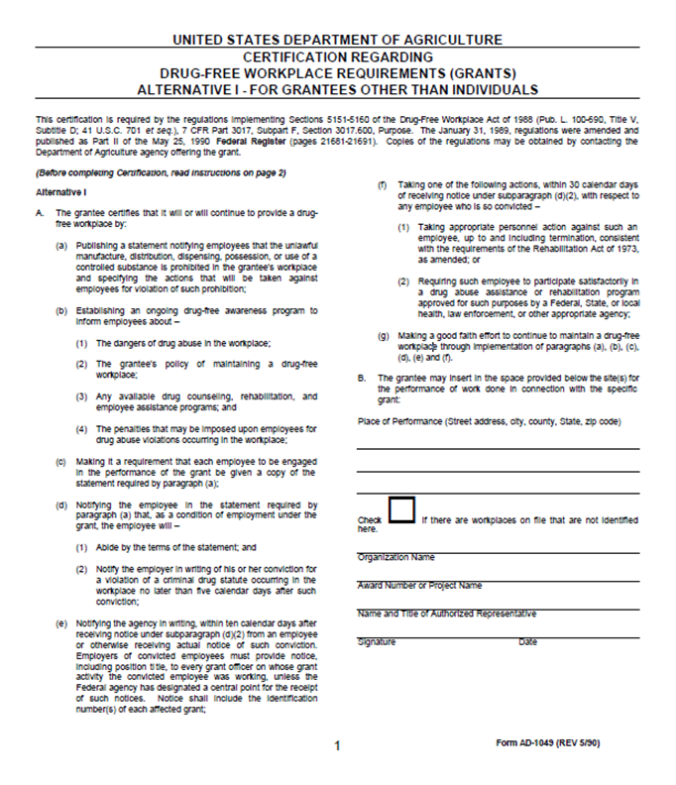

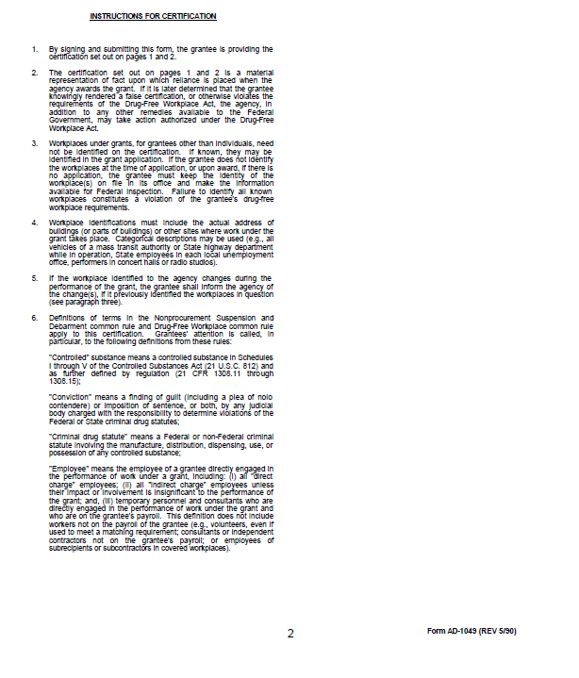

**EXHIBIT J: National School Lunch and School Breakfast Program Meal Patterns**

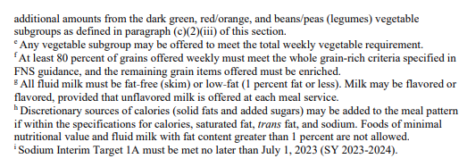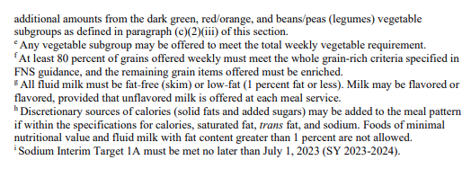

**EXHIBIT K: Afterschool Snack Program Meal Patterns**

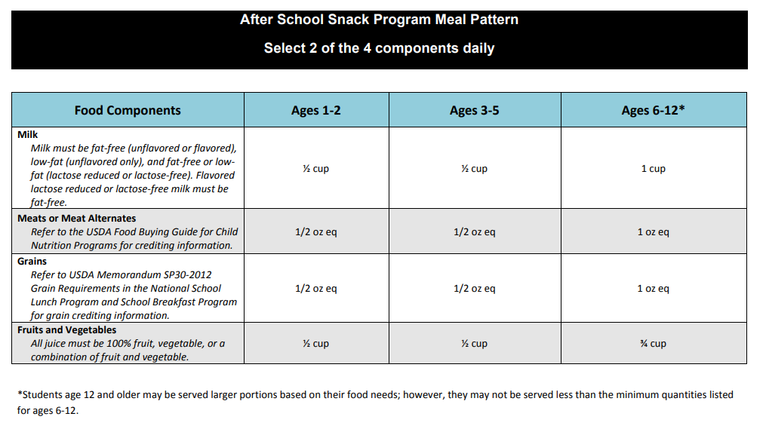

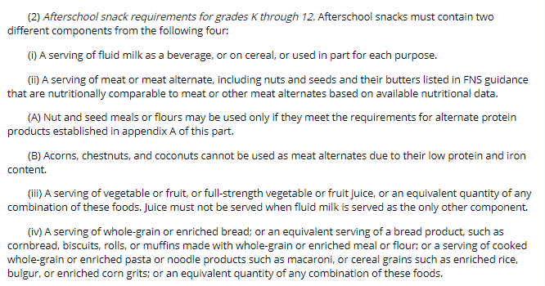

**EXHIBIT L: Summer Food Service Program Meal Pattern**

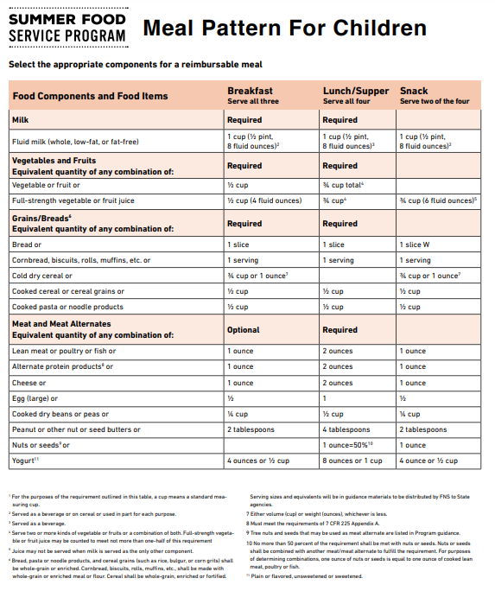

**EXHIBIT M: Child and Adult Care Food Program Meal Pattern**

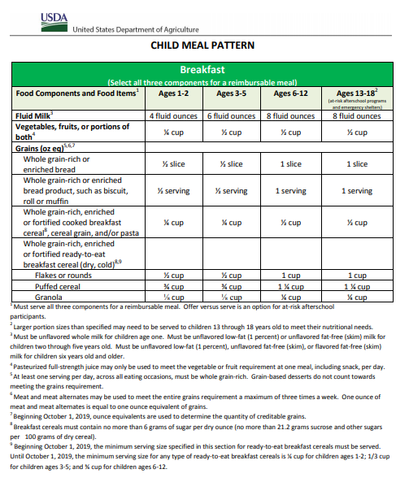

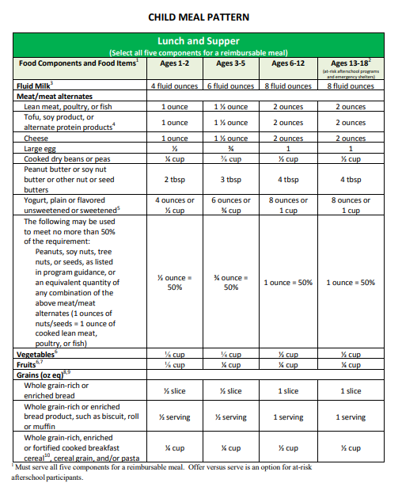**EXHIBIT M: CACFP Meal Pattern Continued**

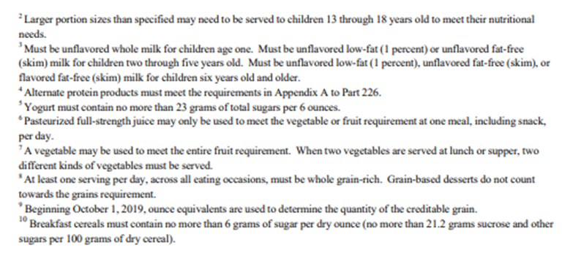

**EXHIBIT M: CACFP Meal Pattern Continued**

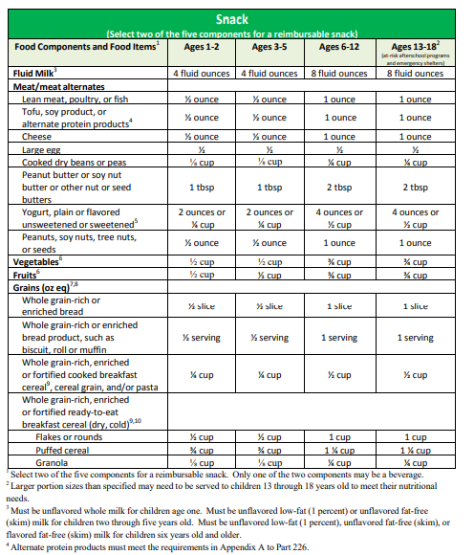

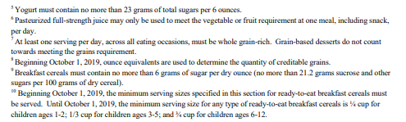

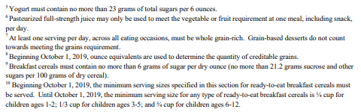

Assurance of Civil Rights Compliance

The School Food Authority (SFA)/Sponsor hereby agrees that it will comply with: i. Title VI of the Civil Rights Act of 1964 (42 U.S.C. 2000d et seq.); ii. Title IX of the Education Amendments of 1972 (20 U.S.C. 1681 et seq.); iii. Section 504 of the Rehabilitation Act of 1973 (29 U.S.C. 794); iv. Age Discrimination Act of 1975 (42 U.S.C. 6101 et seq.); v. Title II and Title III of the Americans with Disabilities Act (ADA) of 1990 as amended by the ADA Amendment Act of 2008 (42 U.S.C. 12131-12189); vi. Executive Order 13166, "Improving Access to Services for Persons with Limited English Proficiency." (August 11, 2000); vii. All provisions required by the implementing regulations of the Department of Agriculture (USDA) (7 CFR Part 15 et seq.); viii. Department of Justice Enforcement Guidelines (28 CFR Parts 35, 42 and 50.3); ix. Food and Nutrition Service (FNS) directives and guidelines to the effect that, no person shall, on the grounds of race, color, national origin, sex (including gender identity and sexual orientation), age, or disability, be excluded from participation in, be denied the benefits of, or otherwise be subject to discrimination under any program or activity for which the Program applicant receives Federal financial assistance from USDA; and hereby gives assurance that it will immediately take measures necessary to effectuate this Agreement. x. The USDA non-discrimination statement that in accordance with Federal civil rights law and U.S. Department of Agriculture (USDA) civil rights regulations and policies, the USDA, its Agencies, offices, and employees, and institutions participating in or administering USDA programs are prohibited from discriminating based on race, color, national origin, religion, sex, gender identity (including gender expression), sexual orientation, disability, age, marital status, family/parental status, income derived from a public assistance program, political beliefs, or reprisal or retaliation for prior civil rights activity, in any program or activity conducted or funded by USDA (not all bases apply to all programs).

This assurance is given in consideration of and for the purpose of obtaining any and all Federal financial assistance, grants, and loans of Federal funds, reimbursable expenditures, grant, or donation of Federal property and interest in property, the detail of Federal personnel, the sale and lease of, and the permission to use Federal property or interest in such property or the furnishing of services without consideration or at a nominal consideration, or at a consideration that is reduced for the purpose of assisting the recipient, or in recognition of the public interest to be served by such sale, lease, or furnishing of services to the recipient, or any improvements made with Federal financial assistance extended to the Program applicant by USDA. This includes any Federal agreement, arrangement, or other contract that has as one of its purposes the provision of cash assistance for the purchase of food, and cash assistance for purchase or rental of food service equipment or any other financial assistance extended in reliance on the representations and agreements made in this assurance.

By accepting this assurance, the SFA/Sponsor agrees to compile data, maintain records, and submit records and reports as required, to permit effective enforcement of nondiscrimination laws and permit authorized USDA personnel during hours of program operation to review and copy such records, books, and accounts, access such facilities and interview such personnel as needed to ascertain compliance with the nondiscrimination laws. If there are any violations of this assurance, the Department of Agriculture, FNS, shall have the right to seek judicial enforcement of this assurance. This assurance is binding on the State agency, its successors, transferees and assignees as long as it receives assistance or retains possession of any assistance from USDA. The person or persons whose signatures appear below are authorized to sign this assurance on behalf of the SFA/Sponsor.