Request for Proposals (RFP) and Contract

Food Service Management Company (FSMC)

United States Department of Agriculture

Child Nutrition Programs

SFA NAME

SFA ADDRESS

SFA CONTACT INFORMATION

In accordance with federal civil rights law and U.S. Department of Agriculture (USDA) civil rights regulations and policies, this institution is prohibited from discriminating on the basis of race, color, national origin, sex (including gender identity and sexual orientation), disability, age, or reprisal or retaliation for prior civil rights activity.

Program information may be made available in languages other than English. Persons with disabilities who require alternative means of communication to obtain program information (e.g., Braille, large print, audiotape, American Sign Language), should contact the responsible state or local agency that administers the program or USDA’s TARGET Center at (202) 720-2600 (voice and TTY) or contact USDA through the Federal Relay Service at (800) 877-8339.

To file a program discrimination complaint, a Complainant should complete a Form AD-3027, USDA Program Discrimination Complaint Form which can be obtained online at: <https://www.usda.gov/sites/default/files/documents/ad-3027.pdf>, from any USDA office, by calling (866) 632-9992, or by writing a letter addressed to USDA. The letter must contain the complainant’s name, address, telephone number, and a written description of the alleged discriminatory action in sufficient detail to inform the Assistant Secretary for Civil Rights (ASCR) about the nature and date of an alleged civil rights violation. The completed AD-3027 form or letter must be submitted to USDA by:

1. **mail:**  
   U.S. Department of Agriculture  
   Office of the Assistant Secretary for Civil Rights  
   1400 Independence Avenue, SW  
   Washington, D.C. 20250-9410; or
2. **fax:**  
   (833) 256-1665 or (202) 690-7442; or
3. **email:**  
   [Program.Intake@usda.gov](mailto:program.intake@usda.gov)

This institution is an equal opportunity provider.

Food Service Management Company (FSMC)

Request for Proposals (RFP) and Contract

**National School Lunch, School Breakfast**

**And Special Milk Programs**

Table of Contents

Page

Part I – General information

A. Intent . 1

B. Bid Submission and Award 1

C. Incurred Cost 4

D. Subcontracts 4

E. Pre-Bid Meeting/Questions 4

F. Late Bids 4

G. Bonding Requirement 4

H. Non-Performance 5

I. Health Department Certification 2

J. Non-Payment for Spoilage 5

K. Gifts from FSMC 5

L. Menu Cycle 6

M. Commodities 6

N. Selection of Manager 6

O. Code of Conduct 6

P. Price Renegotiation 6

Q. A la Carte Meal Equivalents 7

part II – Bid solicitation/Contract Scope

A. General Requirements 8

B. Responsibilities of the SFA 8

C. Responsibilities of the FSMC 9

D. Federally Donated Commodities 10

E. Purchases 12

F. Buy American 12

G. Sanitation 13

H. Clean Air and Water

1. FSMC Responsibilities 13

2. Definitions 14

I. Employees 14

J. Equal Opportunity 15

K. Contract Work Hours and Safety Standards Act – Overtime

Compensation 16

L. Use of Facilities and Equipment 17

M. Licenses, Fees, Taxes 18

N. Terms and Termination 18

O. Recordkeeping 19

P. Revenue 19

Q. Payment of Fees 20

R. Administrative Fee Activities 20

S. A la Carte Meal Equivalent 21

T. Emergency Closings 21

U. Indemnification 21

V. Quantities 22

W. Additional Contract Provisions…………………………………………………………..22

X. Code of Conduct 23

Y. Evaluation of Proposals 24

part III – Bid Qualifications

A. Required Bidder Qualifications 26

B. Optional Bidder Qualifications 26

APPENDICES

A. Services Desired

B. Program(s) Desired

C-1. SFA Individual School Profile

C-2. School Labor Worksheet

D. Meal Pattern Charts

E. FSMC Statement of Projected Expenses

F. Contract to Provide the Operation and Management of Food Service

G. Bid Proposal

H. Certification of Independent Price Determination

I. Certification Regarding Lobbying

J. Award Criteria

K. Certification Regarding Debarment

L. Certification Regarding Drug-Free Workplace

M. Agreement Page

N. USDA Non-Discrimination Statement

O. USDA Civil Rights Assurance Statement

**Part I**

**General Information**

A. Intent

This invitation is for the purpose of entering into a contract for providing food services for School District or Board of Education or, hereinafter referred to as the School Food Authority (SFA). The statements, items, and criteria set forth herein are minimal standards and items to be provided for in the bid submission and the contractual arrangements. This RFP will result in a fixed-price contract with the awarded vendor.

This contract shall be for a period of one year beginning on or about July, 1 ________, and ending June 30, ______. This contract may be renewed annually for up to two years by mutual written agreement between the SFA and the vendor. Each contract extension must receive prior approval from DDOE. Contract extensions or renewals, if applicable, are contingent upon the fulfillment of all contract provisions related to donated foods as required by 7 CFR 250.53(a)(12).

B. Bid Submission and Award

1. Proposal packets will be sent to interested parties by contacting:

[List Contact Information]

1. The SFA will allow written requests for clarification of the RFP. All questions should be directed to the designated contact, [contact name and information]. If clarification of the specifications and/or instructions is required, the SFA will clarify the specifications and/or instructions in the form of an addendum issued to all prospective bidders by [date].
2. Proposals, including all required documentation and attachments, must be received no later than [Date and Time]. Proposals received after this date and time will not be considered. Proposals must be addressed to [Name, Title, and Address] in a sealed envelope. The outside of the envelope should be clearly marked Child Nutrition Proposal.
3. The proposed schedule of events subject to the RFP is outlined below:

Deadline for Receipt of Proposals Date: [Date and Time].

Public Opening and Review of Proposals Date: [Date and Time].

Notification of Award Date: [Date and Time].

1. No proposal may be altered, amended, or withdrawn after the specified time for opening and review of proposals.
   1. Any changes, amendments, or modifications to a proposal must be made in writing, submitted in the same manner as the original response, and conspicuously labeled as a change, amendment, or modification to a previously submitted proposal. Changes, amendments, or modifications to proposals shall not be accepted or considered after the hour and date specified as the deadline for submission of proposals.
2. Vendor may modify or withdraw its proposal by written request, provided that both proposal and request to modify or withdraw is received by the SFA prior to the proposal due date. Proposals may be re-submitted in accordance with the proposal due date in order to be considered further. Proposals become the property of the SFA at the proposal submission deadline. All proposals received are considered firm offers at that time.
3. Late proposals will not be accepted.
4. To be considered, each offeror must submit a complete response to this solicitation **using the forms provided**.
   1. No other documents submitted with the RFP and Contract will affect the Contract provisions, and **there may be no modifications to the RFP and Contract language**.
   2. In the event that Offeror modifies, revises, or changes the RFP and/or Contract in any manner, the SFA may reject the offer as non-responsive.
5. Each proposal must be accompanied by a transmittal letter, which briefly summarizes the proposing firm’s interest in providing the required professional services. The transmittal letter must also clearly state and justify any exceptions to the requirements of the RFP, which the applicant may have taken in presenting the proposal. Furthermore, the transmittal letter must attest to the fact that no activity related to this proposal contract will take place outside of the United States.
6. Prices quoted in the proposal shall remain fixed and binding on the bidder at least through June 30, 20XX. The SFA reserves the right to ask for an extension of time if needed.
7. The SFA discourages overly lengthy and costly proposals. It is the desire that proposals be prepared in a straightforward and concise manner. Unnecessarily elaborate brochures or other promotional materials beyond those sufficient to present a complete and effective proposal are not desired. The SFA’s interest is in the quality and responsiveness of the proposal.
8. It is the expectation of the SFA that vendors can fully satisfy the obligations of the proposal in the manner and time frame defined within the proposal. Proposals must be realistic and must represent the best estimate of time, materials, and other costs including the impact of inflation and any economic or other factors that are reasonably predictable.
9. The SFA shall bear no responsibility or increase obligation for a vendor’s failure to accurately estimate the costs or resources required to meet the obligations defined in the proposal.
10. All documents submitted as part of the vendor’s proposal will be deemed confidential during the evaluation process. Vendor proposals will not be available for review by anyone other than the SFA or its designated agents. There shall be no disclosure of any vendor’s information to a competing vendor prior to award of the contract.
11. Vendor is fully responsible for the completeness and accuracy of their proposal, and for examining this RFP and all addenda. Failure to do so will be at the sole risk of vendor. Should vendor find discrepancies, omissions, unclear or ambiguous intent or meaning, or should any questions arise concerning this RFP, vendor shall notify the SFA’s designated contact [enter contact information], in writing, of such findings. All unresolved issues should be addressed in the proposal.
12. The SFA reserves the right to accept or reject any or all proposals or any part of any proposal; to waive defects, technicalities or any specifications; to sit and act as sole judge of the merit and qualifications of each product offered; or to solicit new proposals on the same project or on a modified project which may include portions of the originally proposed project as the school may deem necessary in the best interest of the school.
13. Awards will be made to the responsible firm whose proposal is most advantageous to the program, with price and other factors considered (2 CFR 200.320):
    1. A responsible offeror is one who’s financial, technical, and other resources indicate an ability to perform the services required.
    2. Offeror shall submit for consideration such records of work and further evidence as may be required by the SFA’s Board of Trustees.
    3. Failure to furnish such records and evidence, or the inclusion of any false or misleading information therein shall be sufficient cause for the rejection of the proposal or termination of any subsequent contract.
    4. The qualification data shall be submitted by each offeror along with the proposal, and shall include the following:
       1. Offeror must be incorporated or licensed to do business in the State of Delaware.
       2. Annual reports or financial statements for the past fiscal year, certified by a licensed public accountant, must be included in the pre-qualification data.
       3. Information that offeror is doing business with like school systems and is familiar with the regulations pertaining to operations in such environments, if applicable.
14. The final award of a contract is subject to approval by the Executive Board of the SFA and the Delaware Department of Education (DDOE). The school has the sole right to select the successful vendor(s) for award, to reject any proposal as unsatisfactory or non-responsive, to award a contract to other than the lowest priced proposal, to award multiple contracts, or not to award a contract, as a result of this RFP.
15. Notice in writing to a vendor of the acceptance of its proposal by the SFA and the subsequent full execution of a written contract will constitute a contract. No vendor will acquire any legal or equitable rights or privileges until the occurrence of both such events.
16. Offerors or their authorized representatives must fully inform themselves as to the conditions, requirements, and specifications before submitting proposals; failure to do so will be at the offeror’s own risk who cannot secure relief on plea of error.
17. Any person that develops or drafts specifications, requirements, statements of work, invitations for bids, requests for proposals, contract terms and conditions or other documents for use by the SFA in conducting a procurement under the USDA entitlement programs specified in 2 CFR 200.319 shall be excluded from competing for such procurements. Such persons are ineligible for contract awards resulting from such procurements regardless of the procurement method used.
18. The SFA is not liable for any cost incurred by the offeror in submitting a proposal. **Paying the Vendor from Child Nutrition Program (CNP) funds is prohibited until the Contract is provided to DDOE and signed by the SFA.**

**All bid proposals must be reviewed by the Delaware Department of Education (DDOE) prior to acceptance by the SFA.**

C. Incurred Cost

The SFA is not liable for any cost incurred by any bidder prior to signing of a contract by all parties.

D. Subcontracts

It is strongly recommended that subcontracting be prohibited. At a minimum, all subcontracts are subject to prior approval by the SFA. The FSMC may not subcontract USDA foods for further processing.

E. A pre-bid meeting is scheduled for (date) ________________________________. Attendance is

required. No bid or proposal will be accepted from a FSMC not in attendance at this meeting. (Pre-bid meetings are optional)

F. Late Bids: Any bid received after the exact time specified for receipt will not be considered.

G. Bonding Requirement

**SNP and CACFP:**

**Bid Bonds -** The bid bond security need not be for a specific sum but may be stated to be for a sum equal to 10% of the bid to which it relates. A bid bond or bid security may be stated as a certain stated sum provided that the sum is equal to or greater than 10% of the bid. A SFA or a CACFP sponsor may choose to waive the requirement of a bid bond. **The decision to waive the requirement of a bid bond must be clearly stated in the bid special provisions.**

**Performance Bonds** - The procuring agency shall require the successful bidder to execute a good and sufficient bond to the State for the benefit of the agency. In cases where contracts for the purchase of material with a **value less than the** $100,000 formal purchase threshold, a SFA or a CACFP sponsor may waive, or reduce, the performance bond requirement from the successful bidder. Such a waiver or reduction must be stated in the bid specifications. The Performance bonds shall be with a corporate surety authorized to do business in this state and be in a sum equal to 100% of the contract award.

**SFSP:** The SFSP requires the following regarding bonds:

**Bid Bond Requirement -** For bids over $150,000, a bid bond in the amount of 10 percent of the estimated value of the contract for which the bid is made must accompany the bid. The bid bond must be from a company listed in the current United States Department of Treasury Circular 570 certified to do business in Delaware. No other type of bid bond is acceptable.

**Performance Bond Requirement -** For contracts over $150,000, a performance bond equal to at least 10 percent, but not more than 25 percent of the value of the winning contract, must be obtained by the contractor. The performance bond must be from a company listed in the current United States Department of Treasury Circular 570 certified to do business in Delaware. The contractor must furnish a copy of the bond to the sponsor within 10 days of the contract’s award. The performance bond must include the entire period that sponsor will operate the feeding program. Sponsors may not accept cash, letter of credit, trust account, land or any other form of guarantee in lieu of the performance bond.

H. Non-Performance

Non-performance shall subject the FSMC to specified sanctions, outlined in the contract, in instances where the FSMC violates or breaches contract terms and/or federal and State law or regulation.

I. State or Local Health Certification

* Per 7 CFR 210.16(a)(7), the FSMC must have applicable State or local health certification for facilities inside or outside the school in which is proposes to prepare or serve meals and shall maintain such certification for the duration of the contract. The certification must cover the transport of food from the facility to the school. The certification should be documented by the prospective vendor at the time of bid or proposal.
* The FSMC must attest or certify that they have a written food safety program for their facilities that complies with HACCP principles.  The written program should be made available for review by the SFA for the FSMC selected for the contract.
* The FSMC must submit their most recent food safety inspection reports conducted by state/local health authorities, as well as their most recent reports every time the contract is renewed (if applicable). SFAs should ensure reports indicate compliance with health standards.

J. Non-Payment for Spoilage

No payment shall be made for meals that are spoiled or unwholesome at time of delivery, or do not meet detailed specifications as developed by the SFA for each food component specified, or do not otherwise meet the requirements of the contract. Specifications shall cover items such as grade, purchase units, style, condition, weight, ingredients, formulations, and delivery time.

K. Gifts from FSMC

The State Agency or SFA’s officers, employees, or agents shall neither solicit nor accept gratuities, favors, or anything of monetary value from contractors or potential contractors. To the extent permissible under State law, rules, or regulations, such standards shall provide for appropriate penalties, sanctions, or other disciplinary actions to be applied for violations of such standards either by the State Agency’s or SFA’s officers, employees, or agents, or by the FSMC or their agents.

L. Menu Cycle

1. The 21-day menu cycle (Appendices D-1 and D-2) must be used as a standard for the purpose of estimating average cost per meal. The 21-day cycle must be adhered to for the first 21 days of meal service. Changes thereafter may be made with the approval of the SFA. However, any changes must equal or exceed the choice selection, quality, grades, and specifications contained in the original menu cycle.

2. Menus must comply with the USDA meal patterns, as described in the federal regulations 7 CFR Part 210.10(c) and 7 CFR Part 220.8. Meal patterns must be used to create the 21-day cycle menu. The SFA may request information such as sample production records, recipes (USDA and/or local) and the nutrient analysis of all manufacturers’ products used to conduct an independent analysis of any menu in the 21-day cycle.

M. Commodities

1. Any federally donated and further processed commodities (USDA Foods) received shall be utilized to the maximum extent practicable and shall accrue only to the benefit of the nonprofit food service account and remain the sole property of the SFA to which they were assigned. If the FSMC is to purchase food as part of the bid price, the SFA shall receive credit based on the value stated by the Commodity Report of the Office of Management and Budget, Government Support Services, contracting.

2. The use of donated foods or processed end products containing USDA Foods for special functions is prohibited.

N. Selection of Manager

The SFA reserves the right to interview and approve the on-site food service manager.

O. Code of Conduct

1. The conduct of the FSMC’s personnel shall at all times be above reproach. The SFA reserves the right to discuss the conduct or performance with the FSMC and require replacement of personnel within a reasonable time period, if such is warranted.

2. The FSMC will incur the fee for criminal background clearance for all employees having contact with students.

P. Price Renegotiation

Renegotiation of price changes will be allowed in any subsequent years of the agreement pertaining to unit price. The annual percentage increase must be based on the Consumer Price Index of Food Eaten Away from Home (from the United States Department of Labor, Bureau of Labor Statistics), or 10%, whichever is less. Before price increases can be implemented, the FSMC must document, through cost or price analysis, the need for such price increase. The SFA must forward all documentation to the DDOE for review and approval. No price increase may be implemented under this provision without prior written approval of the DDOE.

Q. *A la Carte* Meal Equivalents

For the purpose of making the meal count computation, the number of reimbursable lunches/breakfasts served to children shall be determined by actual count. The FSMC and SFA shall determine a la carte equivalents by dividing a la carte revenue by the sum of the Federal free lunch reimbursement plus the per-meal entitlement value of USDA-donated commodities for the first fiscal year in which meals are served. This factor shall remain constant for the duration of the contract.

**Part II**

**Bid Solicitation/Contract Scope**

A. General Requirements

1. The food service shall be operated and maintained as a benefit to the SFA’s students, faculty, and staff.

2. The food service shall be managed to promote maximum participation in the National School Lunch Program, School Breakfast Program, and/or Special Milk Program.

3. The FSMC shall have the exclusive right to manage the food service program at the sites specified in Appendix C-1 (if applicable).

4. The FSMC shall follow the procurement regulations specified in 2 CFR 200, 7 CFR 210, and 7 CFR 220. A copy is available from the SFA’s procurement officer.

5. The FSMC shall provide the type of food service at sites as specified in Appendix C-1. By mutual agreement, sites may be added to or removed from Appendix C-1. However, sites are limited to attendance units of the SFA. Subcontracting with any other SFA is prohibited unless such provision is included in the original bid proposal. All SFAs who receive direct or indirect services from a FSMC must be included in the bid proposal.

6. The SFA reserves the right to maintain food and beverage vending machines in its facilities. Revenues must accrue to the SFA.

7. The FSMC shall be an independent contractor and not an employee of the SFA. The employees of the FSMC are not employees of the SFA.

8. The FSMC shall conduct the food service in such a manner as will ensure compliance with the rules and regulations of the USDA regarding the National School Lunch Program, the School Breakfast Program, and/or the Special Milk Program, and any additions or amendments thereto.

9. The SFA shall have the ultimate legal responsibility for the conduct of the food service and shall supervise the food service in such a manner as will ensure compliance with the rules and regulations of the USDA regarding the National School Lunch Program, the School Breakfast Program, and/or the Special Milk Program.

B. Responsibilities of the SFA

1. The SFA shall ensure that the food service is in conformance with its agreement under the *Policy Statement for Free Meals, Free Milk, and Reduced-Price Meals*. The SFA will make accessible a copy of said Policy Statement.

2. The SFA shall retain control of the quality, extent, and general nature of its food service and the prices to be charged for meals.

3. The SFA shall monitor the food service through periodic on-site visits to include inspection of meals, food preparation, storage and service areas, and sanitation practices.

4. The SFA shall approve the menus and recipes for meals and other food to be served or sold to students to ensure compliance with the rules and regulations of the USDA.

5. The SFA shall approve all a la carte items and the prices charged for those items in advance of the sale by the FSMC. All such items must be in compliance with Smart Snacks Standards.

6. The SFA shall retain signatory authority on the Annual Renewal Application Packet for Participations in the National School Lunch Program, the School Breakfast Program, and/or the Special Milk Program and the monthly claim for reimbursement and financial reports.

7. The SFA shall ensure that all federally donated food received by the SFA and made available to the FSMC shall accrue only to the benefit of the SFA’s nonprofit school food service and is fully utilized therein. Donated commodities may not be transferred to another SFA without permission from the Office of Management and Budget, Government Support Services.

8. The SFA shall maintain applicable health certification and assure that all state and local regulations are met by the FSMC preparing or serving meals at SFA facilities.

9. The SFA shall distribute, collect, and determine eligibility applications for free and reduced-price meals and/or free milk.

10. The SFA shall verify applications for free and reduced-price meals as required by federal regulations.

11. The SFA shall conduct performance, accountability, and other reviews as required by state and federal regulations and guidelines.

12. The SFA shall maintain a system for contract administration to assure compliance with contract terms.

13. The SFA shall maintain a system for assuring that the FSMC operates the food service program in conformance with the SFA’s agreement for participation in the National School Lunch Program, the School Breakfast Program, and/or the Special Milk Program.

14. The SFA shall comply with mandatory standards and policies relating to energy efficiency which are contained in the State Energy Conservation Act.

15. The SFA shall be responsible for the USDA donated commodities processing fees incurred if the FSMC declares bankruptcy.

C. Responsibilities of the FSMC

1. The FSMC shall serve on such days and at such times as requested by the SFA:

a. Breakfasts and lunches, priced as a unit, which meet the requirements prescribed by State and federal regulations.

b. Other foods as may be agreed upon by the FSMC and SFA.

2. The FSMC shall serve free and reduced-price meals or free milk to those children designated by the SFA.

3. The FSMC shall implement the collection procedures as specified by the SFA and approved by the DDOE.

4. The FSMC shall implement the “offer versus serve” provision at the food service sites as specified by the SFA on Appendix C-1.

5. The FSMC shall adhere to the 21-day menu cycle as specified by the SFA on Appendices

D-1 and D-2 for the first 21 days of meal service. Thereafter, changes in the menu may

be made with prior approval of the SFA. Menus must comply with the USDA meal patterns, as described in the federal regulations 7 CFR Part 210.10 and 7 CFR Part 220.

The SFA may request information such as a sample production records, recipes (USDA and/or local) and the nutrient analysis of all manufacturers’ products used to conduct an independent analysis of any menu in the 21-day cycle.

6. The FSMC shall use the SFA facilities for the preparation of food to be served as specified in Appendix C-1.

7. The FSMC shall make substitutes in the food components of the meal pattern or menu plan for disabled students whose disability restricts their diet and those students without disabilities who are unable to consume regular meals because of medical or other special dietary needs. Substitutions shall be made on a case-by-case basis only when supported by a statement of the need for substitutes that includes recommended alternate foods, unless otherwise exempted by the Food and Nutrition Service, USDA, through the DDOE. Such statement shall be signed by a medical authority.

8. The FSMC shall deposit, daily, all monies in the SFA account.

9. The FSMC shall comply with all local and State sanitation requirements.

10. The FSMC must provide program and nonprogram revenue and expenditure breakdowns at least annually to enable the SFA to fulfill its responsibilities related to compliance with nonprogram revenue requirements.

11. Establish and maintain an advisory board composed of parents, teachers, and students to assist in menu planning [7 CFR 210.16(a)(8)].

D. Federally Donated Commodities (if applicable)

1. Bid prices submitted by vendors must be independent of the value of USDA Foods received by the SFA.  Bidders must respond with prices for meals without adjusting for USDA Foods.
2. The FSMC shall have records available to substantiate the use of federally donated food in the food service and to document its compliance with requirements relating to donated foods in accordance with 7 CFR 250.54(b)
3. The FSMC will not itself enter into the processing agreement with the processer required in subpart C of 7 CFR Part 250.
4. The distributing agency, subdistributing agency, or recipient agency, the Comptroller General, the Department of Agriculture, or their duly authorized representatives, may perform onsite reviews of the FSMC’s food service operation, including the review of records, to ensure compliance with requirements for the management and use of donated foods.
5. The FSMC shall select, accept, and use federally donated food in as large quantities as may be efficiently utilized in the SFA’s nonprofit food service subject to approval of the SFA. As required by 7 CFR 250.53(a)(5), the FSMC will use all donated beef and pork products, and all processed end products in the SFA’s food service.
6. The FSMC will use all other donated foods or will use commercially purchased foods of the same generic identity, of U.S. origin, and of equal or better quality than the donated foods, in the SFA’s food service as required by 7 CFR 250.53(a)(6).
7. The SFA shall retain control of all federally donated food solely for the benefit of the SFA’s nonprofit food service program. Transfer outside of the SFA requires written permission from the DDOE and the SFA.
8. The FSMC will credit the SFA for the value of all donated foods received for use in the SFA’s food service in the school year, including the value of donated foods contained in processed end products.  (Contracts must include the method, documentation, and frequency by which crediting will occur, and the method used to determine donated food values.)
   1. The SFA must require crediting to be performed no less frequently than annually and must ensure that the specified method of valuation of donated foods permits crediting to be achieved in the required time period.
   2. The method used to determine the donated food values may not be established through a post-award negotiation, or by any other method that may directly or indirectly alter the terms and conditions of the procurement or contract.

|  |
| --- |
| Crediting USDA Donated Foods  Vendor must state here:  Method of reporting crediting of USDA Donated Foods:  Crediting timeframe beneficial to the SFA, no less than annually: ______________________  Method of documentation utilized to verify that the value of all donated foods has been credited: __________________________________________________________________  _________________________________________________________________________  The method of determining the donated food values to be used in crediting, in accordance with §250.51(c), or the actual donated food values: ________________________________  __________________________________________________________________________ |

1. The procurement by the FSMC of processed end products containing donated foods will comply with the requirements of subpart C of 7 CFR Part 250, and with the provisions of applicable State agency or SFA processing agreements.
2. The FSMC will comply with the storage and inventory requirements for donated foods.
3. The SFA must outline any activities relating to donated foods for which the FSMC will be responsible. All such activities will be performed in accordance with the applicable requirements in 7 CFR 250.

E. Purchases

1. The FSMC shall retain title of all purchased food (with the exception of USDA Foods) and nonfood items.

2. The SFA shall submit, to the FSMC, food specifications to cover grade, purchase units, style, conditions, weight, ingredients, formulation, and delivery time.

3. Nothing in this contract shall prevent the SFA from participating in food co-ops or purchasing food from vendors with whom the FSMC normally does not do business.

F. Buy American

1. The FSMC shall purchase, to the maximum extent practicable, domestic commodities or

products which are either an agricultural commodity produced in the United States (U.S) or a food product processed in the U.S. substantially using agricultural commodities produced in the U.S. Substantially means over 51% from American products. Therefore, over 51% of the final processed product (by weight or volume) must consist of agricultural commodities that were grown domestically. Thus, for foods that are unprocessed, agricultural commodities must be domestic, and for foods that are processed, they must be processed domestically using domestic agricultural food components that are comprised of over 51% domestically grown items, by weight or volume as determined by the SFA.

1. The FSMC shall certify the percentage of U.S. content in the products supplied to the

SFA.

1. There are limited exceptions to the Buy American provision which allow for the purchase of foods not meeting the “domestic” standard as described above (i.e., “non-domestic”) in circumstances when use of domestic foods is truly not practicable. These exceptions, as determined by the SFA, are:
   1. The product is not produced or manufactured in the U.S. in sufficient and reasonably available quantities of a satisfactory quality;
   2. Competitive bids reveal the costs of a U.S. product are significantly higher than the non-domestic product; or
   3. An exception must be approved prior to the vendor accepting a non-domestic substitution, and documentation of the reason for the exception must be on file.
2. The SFA reserves the right to review vendor purchase records, storage facilities, freezers, refrigerators, dry storage, and warehouses, as applicable, to ensure compliance with the Buy American Provision.

G. Sanitation

1. The FSMC shall place garbage containers and trash in designated areas as specified by the SFA (if applicable).

2. The SFA shall remove all garbage and trash from the designated areas on a regularly scheduled basis (if applicable).

3. The FSMC shall clean the kitchen area, including but not limited to sinks, counters, grease traps, tables, chairs, flatware, utensils, walls, floors, light fixtures, and window coverings (if applicable).

4. The FSMC shall operate and maintain all equipment and food service areas in a clean, safe, and healthy condition in accordance with standards acceptable to the SFA and comply with all applicable laws, ordinances, regulations, and rules of federal, State, and local authorities.

5. The SFA shall clean ducts and hoods above the filter line.

6. The SFA shall provide extermination services as needed.

7. The SFA shall clean the dining/cafeteria area, including tables and chairs, after the meal service, each day.

H. Clean Air and Water

This section is applicable only if the contract exceeds $150,000 or if the Contracting Officer has determined that the orders under an indefinite quantity contract in any one year will exceed $150,000 or a facility to be used has been the subject of a conviction under the Clean Air Act Clean Air Act (42 U.S.C. 7401-7671q.) and the Federal Water Pollution Control Act (33 U.S.C. 1251-1387) and is listed by EPA or the contract is not otherwise exempt.

1. FSMC Responsibilities. The FSMC agrees as follows:

a. To comply with all the requirements of Clean Air Act (42 U.S.C. 7401-7671q.) and the Federal Water Pollution Control Act (33 U.S.C. 1251-1387), as amended—Contracts and subgrants of amounts in excess of $150,000 must contain a provision that requires the non-Federal award to agree to comply with all applicable standards, orders or regulations issued pursuant to the Clean Air Act (42 U.S.C. 7401-7671q) and the Federal Water Pollution Control Act as amended (33 U.S.C. 1251-1387). Violations must be reported to the Federal awarding agency and the Regional Office of the Environmental Protection Agency (EPA).

b. That no portion of the work required by this prime contract will be performed in a facility listed on the Environmental Protection Agency List of Violating Facilities on the date when this contract was awarded unless and until the EPA eliminates the name of such facility or facilities from such listing.

c. To use his/her best efforts to comply with clean air standards and clean water standards at the facilities in which the contract is being performed.

d. To insert the substance of the provisions of this clause in any nonexempt subcontract, including this paragraph G-1d.

2. Definitions. The terms in this clause have the following meanings:

a. The term “Air Act” means the Clean Air Act, as amended (41 USC 1857 et seq., as amended by Public Law 91-604).

b. The term “Water Act” means Federal Water Pollution Control Act, as amended (33 USC 1251 et seq., as amended by Public Law 92-500).

c. The term “Clean Air Standards” means any enforceable rules, regulations, guidelines, standards, limitations, orders, controls, prohibitions, or other requirements which are contained in, issued under, or otherwise adopted pursuant to the Air Act or Executive Order 11738, an applicable implementation plan as described in Section 110(d) of the Clean Air Act (42 USC 1857c-5(d)), an approved implementation procedure or plan under Section 111(c) or Section 111(d), respectively, of the Air Act (42 USC 1857c-6(c) or (d)), or approved implementation procedure under Section 112(d) of the Air Act (42 USC 1857c-7(d)).

d. The term “Clean Water Standards” means any enforceable limitation, control, condition, prohibition, standard, or other requirement which is promulgated pursuant to the Water Act or contained in a permit issued to a discharger by the Environmental Protection Agency or by a State under an approved program, as authorized by Section 402 of the Water Act (33 USC 1342) or by local government to ensure compliance with pretreatment regulations as required by Section 307 of the Water Act (33 USC 1317).

e. The term “Compliance” means compliance with clean air or water standards. Compliance shall also mean compliance with a schedule or plan ordered or approved by a court of competent jurisdiction, the Environmental Protection Agency, or an Air or Water Pollution Control Agency in accordance with the requirements of the Air Act or Water Act and regulations issued pursuant thereto:

f. The term “Facility” means any building, plant, installation, structure, mine, vessel, or other floating craft, location, or sites of operations owned, leased, or supervised by the FSMC.

I. Employees

1. The FSMC shall comply with all wage and hours of employment regulations of federal and State law.

2. The FSMC shall pay all FSMC employees in accordance with the Fair Labor Standards Act and any other applicable statutes.

3. The FSMC shall instruct its employees to abide by the policies, rules, and regulations, with respect to use of SFA premises, as established by SFA and furnished in writing to the FSMC.

4. The FSMC shall provide the SFA with a list of personnel policies.

5. The FSMC and SFA shall mutually agree upon staffing patterns.

6. The SFA may require in writing the removal of an employee of the FSMC who violates health requirements or conducts himself/herself in a manner which is detrimental to the physical, mental, or moral well-being of students.

7. In the event of the removal or suspension of any such employee, the FSMC shall immediately restructure its staff without disruption in service.

8. All food service personnel assigned to each school shall be instructed in the use of all emergency valves, switches, and fire and safety devices in the kitchen and cafeteria areas.

9. The use of student workers or students enrolled in vocational classes in the food service shall be mutually agreed upon by the FSMC and SFA (according to SFA/LEA policies).

10. The FSMC shall provide for daily on-site supervision for the overall food service.

11. The FSMC shall conduct periodic training for all food service employees.

J. Equal Opportunity

The following clause is applicable unless this contract is exempt under the rules, regulations, and relevant orders of the Secretary of Labor (41 CFR, ch. 60).

During the performance of this Contract, the FSMC agrees as follows:

1. The FSMC will not discriminate against any employee or applicant for employment because of race, color, religion, sex, age, disability, or national origin. The FSMC will take affirmative action to ensure that applicants are employed, and that employees are treated during employment, without regard to their race, color, religion, sex, age, disability, or national origin. Such action shall include, but not be limited to, the following: employment, upgrading, demotion or transfer, recruitment or recruitment advertising, layoff or termination, rates of pay or other forms of compensation, and selection for training, including apprenticeship. The FSMC agrees to post in conspicuous places available to employees and applicants for employment notices to be provided by the Contracting Officer setting forth the provisions of this Equal Opportunity Clause.

2. The FSMC will, in all solicitations or advertisements for employees placed by or on behalf of the SFA, state that all qualified applicants will receive consideration for employment without regard to race, color, religion, natural origin, sex, sexual orientation, gender identity, marital status, age, disability, genetic information or veteran’s status.

3. The FSMC will send to each labor union or representative of workers with which it has a collective bargaining agreement or other contract or understanding, a notice, to be provided by the SFA Contracting Officer, advising the labor union or workers’ representative of the FSMC commitments under this Equal Opportunity Clause, and shall post copies of the notice in conspicuous places available to employees and applicants for employment.

4. The FSMC will comply with all provisions of the Executive Order No. 11246 of September 24, 1965, as amended by Executive Order No. 11375 of October 13, 1967, and of the rules, regulations, and relevant orders of the Secretary of Labor.

5. The FSMC will furnish all information and reports required by Executive Order No. 11246 of September 24, 1965, as amended by Executive Order No. 11246 of September 24, 1965, as amended by Executive Order No. 11375 of October 13, 1967, and by the rules, regulations, and orders of the Secretary of Labor, or pursuant thereto, and will permit access to the FSMC’s books, records, and accounts by the SFA agency and the Secretary of Labor for purposes of investigation to ascertain compliance with such rules, regulations, and orders.

6. In the event of the FSMCs noncompliance with the Equal Opportunity Clause of this contract or with any of the said rules, regulations, or orders, this contract may be canceled, terminated, or suspended, in whole or in part, and the FSMC may be declared ineligible for further Government contracts in accordance with procedures authorized in Executive Order No. 11246 of September 24, 1965, as amended by Executive Order No. 11375 of October 13, 1967, and such other sanctions as may be imposed and remedies invoked as provided in Executive Order No. 11246 of September 24, 1965, as amended by Executive Order No. 11375 of October 13, 1967, or by rules, regulations, or orders of the Secretary of Labor, or as otherwise provided by law.

7. The FSMC will include the provisions of paragraphs I-1 through I-7 in every purchase order unless exempted by rules, regulations, or orders of the Secretary of Labor issued pursuant to Section 204 of the Executive Order No. 11246 of September 24, 1965, as amended by Executive Order No. 11375 of October 13, 1967, so that such provisions will be binding upon each vendor. The FSMC will take action with respect to any purchase order as the SFA may direct as a means of enforcing such provisions, including sanctions for noncompliance. In the event the contractor becomes involved in, or is threatened with, litigation with a vendor as a result of such direction by the SFA, the FSMC may request the United States to enter into such litigation to protect the interests of the United States.

K. Contract Work Hours and Safety Standards Act – Overtime Compensation

This contract, to the extent that it is of a character specified in the Contract Work Hours and Safety Standards Act (40 USC 327-333), is subject to the following provisions and to all other applicable provisions and exceptions of such Act and the regulations of the Secretary of Labor thereunder.

1. Overtime requirements. No FSMC contracting for any part of the contract work which may require or involve the employment of laborers, mechanics, apprentices, trainees, watchmen, and guards shall require or permit any laborer, mechanic, apprentice, trainee, watchman, or guard in any work week in which he/she is employed on such work to work in excess of eight hours in any calendar day or in excess of forty hours in such week or work subject to the provisions of the Contract Work Hours and Safety Standards Act unless such laborer, mechanic, apprentice, trainee, watchman, or guard receives compensation at a rate not less than one and one-half times his/her basic rate of pay for all such hours worked in excess of eight hours in any calendar day or in excess of forty hours in such work week, whichever is the greater number of overtime hours.

2. Violation; liability of unpaid wages; liquidated damages. In the event of any violation of the provisions of paragraph 1, the contractor responsible therefore shall be liable to any affected employee for his unpaid wages. In addition, such contractor shall be liable to the United States for liquidated damages which shall be computed with respect to each individual laborer, mechanic, apprentice, trainee, watchman, or guard employed in violation of the provisions of paragraph J-1 in the sum of $10 for each calendar day on which such employee was required or permitted to be employed on such work in excess of eight hours or in excess of his/her standard work week of forty hours without payment of the overtime wages required by paragraph 1.

3. Withholding for unpaid wages and liquidated damages. The SFA may withhold from the FSMC any monies payable on account of work performed by the FSMC, such sums as may administratively be determined to be necessary to satisfy any liabilities of FSMC for unpaid wages and liquidated damages as provided in the provisions of paragraph 1.

1. Records. The FSMC shall maintain payroll records containing the information specified

in 29 CFR 516.2(a). Such records shall be preserved for three years from the completion of the contract.

L. Use of Facilities and Equipment

1. The SFA shall make available without any cost or charge to the FSMC the areas of the premises agreeable to both parties in which the FSMC shall render its services.

2. The SFA reserves the right, at its sole discretion, to use its facilities to sell or dispense any food or beverage before or after the regularly scheduled lunch or breakfast periods provided such use does not interfere with the operation of the child nutrition programs.

3. The SFA shall return facilities and equipment to the FSMC in the same condition as received when the SFA uses the facilities for extracurricular activities.

4. The FSMC shall not use the SFAs facilities to produce food, meals, or services for other organizations without the approval of the SFA.

5. The FSMC and the SFA shall inventory the equipment and supplies owned by the SFA at the beginning of the school year, including but not limited to flatware, trays, chinaware, glassware, and kitchen utensils.

6. The FSMC shall maintain the inventory of expendable equipment necessary for the food service and at the inventory level as specified by the SFA.

7. The SFA shall repair and service equipment and make any structural changes needed to comply with federal, State, and local laws, ordinances, rules, and regulations.

8. The SFA shall be legally responsible for any losses of federally donated food which may arise due to equipment malfunction or loss of electrical power not within the control of the FSMC.

9. The FSMC shall not remove food preparation and serving equipment owned by the SFA from the SFA’s premises without prior approval.

10. The FSMC shall provide a written notification to the SFA of any equipment belonging to the FSMC within ten days of its placement on SFA premises.

11. The SFA shall not be responsible for loss or damage to equipment owned by the FSMC and located on the SFA premises.

12. The SFA shall make available sanitary toilet facilities for the employees of the FSMC.

13. The SFA and the DDOE shall have access, with or without notice to the FSMC, to all of the SFA’s facilities used by the FSMC for purposes of inspection, review and audit.

14. The FSMC shall surrender to the SFA upon termination of the contract all equipment and furnishings in good repair and condition.

M. Licenses, Fees, Taxes

1. The FSMC shall maintain all licenses, permits, and health certification required by federal, State, and local law. All employees having contact with students must undergo a criminal background check. The FSMC is responsible for the fee associated with this background check.

2. The FSMC shall have State or local health certification for any facility outside or inside the SFA in which it proposes to prepare meals, and the FSMC shall maintain this health certification for the duration of the contract. If applicable, the transport of food prepared by the FSMC must also be certified by the appropriate health authorities.

N. Terms and Termination

1. This contract is effective for a one-year period commencing July 1, ______, through June 30, ______, with options to renew yearly, not to exceed two annual renewals.
2. Duration of Contract. The contract between a School Food Authority and Food Service Management Company shall be of a duration of no longer than 1 year; and options for the yearly renewal of a contract signed after February 16, 1988, may not exceed two additional years. All contracts shall include a termination clause whereby either party may cancel for cause with 60-day notification. [§210.16(d)]

3. The SFA shall maintain a contract administration system ensuring that the contract is performed in accordance with contract terms and specifications.

4. If the FSMC violates or breaches the terms of and conditions of this Contract, the SFA shall give the FSMC written notice and an opportunity to cure the violation/breach. Should the FSMC fail to make reasonable progress to affect such cure, or correct the violation/breach, the SFA may assess the following penalties against the FSMC:

|  |  |  |
| --- | --- | --- |
| **First Written Notification** | | |
| Correction or reasonable progress to affect a cure must be within five (5) operating days. |  | Failure to comply will result in loss of administrative fee for one (1) day, per school involved. |
|  |  |  |
| **Second Written Notification for the Same Violation/Breach** | | |
| Correction or reasonable progress to affect a cure must be made within five (5) operating dates. |  | Failure to comply will result in loss of administrative fee for five (5) days per school involved. |
|  |  |  |
| **Third Written Notification for the Same Violation/Breach** | | |
| Correction or reasonable progress to affect a cure must be made within five (5) operating days. |  | Failure to comply will result in loss of administrative fee for ten (10) days per school involved. |

5. This contract may be terminated for cause or for convenience by either the SFA or FSMC with a 60-day written notification.

6. The FSMC shall be subject to administrative, contractual, or legal remedies, sanctions, and penalties as may be appropriate in instances where it violates or breaches contract terms.

O. Recordkeeping

1. The FSMC shall maintain such records as the SFA will need to meet monthly reporting responsibilities and the claim for reimbursement, financial, and other reports to the DDOE. The FSMC shall report claims information to the SFA promptly at the end of each month.

2. The FSMC shall maintain such records as the SFA will need to support its claim and such other records as may be necessary to comply with federal and State laws and regulations and must report to the SFA promptly at the end of each month. Such records shall be available for a period of three years from the date of receipt of final payment under the contract, for inspection and audit by representatives of the SFA, DDOE, USDA, and the General Accounting Office, at any reasonable time and place. If audit findings have not been resolved, the records must be retained beyond the three-year period as long as required for the resolution of the issue raised by the audit. All FSMC records pertaining to the SFA shall be maintained at the SFA while the contract is in effect.

3. The FSMC shall not remove federally required records upon contract termination.

4. The SFA may review and audit FSMC records pertaining to the SFA’s food service operation at any time during the period of the contract.

P. Revenue

1. The SFA shall receive all revenue from the food service.

2. The food service revenue shall be used only for the SFA nonprofit food service.

3. The food service revenue shall flow through the SFA chart of accounts.

4. All goods, services, or monies received as the result of a rebate shall be credited to the nonprofit food service account.

5. If reimbursement is denied and/or federal or State fiscal sanctions are assessed against the SFA as a direct result of the failure of the FSMC to comply with the requirements of this contract, the FSMC shall assume responsibility of the amount denied. This responsibility will extend beyond the ending date of the contract.

Q. Payment of Fees

1. The FSMC shall receive the contracted meal rate for each reimbursable school lunch, breakfast, and a la carte equivalent as described in the bid. Milk sold will be part of the a la carte equivalent. (See Part II, Item R).

2. The SFA shall pay the FSMC the meal rate within 15 days of submission of an invoice date for each monthly period of program operation.

3. The FSMC shall receive no payment for meals that are spoiled or unwholesome at time of delivery, or services that do not meet the detailed specification for each food component in the meal pattern or do not otherwise meet the contract requirements.

4. The FSMC must credit the current market value of all federally donated foods to the SFA if the bid price includes food cost.

5. The FSMC must submit all costs incurred pertaining to the SFA food service within 30 days of the last day of each month or the final day of the program.

6. The SFA may withhold final payment upon termination of contract until all federally required records have been turned over to the SFA.

R. Administrative Fee Activities

1. The following must be included in the Administrative Fee and may not be charged in any other expense:

* Travel expense of all FSMC personnel;
* Menu development specific to the operation;
* On-site food service employee training, management meetings, and/or management development programs specific to the operation;
* Nutrition education material and program expense;
* Design services specific to the operation;
* Cost of production of the following:
* Training manuals
* Procedure manuals
* Food service control forms and supplies
* Material for school lunch promotions;
* Personal representation, visitation, and coverage, on a regular basis, by a principal of the FSMC;
* Education programs via assembly programs, school room programs, parent-teaching meetings, and school food advisory committee meetings;
* The implementation of current policies and procedures of State and federal government as far as school lunch and nutrition are concerned;
* All accounting, including any on-site bookkeeping or bookkeeper charges and the preparation of the State reimbursement claim report;
* All payroll reporting, recording, and documentation, including the issuance of weekly payroll checks;
* Training of staff; and
* Supply of all administrative, dietetic, nutritional, sanitation, and personnel advice.

2. The Local Education Agency/School Food Authority has the right to disqualify a proposal if any of the above expenses are charged other than in the Administrative Fee.

S. *A la Carte* Meal Equivalent

The SFA and FSMC shall determine a la carte meal equivalents by dividing the a la carte revenue by the sum of the per-meal federal reimbursement for free lunch plus the per-meal value of USDA-donated commodities. [Note: The same procedure applies to breakfast equivalents; however, no commodities are allocated/available for breakfast.] The meal equivalent calculation is determined for the first year of the contract and shall remain constant for the duration of the contract.

T. Emergency Closings

The SFA will establish procedures on a school-by-school basis for working with the FSMC when there is a snow emergency, change in school schedule, field trips, unexpected closings, or other event known to SFA that may affect participation in the meal program. Events not under control of the SFA and acts of God shall not be assumed by the SFA.

U. Indemnification

The FSMC shall indemnify and save harmless the SFA against or from all costs, expenses, damages, injury or loss to which the SFA may be subjected by reason of any wrongdoing, misconduct, want of care, skill, negligence, or default in the execution or performance of this contract and shall save and keep harmless the SFA against and from all claims and losses to it from any causes whatsoever, in the matter of making, furnishing and delivering materials/services as called for in contract documents.

V. Quantities

The dollar values and/or quantities stated herein are given as a general guide for bidding but are not guaranteed amount; they represent the best estimates of the SFA.

W. Additional Contract Provisions (per 2 CFR 200, Appendix II)

(A) Contracts for more than the simplified acquisition threshold, which is the inflation adjusted amount determined by the Civilian Agency Acquisition Council and the Defense Acquisition Regulations Council (Councils) as authorized by 41 U.S.C. 1908, must address administrative, contractual, or legal remedies in instances where contractors violate or breach contract terms, and provide for such sanctions and penalties as appropriate. [The SFA will need to determine the language for this provision and insert prior to solicitation.]

(B) Mandatory standards and policies relating to energy efficiency which are contained in the state energy conservation plan issued in compliance with the Energy Policy and Conservation Act (42 U.S.C. 6201).

1. Debarment and Suspension (Executive Orders 12549 and 12689)—A contract award (see 2 CFR 180.220) must not be made to parties listed on the governmentwide Excluded Parties List System in the System for Award Management (SAM), in accordance with the OMB guidelines at 2 CFR 180 that implement Executive Orders 12549 (3 CFR Part 1986 Comp., p. 189) and 12689 (3 CFR Part 1989 Comp., p. 235), “Debarment and Suspension.” The Excluded Parties List System in SAM contains the names of parties debarred, suspended, or otherwise excluded by agencies, as well as parties declared ineligible under statutory or regulatory authority other than Executive Order 12549.

(1) This contract is a covered transaction for purposes of 2 CFR pt. 180 and 2 CFR pt. 3000. As such, the contractor is required to verify that none of the contractor’s principals (defined at 2 CFR § 180.995) or its affiliates (defined at 2 CFR § 180.905) are excluded (defined at 2 CFR § 180.940) or disqualified (defined at 2 CFR § 180.935).

(2) The contractor must comply with 2 CFR pt. 180, subpart C and 2 CFR pt. 3000, subpart C, and must include a requirement to comply with these regulations in any lower tier covered transaction it enters into.

(3) This certification is a material representation of fact relied upon by the SFA. If it is later determined that the contractor did not comply with 2 CFR pt. 180, subpart C and 2 CFR pt. 3000, subpart C, in addition to remedies available to the vendor, the federal Government may pursue available remedies, including but not limited to suspension and/or debarment.

(4) The bidder or proposer agrees to comply with the requirements of 2 CFR pt. 180, subpart C and 2 CFR pt. 3000, subpart C while this offer is valid and throughout the period of any contract that may arise from this offer. The bidder or proposer further agrees to include a provision requiring such compliance in its lower tier covered transactions.

(D) Byrd Anti-Lobbying Amendment (31 U.S.C. 1352)— Contractors who apply or bid for an award of $100,000 or more shall file the required certification. Each tier certifies to the tier above that it will not and has not used federally-appropriated funds to pay any person or organization for influencing or attempting to influence an officer or employee of any agency, a Member of Congress, officer or employee of Congress, or an employee of a Member of Congress in connection with obtaining any federal contract, grant, or any other award covered by 31 U.S.C. § 1352. Each tier shall also disclose any lobbying with non-federal funds that takes place in connection with obtaining any federal award. Such disclosures are forwarded from tier to tier up to the recipient who in turn will forward the certification(s) to the awarding agency. If applicable, the contractor must sign and submit to the non-federal entity, a certification regarding lobbying activities.

(E) See § 200.322 Procurement of recovered materials.

In the performance of this contract, the Contractor shall make maximum use of products containing recovered materials that are EPA-designated items unless the product cannot be acquired:

1. Competitively within a timeframe providing for compliance with the contract performance schedule;

2. Meeting contract performance requirements; or

3. At a reasonable price.

Information about this requirement, along with the list of EPA-designated items, is available at EPA’s Comprehensive Procurement Guidelines web site, https://www.epa.gov/smm/comprehensiveprocurement-guideline-cpg-program.

The Contractor also agrees to comply with all other applicable requirements of Section 6002 of the Solid Waste Disposal Act.

(F) Domestic Preferences for Procurements (2 CFR 200.322)

The District(s) participates in the National School Lunch Program and School Breakfast Program and is required to use the nonprofit food service funds, to the maximum extent practical, to provide a preference for the purchase, acquisition, or use of goods, products, or materials produced in the United States (including but not limited to iron, aluminum, steel, cement, and other manufactured products) for the production of Program meals. For purposes of this contract, “Produced in the United States” means, for iron and steel products, that all manufacturing processes, from the initial melting stage through the application of coatings, occurred in the United States. “Manufactured products” means items and construction materials composed in whole or in part of non-ferrous metals such as aluminum; plastics and polymer-based products such as polyvinyl chloride pipe; aggregates such as concrete; glass, including optical fiber; and lumber.

(G) Drug-Free Workplace Act of 1988 (41 U.S.C. 81)

The awarded contractor and all grantees, including the SFA, are required to abide by the provisions set forth in the Drug-Free Workplace Act of 1988. Failure to adhere to these provisions can result in debarment.

X. Code of Conduct

No employee, officer, or agent may participate in the selection, award, or administration of a contract supported by a Federal, State, or local award if he or she has a real or apparent conflict of interest. Such a conflict of interest would arise when the employee, officer, or agent, any member of his or her immediate family, his or her partner, or an organization which employs or is about to employ any of the parties indicated herein, has a financial or other interest in or a tangible personal benefit from a firm considered for a contract.

The officers, employees, and agents of the SFA/Sponsor may neither solicit nor accept gratuities, favors, or anything of monetary value from contractors or parties to subcontracts. However, the SFA/Sponsor may set standards for situations in which the financial interest is not substantial or the gift is an unsolicited item of nominal value.

The standards of conduct must provide for disciplinary actions to be applied for violations of such standards by officers, employees, or agents of the SFA/Sponsor. Based on the severity of the infraction, the penalties could include a written reprimand to their personnel file, a suspension with or without pay, or termination.

Y. Evaluation of Proposal

### Award Criteria

* 1. Proposals will be evaluated by the SFA committee based on the offer per meal or meal equivalent and the criteria, categories, and assigned weights as stated herein below (to the extent applicable).
  2. Committee members must consist of SFA employees familiar with the regulations and requirements of the Child Nutrition Programs.
  3. If a committee member is an agent for, employee of, or in any manner associated with a Vendor, that Vendor may not participate in the RFP and subsequent contract or comply with the conflict of interest policies of the SFA or district.
  4. Each area of the award criteria must be addressed in detail in the Proposal.
  5. The SFA will maintain records sufficient to detail the significant history of a procurement to include, but not limited to, the following: rationale for the method of procurement, selection of contract type, contractor selection or rejection, and the basis for the contract price.
  6. The SFA reserves the right to:
     1. Reject any and all proposals or portions of proposals received in response to this RFP or to make no award or issue a new RFP.
     2. Waive or modify any information, irregularity, or inconsistency in proposals received.
     3. Request modification to proposals from any or all vendors during the contract review and negotiation.
     4. Negotiate any aspect of the proposal with any vendor and negotiate with more than one vendor at the same time.

### Evaluation Process

1. The SFA will evaluate proposals on a variety of quantitative criteria. Neither the lowest price nor highest scoring proposal will necessarily be selected. Price will be the most heavily weighted evaluation criteria for submitted proposals.
2. The SFA reserves full discretion to determine the competence and responsibility, professionally and/or financially, of vendors. Vendors are to provide, in a timely manner, any and all information that the school may deem necessary to make a decision.

**Weight Criteria**

1. The SFA must determine prior to advertising the RFP what percentage (total of 100 points which equals 100%) each category below will be given when comparing proposals. Cost must be the most heavily weighted criteria.
2. The SFA may insert additional categories if needed.
3. The SFA may not include as a category: prior experience with the SFA, as it would violate USDA’s free and open competition regulation for procurement.

|  |  |
| --- | --- |
| **Points** | **Criteria** |
|  | Cost (must be primary consideration)   * Vendor provides pricing that aims to develop a cost-neutral program for the school including vendor support and responsibility for waste management. |
|  | Service Capability Plan (describes Vendor’s ability to provide services as stated in the RFP)   * Vendors is able to provide meals at the locations and times in the RFP * Vendor is able to provide HACCP trained server(s) to both serve food as well as operate POS systems for the SFAs (if applicable) * Vendor is responsive to the SFA needs and remedies problems immediately * Vendor will provide paperwork that incorporates daily HACCP and production worksheet required information (provide sample) * Vendor provides necessary paperwork and documents to the SFA, including the SFA invoices, menus and production worksheets, menu substitutions, in order for the SFA to properly monitor performance This includes FFVP, SFSP, and CACFP documentation if necessary |
|  | Experience, References with programs like the SFA’s and familiarity with regulations pertaining to such operations   * Vendor is able to provide three references with programs like the SFAs * Vendor is able to describe familiarity with program regulations |
|  | Financial Condition/Stability, Business Practices   * Vendor is able to finance meal preparation and delivery without pre-payments * Vendor is able to provide documentation of financial stability and sound business practices |
|  | Accounting and Reporting Systems   * Vendor is able to provide monthly invoices that show credits for USDA foods (if this is not applicable, do not use this criteria) * Vendor is able to provide a year-end summary of the total meals invoiced/served by meal type, total amount of USDA foods credited, and total fees charged by site (if this is not applicable, do not use this criteria) |
|  | Menu and Food Quality   * Vendor is able to provide a cycle menu that meets the specifications of the programs being served * Vendor involves students, staff, and patrons in menu planning * Portion and serving sizes are easily identifiable and provided by the Vendor * Menus offer a variety of food items appropriate for each grade/age group served * Vendor is able to accommodate special dietary needs as outlined in the RFP * Food specifications meet the requirements of the RFP * Food delivered is prepared fresh, free of spoilage, and minimally processed. Fresh fruit and vegetable options are available daily. |
|  | Flexibility in Ordering   * The SFA has flexibility and autonomy to request meals at dates/times of their choosing, despite traditional closed days * Field trip and shelf-stable meals are available (meet USDA reimbursable meal requirements.) |
|  | Waste Management   * Vendor works with the SFA to look at trends for more accurate ordering and to help reduce waste |
| 100 | TOTAL |

**PART III**

**BID QUALIFICATIONS**

A. Required Bidder Qualifications

The criteria below represent the minimum qualifications for an allowable bid.

1. Submit 21-day menu cycle based on program(s) indicated in Request for Proposal (RFP).

2. Provide evidence of 10% bid bond based on total contract price.

3. Certify that the FSMC has not been denied approval or terminated as FSMC for the Summer Food Service Program (SFSP) for Children in the past three years.

4. List SFAs where contracts were lost in the past three years (maximum of ten).

5. Provide a sealed bid proposal by the prescribed deadline.

6. Submit copies of FSMC financial statements (audited or reviewed preferred) for the past two years with an income statement and balance sheet.

7. Submit non-Collusion Affidavit.

8. FSMC shall attend a pre-bid meeting as specified.

9. Submit State or local health certification for facilities inside or outside the school where the meals are prepared.

10. Submit most recent food safety inspection reports conducted by State/local health authorities.

B. Optional Bid Qualifications

1. SFAs may require potential bidders to submit resumes of manager candidates.

2. FSMC may be required to submit a copy of procurement policies and procedures.

3. If required, the FSMC performance bond in excess of fifty percent (50%) of the total cost of the contract for one year shall be based on the SFA’s performance bonding requirements.

APPENDIX A

SERVICES DESIRED

An important part of contracting for an FSMC is deciding which services the SFA wants the FSMC to provide. The following is a brief description of the options that are available. Once the desired service has been determined, check the appropriate block. Please see important note below about USDA Professional Standards requirements.

* Food

FSMC will provide food only. Food provided must comply with the USDA Meal Pattern Chart (Appendix E).

* Management

FSMC will provide manager(s) to oversee the total operation of SFAs food service. Responsibilities will include planning menus to comply with desired SA program, scheduling SFA employees, ordering food, and training employees. The cost of these services will be a major part of the bid price. Manager shall follow proper purchasing practices.

* Management and Labor

FSMC will provide manager(s) as above and will also provide necessary food service employees. The cost of manager(s) and food service employees will be the major part of the bid price.

* Management and Food

FSMC will provide manager(s) and all food supplies as per SFA specifications. The cost of the manager and food will be a major part of the bid price.

* Management, Labor, and Food

FSMC will provide manager(s), food service employees above, and all food supplies as per SFA specifications. The cost of manager(s), food service employees, and food supplies will be the major part of the bid price. SFA must provide food specifications if food is purchased through FSMC vendors. Periodic price comparison should be made between FSMC food prices and local market.

NOTE: USDA has established minimum Professional Standards requirements for School Nutrition professionals who manage and operate the NSLP and SBP:

* The SFA director must ensure that FSMC employees providing services for the school meal programs have the required annual training.
* The SFA must require the FSMC to provide documentation showing the annual training hours and topics completed by the employees.
* The FSMC staff must track their annual training hours to be able to demonstrate they have the knowledge and skills to supply safe and nutritious meals.
* The SFA maintains oversight and responsibility for planning, administering, implementing, monitoring, and evaluating the school meal programs; therefore, the role of program director must remain with the SFA. The SFA-State agency permanent agreement names the individual considered the SFA director or contact. This is the person, or any other designated staff who fulfills those duties, that must meet the hiring standards for new directors. Thus, in some cases, both the SFA contact and FSMC staff person must meet the hiring standards, depending on the duties of these individuals.

APPENDIX B

(To be completed by SFA)

PROGRAM(S) DESIRED

Check (✓) appropriate boxes:

🞏 Breakfast

🞏 Lunch

🞏 Afterschool Snacks

🞏 Child and Adult Care Food Program – At Risk Afterschool Meals Program

🞏 Summer Food Service Program

🞏 A la Carte

🞏 Adult Meals

🞏 Other (specify) ________________________________

APPENDIX C-1

(To be completed by SFA)

SFA Individual School Profile

|  |  |  |  |  |  |  |  |
| --- | --- | --- | --- | --- | --- | --- | --- |
| School Name | Address | Grade  Levels | Student  Enrollment | Meal  Service* | Average Daily Participation | Meal  Service  Times | Total Service  Days |
|  |  |  |  |  |  |  |  |
|  |  |  |  |  |  |  |  |
|  |  |  |  |  |  |  |  |
|  |  |  |  |  |  |  |  |
|  |  |  |  |  |  |  |  |
|  |  |  |  |  |  |  |  |
|  |  |  |  |  |  |  |  |
|  |  |  |  |  |  |  |  |
|  |  |  |  |  |  |  |  |
|  |  |  |  |  |  |  |  |
|  |  |  |  |  |  |  |  |
|  |  |  |  |  |  |  |  |
|  |  |  |  |  |  |  |  |
|  |  |  |  |  |  |  |  |
|  |  |  |  |  |  |  |  |
|  |  |  |  |  |  |  |  |

*Meal Service: National School Lunch

School Breakfast

Afterschool Snack

CACFP At-Risk

SFSP

FFVP

A la Carte

APPENDIX C-2

(To be completed by FSMC if Labor is Part of Contract)

School Labor Worksheet

Pay Rates for the Year:

|  |  |  |  |  |  |  |
| --- | --- | --- | --- | --- | --- | --- |
| School | Employee | Job  Title | Hourly  Rate | Daily  Hours | Number  of Days  Paid | Total  Annual  Wages |
|  |  |  |  |  |  |  |
|  |  |  |  |  |  |  |
|  |  |  |  |  |  |  |
|  |  |  |  |  |  |  |
|  |  |  |  |  |  |  |
|  |  |  |  |  |  |  |
|  |  |  |  |  |  |  |
|  |  |  |  |  |  |  |
|  |  |  |  |  |  |  |
|  |  |  |  |  |  |  |
|  |  |  |  |  |  |  |
|  |  |  |  |  |  |  |
|  |  |  |  |  |  |  |
|  |  |  |  |  |  |  |
|  |  |  |  |  |  |  |
|  |  |  |  |  |  |  |
|  |  |  |  |  |  |  |

Total Labor $

Substitute Pay $

APPENDIX D

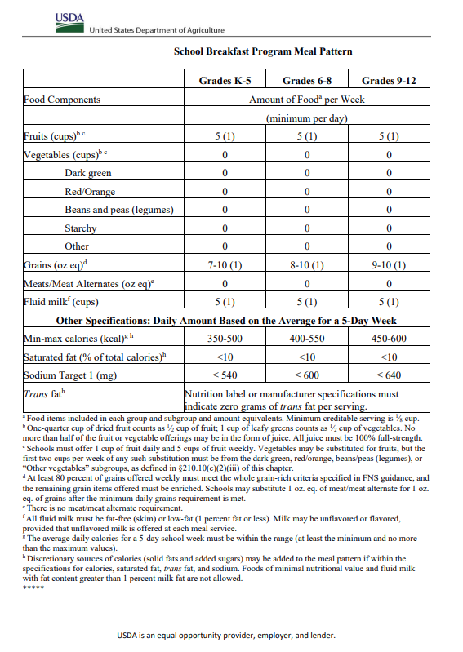

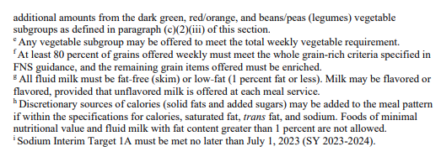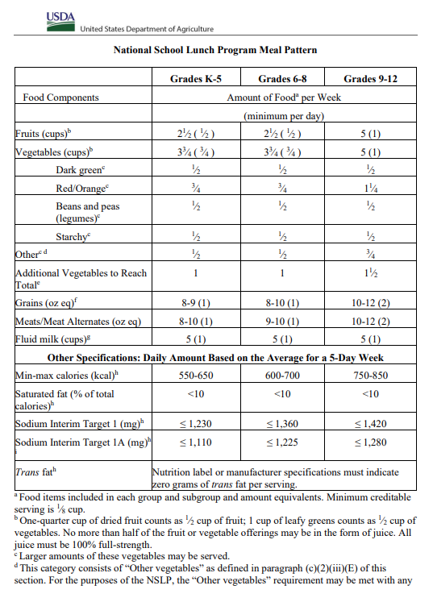

APPENDIX D Continued

CHILD AND ADULT CARE FOOD PROGRAM MEAL PATTERNS

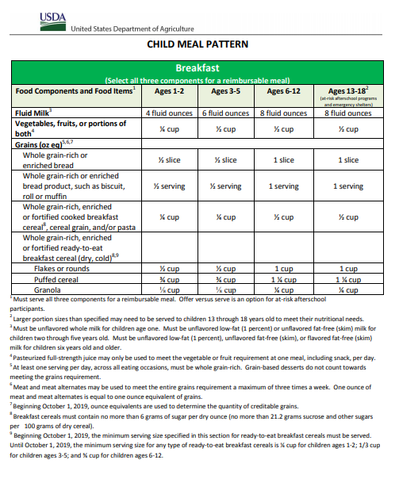

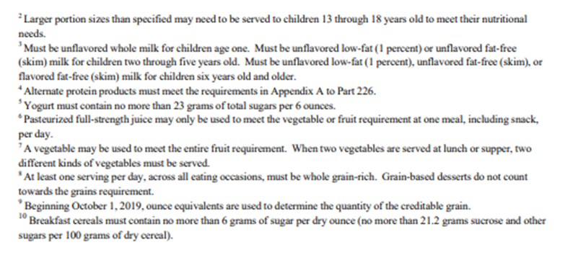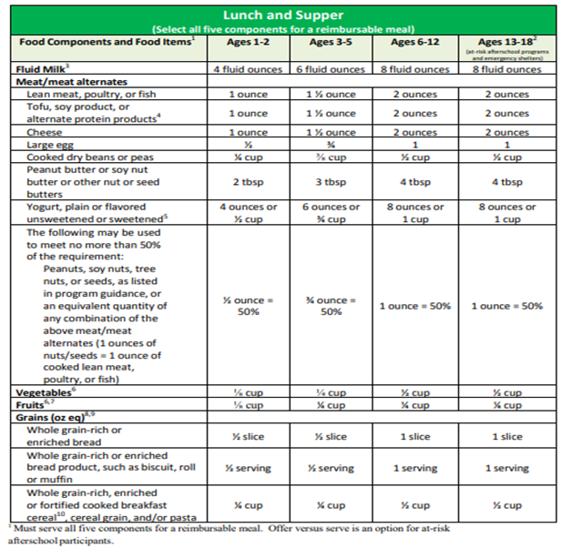

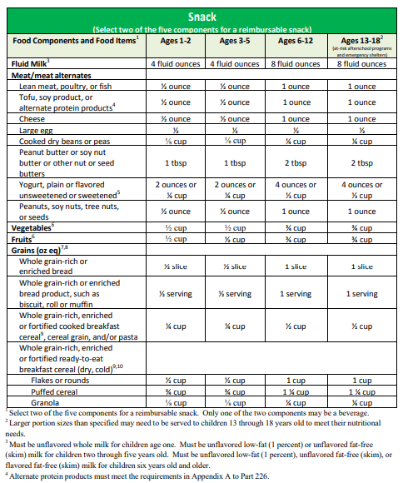

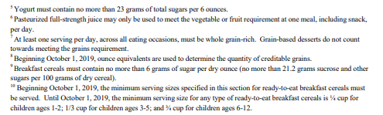

APPENDIX D CONTINUED

Summer food service program meal patterns

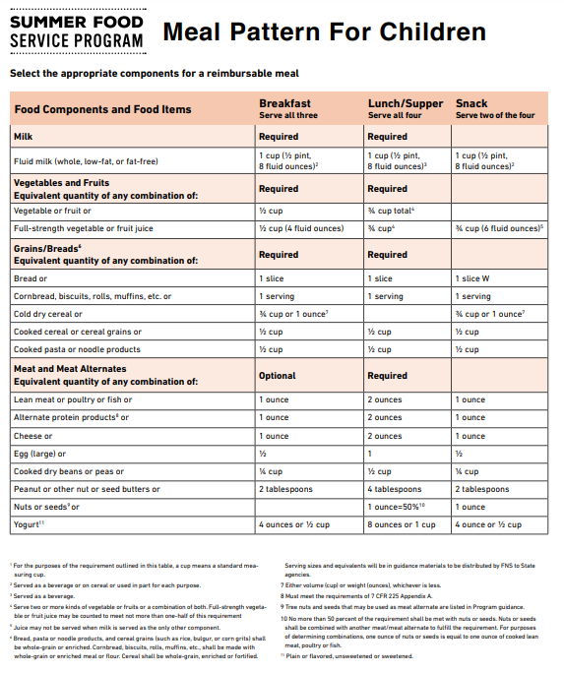

Appendix E

(This part to be completed by FSMC)

FSMC STATEMENT OF PROJECTED EXPENSES

|  |  |  |  |
| --- | --- | --- | --- |
|  | Total Cost |  | Cost per Meal |
|  |  |  |  |
| Food Cost |  |  |  |
| District Labor | $0.00 |  | $0.00 |
| Fringes | $0.00 |  | $0.00 |
| Manager/Supervisor Total | $0.00 |  | $0.00 |
| District Paid Costs | $0.00 |  | $0.00 |
| Non-Food |  |  |  |
| FSMC Administrative Cost* |  |  |  |
| FSMC Management Fee* |  |  |  |
| Other |  |  |  |
|  |  |  |  |
|  |  |  |  |
| TOTAL EXPENSES | $ |  |  |
| BID PRICE (TOTAL X COSTS) | $ |  |  |
| PROFIT OR (LOSS) | $ |  |  |

*Expenses that SFA is contracting for.

Appendix F

(To be completed by FSMC)

Contract to Provide for the Operation and Management

of Food Service

Bid Proposal

|  |  |  |  |  |
| --- | --- | --- | --- | --- |
| Proposal of |  |  | Phone |  |

|  |  |  |  |  |
| --- | --- | --- | --- | --- |
| Address |  |  | Zip Code |  |

|  |  |  |
| --- | --- | --- |
| Bids Due |  |  |
| Bids Open |  |  |

|  |  |
| --- | --- |
| To the Board of Education of | : |

The undersigned agrees to provide for the Operation and Management of Food Service for the

|  |
| --- |
|  |

|  |  |
| --- | --- |
| in accordance with the specifications, terms, and conditions to approximately |  |

|  |  |
| --- | --- |
| site locations, more or less, in the |  |

at the prices specified in Appendix F.

|  |  |  |
| --- | --- | --- |
|  | NOTE: Award to be made to the lowest responsive and responsible bidder meeting specifications and who receives the highest point score based on criteria listed in Appendix K. |  |

Additional sites may be added to, or listed sites may be deleted from, the list included with this contract.

Quantities are estimates based on information from the School Food and Nutrition office’s records for the school year ________ to ________.

Per-meal costs offered herein are to include all contractual obligations assigned to the FSMC including, but not limited to: Administrative fees, management fees, food and preparation costs, labor, license, expendable and disposable supplies/equipment, etc.

Per-meal cost shall not include the value of any USDA commodities.

|  |  |  |
| --- | --- | --- |
| ATTEST: |  | FOOD SERVICE MANAGEMENT COMPANY |
|  |  |  |
|  |  |  |
|  |  |  |
|  |  |  |
|  |  | Name |
|  |  |  |
|  |  |  |
|  |  | Title |
|  |  |  |
|  |  |  |
|  |  | Date |

Appendix G

BID PROPOSAL

|  |  |  |
| --- | --- | --- |
| A. |  | Breakfasts as per contract specifications. |
|  | (Number of meals) |  |

|  |  |  |  |  |  |
| --- | --- | --- | --- | --- | --- |
|  | $ | Each |  | $ | Total |

The above Part A per-meal cost includes:

|  |  |  |  |  |  |
| --- | --- | --- | --- | --- | --- |
|  | $ | Food |  |  |  |
|  | $ | Labor |  |  |  |
|  | $ | Supplies, disposables, etc. |  |  |  |
|  | $ | Administrative fee |  |  |  |
|  | $ | Management Fee |  |  |  |

|  |  |  |
| --- | --- | --- |
| B. |  | Lunches/Meal equivalents as per contract specifications. |
|  | (Number of meals) |  |

|  |  |  |  |  |  |
| --- | --- | --- | --- | --- | --- |
|  | $ | Each |  | $ | Total |

The above Part B per-meal cost includes:

|  |  |  |  |  |  |
| --- | --- | --- | --- | --- | --- |
|  | $ | Food |  |  |  |
|  | $ | Labor |  |  |  |
|  | $ | Supplies, disposables, etc. |  |  |  |
|  | $ | Administrative fee |  |  |  |
|  | $ | Management Fee |  |  |  |

|  |  |
| --- | --- |
| TOTAL BID (ITEM A + ITEM B) | $ |

|  |  |  |
| --- | --- | --- |
| Terms |  | F.O.B. destination |

Appendix H

Certificate of Independent Price Determination

Both the School Food Authority (SFA) and Food Service Management Company (offeror) shall execute this Certificate of Independent Price Determination.

_______________________________________ ____________________________________

NAME OF FOOD SERVICE MANAGEMENT NAME OF SCHOOL FOOD AUTHORITY

COMPANY

(A) By submission of this offer, the offeror certifies, and in the case of a joint offer, each party thereto certifies as to its own organization, that in connection with this procurement:

(1) The prices in this offer have been arrived at independently, without consultation, communication or agreement, for the purpose of restricting competition, as to any matter relating to such prices with any other offeror or with any competitor;

(2) Unless otherwise required by law, the prices which have been quoted in this offer have not been knowingly disclosed by the offeror and will not knowingly be disclosed by the offeror prior to opening in the case of an advertised procurement or prior to award in the case of a negotiated procurement, directly or indirectly to any other offeror or to any competitor; and

(3) No attempt has been made or will be made by the offeror to induce any person or firm to submit or not to submit, an offer for the purpose of restricting competition.

(B) Each person signing this offer on behalf of the Food Service Management Company certifies that:

(1) He or she is the person in the offeror’s organization responsible within the organization for the decision as to the prices being offered herein and has not participated, and will not participate, in any action contrary to (A)(1) through (A)(3) above; or

(2) He or she is not the person in other offeror’s organization responsible within the organization for the decision as to the prices being offered herein, but that he or she has been authorized in writing to act as agent for the persons responsible for such decision in certifying that such persons have not participated and will not participate, in any action contrary to (A)(1) through (A)(3) above, and as their agent does hereby so certify; and he or she has not participated, and will not participate, in any action contrary to (A)(1) through (A)(3) above.

To the best of my knowledge, this Food Service Management Company, its affiliates, subsidiaries, officers, directors and employees are not currently under investigation by any governmental agency and have not in the last three years been convicted or found liable for any act prohibited by State or Federal law in any jurisdiction, involving conspiracy or collusion with respect to bidding on any public contract, except as follows:

_______________________________ _________________________ _____________

Signature of Food Service Management Title Date

Company’s Authorized Representative

In accepting this offer, the SFA certifies that no representative of the SFA has taken any action that may have jeopardized the independence of the offer referred to above.

________________________________ ________________________ _____________

Signature of School Food Authority Title Date

Company’s Authorized Representative

NOTE: ACCEPTING A BIDDER’S OFFER DOES NOT CONSTITUTE AWARD OF THE CONTRACT.

APPENDIX I

CERTIFICATION REGARDING LOBBYING

|  |
| --- |
| Applicable to Grants, Subgrants, Cooperative Agreements, and Contracts Exceeding $100,000 in Federal Funds. |

Submission of this certification is a prerequisite for making or entering into this transaction and is imposed by section 1352, Title 31, U.S. Code. This certification is a material representation of fact upon which reliance was placed when this transaction was made or entered into. Any person who fails to file the required certification shall be subject to a civil penalty of not less than $10,000 and not more than $100,000 for each such failure.

The undersigned certifies, to the best of his or her knowledge and belief, that:

(1) No Federal appropriated funds have been paid or will be paid by or on behalf of the undersigned, to any person for influencing or attempting to influence an officer or employee of any agency, a Member of Congress, an officer or employee of Congress, or an employee of a Member of Congress in connection with the awarding of a Federal contract, the making of a Federal grant, the making of a Federal loan, the entering into a cooperative agreement, and the extension, continuation, renewal, amendment, or modification of a Federal contract, grant, loan, or cooperative agreement.

(2) If any funds other than Federal appropriated funds have been paid or will be paid to any person for influencing or attempting to influence an officer or employee of any agency, a Member of Congress, an officer or employee of Congress, or an employee of a Member of Congress in connection with this Federal grant or cooperative agreement, the undersigned shall complete and submit Standard Form-LLL, “Disclosure Form to Report Lobbying,” in accordance with its instructions.

(3) The undersigned shall require that the language of this certification be included in the award documents for all covered subawards exceeding $100,000 in Federal funds at all appropriate tiers and that all subrecipients shall certify and disclose accordingly.

Name/Address of Organization

Name/Title of Submitting Official

_____________________________________ __________________________

Signature Date

INSTRUCTIONS FOR COMPLETION OF SF-LLL, DISCLOSURE OF LOBBYING ACTIVITIES

This disclosure form shall be completed by the reporting entity, whether subawardee or prime Federal recipient, at the initiation or receipt of a covered Federal action, or a material change to a previous filing, pursuant to title 31 U.S.C. section 1352. The filing of a form is required for each payment or agreement to make payment to any lobbying entity for influencing or attempting to influence an officer or employee of any agency, a Member of Congress, an officer or employee of Congress, or an employee of a Member of Congress in connection with a covered Federal action. Use of SF-LLL-A Continuation Sheet for additional information if the space on the form is inadequate. Complete all items that apply for both the initial filing and material change report. Refer to the implementing guidance published by the Office of Management and Budget for additional information.

Identify the type of covered Federal action for which lobbying activity is and/or has been secured to influence the outcome of a covered Federal action.

Identify the status of the covered Federal action.

Identify the appropriate classification of this report. If this is a follow-up report caused by a material change to the information previously reported, enter the year and quarter in which the change occurred. Enter the date of the last previously submitted report by this reporting entity for this covered Federal action.

Enter the full name, address, city, state and zip code of the reporting entity. Include Congressional District, if known. Check the appropriate classification of the reporting entity that designates if it is, or expects to be, a prime or subaward recipient. Identify the tier of the subawardee, e.g., the first subawardee of the prime is the 1st tier. Subawards include but are not limited to subcontracts, subgrants and contract awards under grants.

If the organization filing the report in item 4 checks “Subawardee”, then enter the full name, address, city, state and zip code of the prime Federal recipient. Include Congressional District, if known.

Enter the name of the Federal agency making the award or loan commitment. Include at least one organizational level below agency name, if known. For example, Department of Transportation, United States Coast Guard.

Enter the Federal program name or description for the covered Federal action (item 1). If known, enter the full Catalog of Federal Domestic Assistance (CFDA) number for grants, cooperative agreements, loans, and loan commitments.

Enter the most appropriate Federal identifying number available for the Federal action identified in item 1 (e.g., Request for Proposal (RFP) Number, Invitation for Bid (IFB) Number; grant announcement number; the contract, grant or loan award number; the application/proposal control number assigned by the Federal agency). Include prefixes, e.g., “RFP-DE-90-001.”

For a covered Federal action where there has been an award or loan commitment by the Federal agency, enter the Federal amount of the award/loan commitment for the prime entity identified in item 4 or 5.

(a) Enter the full name, address, city, state and zip code of the lobbying entity engaged by the reporting entity identified in item 4 to influence the covered Federal action.

(b) Enter the full names of the individual(s) performing services, and include full address if different from 10(a). Enter Last Name, First Name, and Middle Initial (MI).

Enter the amount of compensation paid or reasonably expected to be paid by the reporting entity (item 4) to the lobbying entity (item 10). Indicate whether the payment has been made (actual) or will be made (planned). Check all that apply. If this is a material change report, enter the cumulative amount of payment made or planned to be made.

Check all that apply. If payment is made through an in-kind contribution, specify the nature and value of the in-kind payment.

Check all that apply. If other, specify nature.

Provide a specific and detailed description of the services that the lobbyist has performed, or will be expected to perform, and the date(s) of any services rendered. Include all preparatory and related activity, not just time spent in actual contact with Federal officials. Identify the Federal official(s) or employee(s) contacted or the officer(s), employee(s), or Member(s) of Congress that were contacted.

Check whether or not a SF-LLL-A Continuation Sheet(s) is attached. List number of sheets if yes.

The certifying official shall sign and date the form, print his/her name, title, and telephone number.

|  |
| --- |
| Public reporting burden for this collection of information is estimated to average 30 minutes per response, including time for reviewing instructions, searching existing data sources, gathering and maintaining the data needed, and completing and reviewing the collection of information. Send comments regarding the burden estimate or any other aspect of this collection of information, including suggestions for reducing this burden, to the Office of Management and Budget. Paperwork Reduction Project (0348-00046), Washington, DC 20503. |

DISCLOSURE OF LOBBYING ACTIVITIES

Complete this form to disclose lobbying activities pursuant to 31 U.S.C. 1352

(See reverse for public burden disclosure.)

|  |  |  |
| --- | --- | --- |
| 1. Type of Federal Action: _____  a. contract  b. grant  c. cooperative agreement  d. loan  e. loan guarantee  f. loan insurance | 2. Status of Federal Action: _____  a. bid/offer/  application  b. initial award  c. post-award | 3. Report Type: _____  a. initial filing  b. material change  For Material Change Only: Year _____  Quarter _____ Date of Last Report _________ |
| 4. Name and Address of Reporting Entity:  _____Prime _____Subawardee  Tier ____, if known:  Congressional District, if known: | 5. If Reporting Entity in No. 4 is Subawardee, Enter Name and Address of Prime:  Congressional District, if known: | |
| 6. Federal Department/Agency: | 7. Federal Program Name/Description:  CFDA Number, if applicable: ________________ | |
| 8. Federal Action Number, if known: | 9. Award Amount, if known:  $ | |
| 10. a. Name and Address of Lobbying Entity:  (if individual, last name, first name, middle)  (Attach Continuation Sheet(s) | 10. b. Individuals Performing Services (including address if different from No. 10, a.) (last name, first name, middle)  SF-LLL-A If Necessary) | |
| 11. Amount of Payment (check all that apply):  $  ___ Actual ___ Planned | 13. Type of payment (check all that apply):  ___ a. retainer  ___ b. one-time fee  ___ c. commission  ___ d. contingent fee  ___ e. deferred  ___ f. other; specify:  __________________________________ | |
| 12. Form of Payment (check all that apply):  ___ a. cash  ___ b. in-kind; specify:  Nature __________________________  Actual __________________________ |  | |
| 14. Brief Description of Services Performed or to be Performed and Date(s) of Service, including officer(s), employee(s), or member(s) contracted for Payment indicated in Item 11:  (Attach Continuation Sheet(s) SF-LLL-A, if necessary) | | |
| 15. Are Continuation Sheet(s) SF-LLL-A Attached: | Yes_____ (Number ________) | No _____ |
| 16. Information requested through this form is authorized by Title 31 U.S.C. section 1352. This disclosure of lobbying activities is a material representation of fact upon which reliance was placed by the tier above when this transaction was made or entered into. This disclosure is required pursuant to 31 U.S.C. 1352. This information will be reported to the Congress semi-annually and will be available for public inspection. Any person who fails to file the required disclosure shall be subject to a civil penalty of not less than $10,000 and not more than $100,000 for each such failure. | Signature: ___________________________________________  Print Name: __________________________________________  Title: _______________________________________________  Telephone: ___________________________________________  Date: ________________________________________________ | |
| Federal Use Only: | | Authorized for Local Reproduction Standard Form—LLL |

DISCLOSURE OF LOBBYING ACTIVITIES

CONTINUATION SHEET SF-LLL-A

|  |
| --- |
| Reporting Entity: ______________________________________________ Page _____ of _____ |

Appendix J

AWARD CRITERIA

The relative value assigned to the evaluation of each criterion must be specified by the SFA prior to soliciting for proposals. The highest consideration (the most weight) must be given to bid price. An evaluation committee must be comprised of at least three people. Each committee member evaluates proposals independently.

Weight Criteria

1. The SFA must determine prior to advertising the RFP what percentage (total of 100 points which equals 100%) each category below will be given when comparing proposals. Cost must be the most heavily weighted criteria.
2. The SFA may insert additional categories if needed.
3. The SFA may not include as a category: prior experience with the SFA, as it would violate USDA’s free and open competition regulation for procurement.

|  |  |
| --- | --- |
| **Points** | **Criteria** |
|  | Cost (must be primary consideration)   * Vendor provides pricing that aims to develop a cost-neutral program for the school including vendor support and responsibility for waste management. |
|  | Service Capability Plan (describes Vendor’s ability to provide services as stated in the RFP)   * Vendors is able to provide meals at the locations and times in the RFP * Vendor is able to provide HACCP trained server(s) to both serve food as well as operate POS systems for the SFAs (if applicable) * Vendor is responsive to the SFA needs and remedies problems immediately * Vendor will provide paperwork that incorporates daily HACCP and production worksheet required information (provide sample) * Vendor provides necessary paperwork and documents to the SFA, including the SFA invoices, menus and production worksheets, menu substitutions, in order for the SFA to properly monitor performance This includes FFVP, SFSP, and CACFP documentation if necessary |
|  | Experience, References with programs like the SFA’s and familiarity with regulations pertaining to such operations   * Vendor is able to provide three references with programs like the SFAs * Vendor is able to describe familiarity with program regulations |
|  | Financial Condition/Stability, Business Practices   * Vendor is able to finance meal preparation and delivery without pre-payments * Vendor is able to provide documentation of financial stability and sound business practices |
|  | Accounting and Reporting Systems   * Vendor is able to provide monthly invoices that show credits for USDA foods * Vendor is able to provide a year-end summary of the total meals invoiced/served by meal type, total amount of USDA foods credited, and total fees charged by site |
|  | Menu and Food Quality   * Vendor is able to provide a cycle menu that meets the specifications of the programs being served * Vendor involves students, staff, and patrons in menu planning * Portion and serving sizes are easily identifiable and provided by the Vendor * Menus offer a variety of food items appropriate for each grade/age group served * Vendor is able to accommodate special dietary needs as outlined in the RFP * Food specifications meet the requirements of the RFP * Food delivered is prepared fresh, free of spoilage, and minimally processed. Fresh fruit and vegetable options are available daily. |
|  | Flexibility in Ordering   * The SFA has flexibility and autonomy to request meals at dates/times of their choosing, despite traditional closed days * Field trip and shelf-stable meals are available (meet USDA reimbursable meal requirements.) |
|  | Waste Management   * Vendor works with the SFA to look at trends for more accurate ordering and to help reduce waste |
| 100 | TOTAL |

Appendix K

**CERTIFICATION REGARDING DEBARMENT, SUSPENSION, INELIGIBILITY**

**AND VOLUNTARY EXCLUSION**

2 CFR Part 200.213 and 2 CFR Part 180.300 (see also Appendix II to Part 200, Section H) as adopted and modified by USDA regulations at 2 CFR 417; all program participants must ensure that they do not enter into a covered transaction with a suspended or debarred entity by doing one of the following:

1. Check the EPLS (Excluded Parties List System) part of the System of Awards Management (SAM). See this at [www.sam.gov](http://www.sam.gov). This system lists all suspended and debarred organizations; or,
2. Collect a certification from the organization stating that they are not suspended or debarred (The USDA form is no longer active so must be a State Agency or SFA form). This appendix can serve as such form if the FSMC representative signs and attests below:

[Enter Food Service Management Company Name] certifies, by submission of this proposal that neither the FSMC nor its principals are presently debarred, suspended, proposed for debarment, declared ineligible, or voluntarily excluded from participation in this transaction by any Federal department or agency.

_____________________________________________________

Food Service Management Company/Vendor Name and Address

_____________________________________________________

Name and Title of Authorized Representative

_____________________________________________________

Signature of Authorized Representative

_____________________________________________________

Date

Appendix L

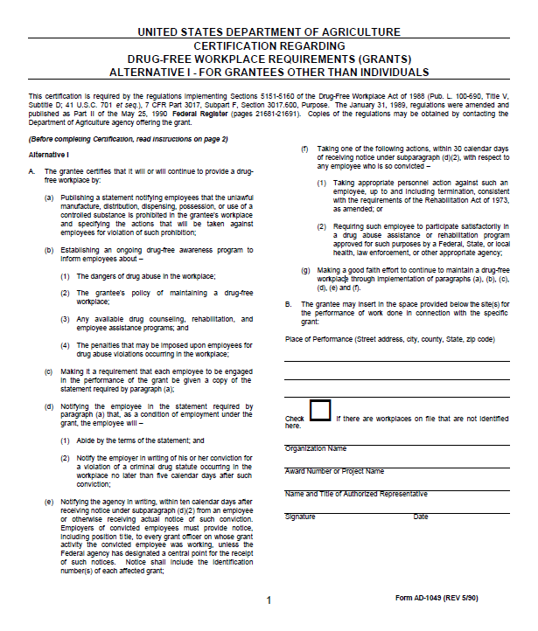

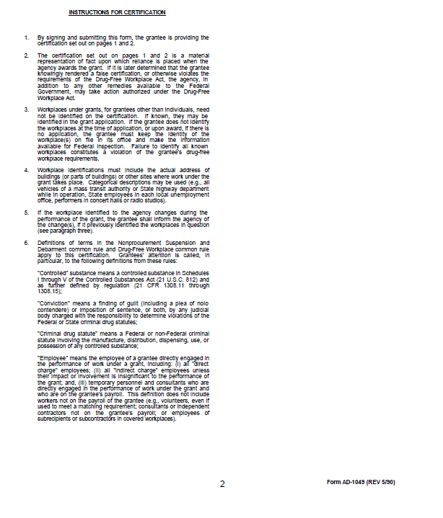

Appendix M

**AGREEMENT PAGE (initial before each condition)**

______ The bidder certifies that he/she shall operate in accordance with all applicable State and federal regulations.

______ The bidder certifies that all terms and conditions within the Bid Solicitation shall be considered a part of the contract as if incorporated therein.

______ The bidder certifies that the FSMC is neither excluded nor disqualified from doing business with federally funded School Nutrition Programs.

______ This agreement shall be in effect for one year and may be renewed by mutual agreement for two additional one-year periods.

IN WITNESS WHEEOF, the parties hereto have caused this Agreement to be signed by their duly authorized representative this _______ day of ____________________________________, in the year ________.

**ATTEST: ATTEST:**

**SCHOOL FOOD AUTHORITY** **FOOD SERVICE MANAGEMENT COMPANY**

____________________________________ __________________________________

Printed Name of Authorized Representative Printed Name of Authorized Representative

____________________________________ __________________________________

Signature of Authorized Representative Signature of Authorized Representative

____________________________________ __________________________________

Title of Authorized Representative Title of Authorized Representative

**ATTEST:**

**DELAWARE DEPARTMENT OF EDUCATION**

____________________________________

Printed Name of Authorized Representative

____________________________________

Signature of Authorized Representative

____________________________________

Title of Authorized Representative

____________________________________

Date

**Updated June 2024**

APPENDIX N

In accordance with federal civil rights law and U.S. Department of Agriculture (USDA) civil rights regulations and policies, this institution is prohibited from discriminating on the basis of race, color, national origin, sex (including gender identity and sexual orientation), disability, age, or reprisal or retaliation for prior civil rights activity.

Program information may be made available in languages other than English. Persons with disabilities who require alternative means of communication to obtain program information (e.g., Braille, large print, audiotape, American Sign Language), should contact the responsible state or local agency that administers the program or USDA’s TARGET Center at (202) 720-2600 (voice and TTY) or contact USDA through the Federal Relay Service at (800) 877-8339.

To file a program discrimination complaint, a Complainant should complete a Form AD-3027, USDA Program Discrimination Complaint Form which can be obtained online at: <https://www.usda.gov/sites/default/files/documents/ad-3027.pdf>, from any USDA office, by calling (866) 632-9992, or by writing a letter addressed to USDA. The letter must contain the complainant’s name, address, telephone number, and a written description of the alleged discriminatory action in sufficient detail to inform the Assistant Secretary for Civil Rights (ASCR) about the nature and date of an alleged civil rights violation. The completed AD-3027 form or letter must be submitted to USDA by:

1. **mail:**  
   U.S. Department of Agriculture  
   Office of the Assistant Secretary for Civil Rights  
   1400 Independence Avenue, SW  
   Washington, D.C. 20250-9410; or
2. **fax:**  
   (833) 256-1665 or (202) 690-7442; or
3. **email:**  
   [Program.Intake@usda.gov](mailto:program.intake@usda.gov)

This institution is an equal opportunity provider.

APPENDIX O

Assurance of Civil Rights Compliance

The School Food Authority (SFA)/Sponsor hereby agrees that it will comply with: i. Title VI of the Civil Rights Act of 1964 (42 U.S.C. 2000d et seq.); ii. Title IX of the Education Amendments of 1972 (20 U.S.C. 1681 et seq.); iii. Section 504 of the Rehabilitation Act of 1973 (29 U.S.C. 794); iv. Age Discrimination Act of 1975 (42 U.S.C. 6101 et seq.); v. Title II and Title III of the Americans with Disabilities Act (ADA) of 1990 as amended by the ADA Amendment Act of 2008 (42 U.S.C. 12131-12189); vi. Executive Order 13166, "Improving Access to Services for Persons with Limited English Proficiency." (August 11, 2000); vii. All provisions required by the implementing regulations of the Department of Agriculture (USDA) (7 CFR Part 15 et seq.); viii. Department of Justice Enforcement Guidelines (28 CFR Parts 35, 42 and 50.3); ix. Food and Nutrition Service (FNS) directives and guidelines to the effect that, no person shall, on the grounds of race, color, national origin, sex (including gender identity and sexual orientation), age, or disability, be excluded from participation in, be denied the benefits of, or otherwise be subject to discrimination under any program or activity for which the Program applicant receives Federal financial assistance from USDA; and hereby gives assurance that it will immediately take measures necessary to effectuate this Agreement. x. The USDA non-discrimination statement that in accordance with Federal civil rights law and U.S. Department of Agriculture (USDA) civil rights regulations and policies, the USDA, its Agencies, offices, and employees, and institutions participating in or administering USDA programs are prohibited from discriminating based on race, color, national origin, religion, sex, gender identity (including gender expression), sexual orientation, disability, age, marital status, family/parental status, income derived from a public assistance program, political beliefs, or reprisal or retaliation for prior civil rights activity, in any program or activity conducted or funded by USDA (not all bases apply to all programs).

This assurance is given in consideration of and for the purpose of obtaining any and all Federal financial assistance, grants, and loans of Federal funds, reimbursable expenditures, grant, or donation of Federal property and interest in property, the detail of Federal personnel, the sale and lease of, and the permission to use Federal property or interest in such property or the furnishing of services without consideration or at a nominal consideration, or at a consideration that is reduced for the purpose of assisting the recipient, or in recognition of the public interest to be served by such sale, lease, or furnishing of services to the recipient, or any improvements made with Federal financial assistance extended to the Program applicant by USDA. This includes any Federal agreement, arrangement, or other contract that has as one of its purposes the provision of cash assistance for the purchase of food, and cash assistance for purchase or rental of food service equipment or any other financial assistance extended in reliance on the representations and agreements made in this assurance.

By accepting this assurance, the SFA/Sponsor agrees to compile data, maintain records, and submit records and reports as required, to permit effective enforcement of nondiscrimination laws and permit authorized USDA personnel during hours of program operation to review and copy such records, books, and accounts, access such facilities and interview such personnel as needed to ascertain compliance with the nondiscrimination laws. If there are any violations of this assurance, the Department of Agriculture, FNS, shall have the right to seek judicial enforcement of this assurance. This assurance is binding on the State agency, its successors, transferees and assignees as long as it receives assistance or retains possession of any assistance from USDA. The person or persons whose signatures appear below are authorized to sign this assurance on behalf of the SFA/Sponsor.