sussex academy
annual report

Report Date: January 15, 2024

Delaware Department of Education
Charter School Office
401 Federal Street, Suite 2
Dover, DE 19901
Phone: (302) 735-4020
Email: infocso@doe.k12.de.us
Homepage: https://www.doe.k12.de.us/Page/2267

I. Overview

1.1 School Profile
Sussex Academy | 21150 Airport Road, Georgetown, DE 19947
http://www.sussexacademy.org/
Year Opened | 2000 | District(s) of Residence | Indian River School District
2022-23 Enrollment | 1,118 | Approved Enrollment | 1,112
Current Grade Span | K-12 | Approved Grade Span | K-12
School Leader(s) | Janet Owens | School Leader Phone & Email | Janet.owens@saas@k12.de.us
Board President | Jennifer Donahue | Board President Email | jennifer.donahue@saas.k12.de.us
Mission Statement: The mission of the Sussex Academy is to prepare students for future academic success by providing an accelerated, supportive academic environment within a small school setting.

1.2 Student Demographics
Enter the number of students on your waiting list (if applicable).
 | 2022-2023
Total Enrollment | 1,118
Students on Waiting List
% Male | 46.06%
% Female | 53.94%
% African American | 4.11%
% American Indian | 1.52%
% Asian | 3.49%
% Hispanic/Latino | 15.21%
% White | 71.65%
% Multiracial | 3.76%
% Native Hawaiian or Other Pacific Islander | 0.27%
%Special Education | 5.99%
% English Language Learners | 3.94%
% Low-Income | 6.53%

1.3 Approved minor and major modifications
Date | Modification Requested | Outcome
5/4/2020 | Major Modification to increase enrollment from 840 to 1,080 students; change the school’s grade configuration from 6-12 to K-12; establish a second campus; and remove its special interest preference. | Approved
12/31/18 | Increase enrollment from 776 to 840 students SY 20/21. | Approved

1.4 school enrollment
 | Approved  Enrollment | 30-Sep  Enrollment Count | % of Actual  Enrollment
K |  | 42
1 |  | 42
2 |  | 42
3 |  | 44
4 |  | 44
5 |  | 44
6 |  | 124
7 |  | 134
8 |  | 129
9 |  | 121
10 |  | 116
11 |  | 115
12 |  | 121
Total | 1,112 | 1,118 | 101%

- Explain successes or challenges of implementing the school’s recruitment plan.

School Comments:

1.5 school reenrollmenT
Reenrollment Rate is the percentage of students continuously enrolled in the school from one year to the next.
Grades | NUMBER OF STUDENTS REENROLLED | PERCENT OF STUDENTS REENROLLED
K | 0
1 | 40 | 95.24%
2 | 40 | 95.24%
3 | 41 | 93.18%
4 | 42 | 100%
5 | 42 | 91.8%
6 | 41 | 93.18%
7 | 125 | 99.21%
8 | 114 | 92.68%
9 | 95 | 75.4%
10 | 104 | 85.25%
11 | 103 | 86.55%
12 | 117 | 87.97%
Total/Avg | 904 | 89.59%

- Explain successes or challenges of implementing the school’s retention plan.
School Comments:

II. academic Performance
Delaware operates under the belief that all schools benefit from continuous improvement – including those that receive exceeds expectations ratings – to best support all students. The Delaware School Success Framework (DSSF) outlines the accountability standards by which all Delaware public schools are measured. This state- and school-level data helps identify each school’s needs and determine how best to support students across the state.
DSSF measures the following areas to determine school success. This annual data is publicly available on the Delaware Report Card.
- Academic achievement – Proficiency for ELA and math (grades 3-8 and 11)
- Academic progress – Growth in ELA and math (grades 4-8); includes growth of the lowest and highest performing students in a school
- School quality/student success – On-track attendance (K-12), science proficiency (grades 5, 8 and biology), social studies proficiency (grades 4, 7 and 11), college/career preparedness (grades 9-12), and on-track in 9th grade
- Graduation rates – 4-year, 5-year and 6-year adjusted cohort graduation rates
- English language proficiency (ELP) – Progress toward English language proficiency (grades 1-12)

2.1 delaware school success framework – SY 2022-2023
Indicators/Measures | Weight | Metric Value | Points Possible | Points Earned
Academic Achievement | 20% |  | 100 | 67
 |  |  |  | Meets Expectations
Proficiency ELA (grades 3-8 and 11) | 10% | 77.19% | 50 | 39
Proficiency Math (grades 3-8 and 11) | 10% | 56.81% | 50 | 28
Academic Progress | 25% |  | 112.50 | 70
 |  |  |  | Approaching Expectations
Growth in ELA (grades 4-8) | 10% | 63.72% | 50 | 32
Growth in Math (grades 4-8) | 10% | 60.07% | 50 | 30
Growth of lowest quartile ELA (grades 4-8) | 1.25% | 74.32% | N/A | *
Growth of highest quartile ELA (grades 4-8) | 1.25% | 57.98% | 6.25 | 4
Growth of lowest quartile Math (grades 4-8) | 1.25% | 72.67% | N/A | *
Growth of highest quartile Math (grades 4-8) | 1.25% | 60.31% | 6.25 | 4
School Quality/Student Success | 25% |  | 125 | 105
 |  |  |  | Meets Expectations
On Track Attendance (grade K-12) | 3% | 84.30% | 12.5 | 11
Proficiency Science (grade 8 and Biology) | 5% | 55.66% | 25 | 14
Proficiency Social Studies (Grades 7 and 11) | 5% | 69.64% | 25 | 17
College and/or Career Preparedness (9-12) | 8% | 100.25% | 37.5 | 38
On Track in 9th Grade | 5% | 100.76% | 25 | 25
Graduation Rate | 20% | N/A | 100 | 96
 |  |  |  | Exceeds Expectations
4-Year Cohort Graduation Rate | 15% | 95.04% | 75 | 71
5-Year Cohort Graduation Rate | 3% | 100% | 13 | 13
6-Year Cohort Graduation Rate | 2% | 100% | 12 | 12
Progress toward English Language Proficiency | 10% | 34.78% | 50 | 17
 |  |  |  | Well Below Expectations
Total | 100% |  | 487.5 | 355
Overall Percentage / Rating |  |  |  | 72.82%
Approaching
Expectations

2.2 Academic performance expectations
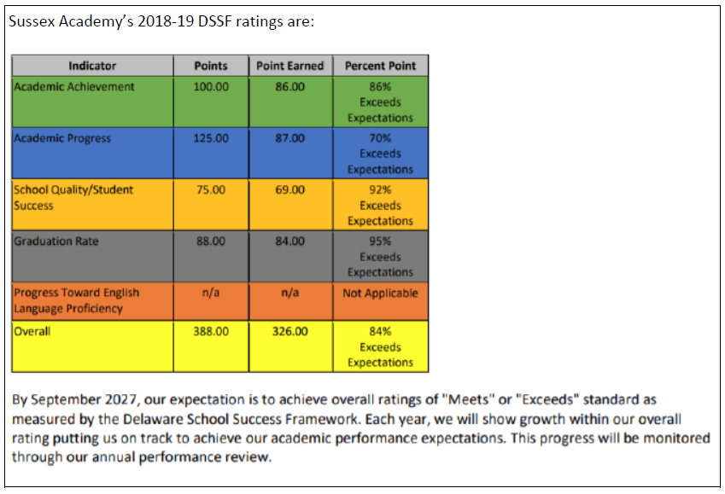
- Reflect on your school’s academic performance in relation to the goals set forth in the performance agreement. Please reference the specific Delaware School Success Framework (DSSF) listed below. Highlight successes, challenges, root causes, and describe how the school will address the challenges.
- Academic Achievement
- Academic Progress
- School Quality/Student Success
- Graduation Rate (if applicable)
- Progress toward English Language Proficiency
School Comments:

2.3 SUPPLEMENTAL ACADEMIC PERFORMANCE DATA
- Provide any academic performance-related evidence, supplemental data, or contextual information. In this section, you may provide graphs and/or charts to supplement your narrative as Appendix 1.
School Comments:

- Reflect on other aspects of the school’s academic performance that may not be captured by the DSSF. Highlight successes, challenges, root causes, and describe below how the school will address the challenges.
School Comments:

- Provide and reflect on additional information regarding academic-related indicators your school would like the Accountability Committee to consider. (This could include social and emotional development, attendance and retention, student engagement, student discipline, and others as appropriate.) Highlight successes, challenges, root causes, and describe how the school will address the challenges.
School Comments:

III. organizational performance
The Organizational Performance Framework reflects expectations the charter school is required to meet through state and federal law and the charter performance agreement, and seeks to provide information regarding these key questions:
- Is the school organizationally sound and well operated?
- Is the school fulfilling its legal obligations and sound public stewardship?
- Is the school meeting its obligations and expectations for appropriate access, education, support services, and outcomes for students with disabilities?

3.1 Organizational performance framework
SUMMARY AND OVERALL RATINGS
YEAR | Education Program |  |  |  | Governance & Reporting |  |  | Students & Staff |  | Facilities, Transportation, Health, & Safety
 | Mission Fidelity | Applicable State & Federal Requirements | Students with Disabilities | English Learners | Governance & Public Stewardship | Oversight & School Management | Reporting & Requirements | Student Rights | Teacher Certification and Hiring REquirements
 | 1a | 1b | 1c | 1d | 2a | 2b | 2c | 3a | 3b | 4a | OVERALL  RATING
2022-23 | M | M | M | M | M | M | M | M | M | M | Meets  Standard
M: Meets Standard
AS: Approaching Standard
F: Far Below Standard

3.2 ORGANIZATIONAL performance expectations

PERFORMANCE AGREEMENT

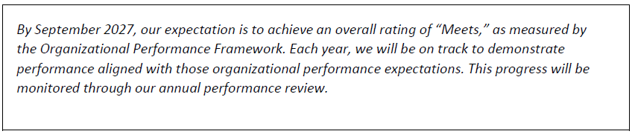

- Describe the school’s organizational performance during school year 2022-23. (This section is for the school to address any overall rating where the school has not met standards. The school will be able to address individual metrics in the sections below.)
School Comments:

- Discuss management and operations successes and challenges during the 2022-23 school year. Areas you may want to consider as appropriate:
- School leadership
- Day-to-day operations including: transportation; facilities; food service; staffing (hiring, retention, professional development, evaluation); health and safety; community engagement
School Comments:

- Address any measure(s) where the school did not meet standard or is approaching standard (if applicable).
School Comments:

3.3 aT-RISK STUDENTS, STUDENTS WITH DISABILITIES, AND ENGLISH LANGUAGE LEARNERS
- If applicable, describe any changes or enhancements the school has made based on findings from audits, investigations, or other administrative proceedings related to at- risk students, students with disabilities, gifted and talented students, or Multilingual Learners.
School Comments:

- Describe any changes or enhancements to the process by which at-risk students, students with disabilities and gifted and talented students are identified and the evidence that the school was able to provide the right resources and services for these students.
School Comments:

- Describe any changes or enhancements to the process by which Multilingual Learners are identified and the evidence that the school was able to provide the right resources and services for these students.

School Comments:

gOVERNANCE AND REPORTING REQUIREMENTS
- Describe how the board has provided oversight in the areas of academics, finance, and operations, including legal compliance.
School Comments:

- Discuss board-related success and challenges during school year 2022-23. Areas you may want to consider as appropriate include:
- Membership and recruitment
- New member induction and ongoing governance training
- Meeting attendance
- Board self-evaluation
- Progress on particular board-level projects
School Comments:

- Describe the process used by the board to evaluate school leadership.
School Comments:

- Describe the school’s process for success planning including identification, development, and retention of school leaders.
School Comments:

- Share how the board supports the school. Speak to the board’s involvement in events, operations, and fundraising activities.
School Comments:

3.5 students and school environment
- Describe how the school solicits feedback from parents and students regarding satisfaction with the school. Provide summary data and reflect on the feedback. How does the school use this information to inform ongoing school improvement?
School Comments:

3.6 teacher retention
Is the school monitoring and minimizing teacher attrition rates and maintaining a stable teacher staff?
Note: Complete the table below.
SCHOOL YEAR | PERCENT OF TEACHERS  RETAINED | NUMBER OF TEACHERS  RETAINED | NUMBER OF TEACHERS  ELIGIBLE
2022-23
- Explain successes or challenges of implementing the school’s teacher retention plan.
School Comments:

- Describe how the school’s professional development plans have evolved to support teachers and leadership.
School Comments:

- Describe how the school’s completion of educator evaluations has evolved.
School Comments:

iv. FINANCIAL performance
The Financial Performance Framework is a reporting tool that provides the Department of Education with the necessary data to assess the financial health and viability of charter schools in its portfolio for the purposes of an annual review. The framework summarizes a charter school’s financial health while taking into account the school’s financial trends over a period of three years.

4.1 financial performance Framework
SUMMARY AND OVERALL RATINGS
YEAR | Current Ratio  (Working Capital Ratio) | Debt to Asset Ratio | Days Cash | Debt Service Payments /  Loan Covenants | Aggregated Three-Year Total Margin | Cash Flow | Debt Service Coverage Ratio | Enrollment Variance | Student Retention | Financial Management & Oversight
 | 1a | 1b | 1c | 1d | 2a | 2b | 2c | 2d | 3 | 4 | OVERALL  RATING
2022-23 | AS | F | AS | M | F | F | M | M | Not Rated | M | Approaching Standard
M: Meets Standard
AS: Approaching Standard
F: Far Below Standard

4.2 FINANCIAL performance expectations
PERFORMANCE AGREEMENT
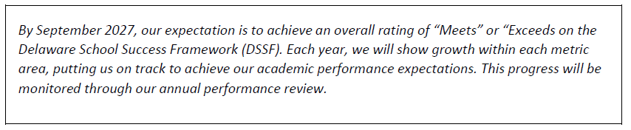
- Using the results contained in the Financial Performance Framework, describe the school’s financial performance during school year 2022-23. (This section is for the school to address any overall rating where the school has not met standard. The school will be able to address individual metrics in the sections below).
School Comments:

- Identify changes to financial practices that the school has implemented to improve the school's financial outcomes.
School Comments:

- Address any measure(s) where the school did not meet the standard (if applicable).
School Comments:

- Describe how the schools developed and implemented a corrective action plan in response to audit findings (if applicable).

School Comments:

v. innovative practices
- Describe effective systems, structures, and/or processes that have led to significant school improvement that could be replicated at other schools. Please include the data that supports the success of these practices. Areas you may want to consider, as appropriate:
- Leadership
- Professional Learning
- Instructional Transformation
- Equity
- Culture and Climate Shift
- Collaboration/Partnerships
School Comments:

vI. annual report certification statement
Name of School:
Location:

I hereby certify that the information submitted in this annual report of a charter school is true to the best of my knowledge and belief; that this application has been approved by the school’s Board of Directors.
Signature: Chairperson of Board of Directors (or designated signatory authority) | Date

Print/Type Name:
Title (if designated):
Date of approval by board of directors:

